**Working collectively for food and mutual aid projects:**

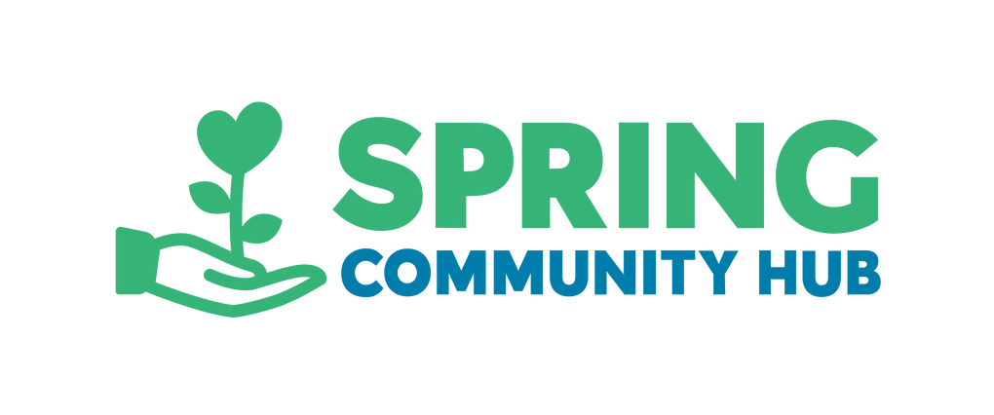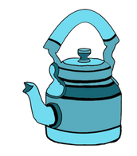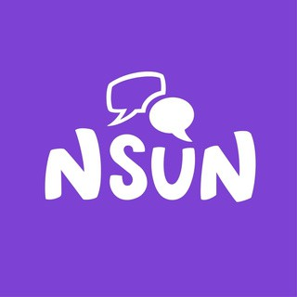

**A 3-Step Guide**

This guide is made in collaboration with Spring Community Hub, a Southwark-based charity which aims to address the root causes of food poverty and food insecurity, National Survivor User Network and The Teapot Collective.

**Who is this guide for?**

This guide is for community- led mutual aid and food projects.

This 3-Step Guide could also be used more broadly to support those who:

 are looking to start a new project

 have recently started a project

 feel that your existing project could be more embedded within the community

This guide is also for anyone who believes that working together brings us closer to living in a world that’s socially just.

We invite you to engage with the 3 Steps in this guide to support you with your community development work.

**Introducing the 3 Steps**

Step 1: Capture

Step 2: Connect

Step 3: Co-Create

# 1

**Step 1: Capture**

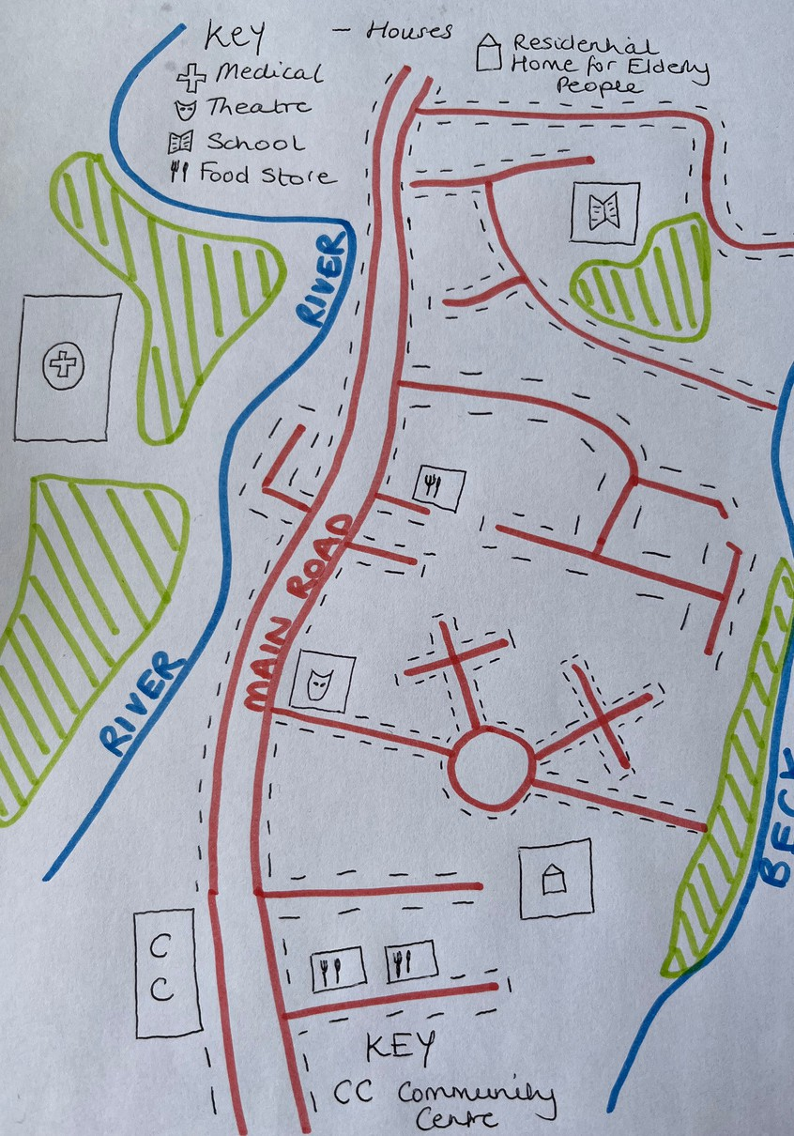

Photo of a neighbourhood map drawn by the author including roads, a school, shops, rivers, parks, hospital, a community centre and a theatre.

## We invite you to develop a community resource map.

1: Using Google Maps, draw a map of the area where your project resides: start small with a few streets with the aim to expand the map with time.

2: In a group, take a walk or drive around along the streets on your map, do some

research on some of the places you find, and add detail to the map.

3: Identify on your map things such as: other organisations, event venues, religious centres, food places, bus routes, accessible routes, places of inaccessibility, shops, community centres, parks and more.

## “Resource mapping opens a world of possibility, under our feet.”

@badschoolbadschool

**Step 2: Connect**

## Visit local projects and community spaces

After you’ve drawn your map and now have a better understanding of the services and resources that exist in your local area, we invite you to take a visit to local projects and community venues and ask them what they need.

# 2

**Felicia Boshorin**, Founder and CEO of Spring Community Hub, says:

“We invite people to come and visit the team if they’re looking to start up a mutual aid and food project. The staff and volunteers at Spring know where the gaps in provision are, particularly regarding food and mutual aid; the staff will be able to guide you toward addressing the unmet needs of the local community.”

**Step 3: Co-Create**

## We encourage you to consider the people who will, or who already access, your service.

How will you ensure that their needs are met? How will you involve the people accessing your service in decision making processes for the project? How can you design the service together?

We invite you to actively maintain the relationships you’ve started to build with local community centres & projects.

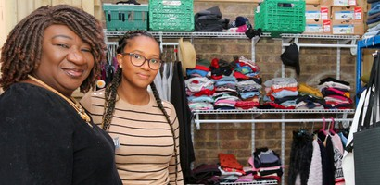

Photo of two Spring Community Hub members standing and smiling in front of the clothes bank.

## Co-Create Case Study: Spring Community Hub

There continue to be many new food projects starting up across the country, with the important aim of giving away food before it gets thrown away. In principle this is a great idea, but unfortunately it can have some unintended consequences.

Spring Community Hub has sometimes found that local food donors only have two or three products available, e.g. bread, chocolate or milk, which means projects distributing food are frequently unable to offer guests ingredients for balanced, healthy meals.

This is an example where food donation projects may not have considered the wider impact on communities.

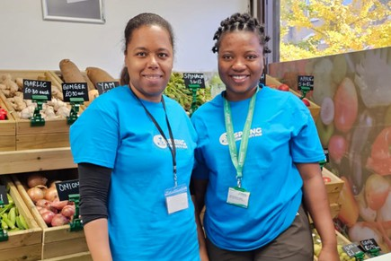

Photo of two Spring Community Hub members standing and smiling in front of the food store.

Spring Community Hub suggests that if you’re setting up a project like this, **to speak to the local community centres and food projects to see how you can work together, co-create,** to ensure that the food you have doesn’t go to waste and people eat nutritiously.

For example, you could run a crowdfunding campaign so that you’re able to purchase wholesale, healthy foods to supplement food donations received, helping food project guests to create healthy meals.

## About Spring Community Hub

Spring Community Hub exists to ensure that no-one in our Southwark community goes hungry. But we don't just provide food: we work alongside people in Southwark to help them escape poverty, build confidence and find community.

Our vision is to tackle food insecurity and hunger before people find themselves in crisis. We want to see equality in our communities and be a vehicle for positive and lasting change so that our guests never need a food bank again.

Our mission is to support local people in, or at risk of, crisis to achieve social, economic and emotional independence and to live healthy lives within a community whose members support each other.

Our new Social Supermarket offers a pioneering approach to food aid, giving members dignity and choice in how they access a wide range of healthy, affordable and culturally sensitive food.

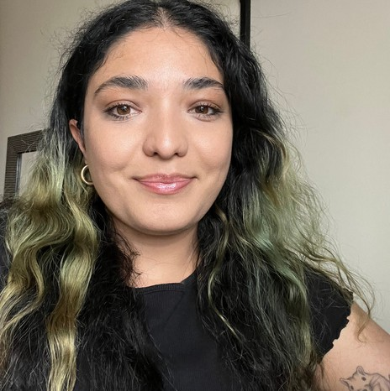Co-author & Coordinator Amy Bullard from The Teapot Collective.

Image of Amy smiling with long black and green hair, wearing a black t-shirt.

We hope you found value in this guide and thank you for reading.

**4**