**Menstrual health in psychiatric inpatient settings**

**May 2024**

**Written by Hat Porter**

**Commissioned by the National Survivor User Network**

**Contents**

Terms and definitions: page 2

Foreword and acknowledgements: page 4

Background: page 5

Methods: page 7

Findings: page 10

Institutional contexts: page 18

Interpersonal contexts: page 24

Freedom of information requests: page 31

Discussion: page 36

Conclusion: page 43

Guidelines: page 45

References: page 52

***This report contains details of distressing and traumatic experiences of menstrual injustice in psychiatric inpatient settings. There is also discussion of self-harm, suicide, eating disorders, sexual abuse, trauma and abuse from psychiatric services.***

**Terms and definitions**

| Psychiatric inpatient settings | The term ‘psychiatric inpatient settings’ is used throughout this report to refer to a range of mental health hospitals, units or wards. In England, the majority of these are operated by the NHS. At times these may also be referred to as ‘wards’ or ‘hospital settings’.  Throughout the report, a number of [**different types of psychiatric inpatient settings**](https://www.rethink.org/advice-and-information/living-with-mental-illness/treatment-and-support/going-into-hospital-for-mental-health-treatment/) are described. In brief, hospitals are split into three categories: child and adolescent mental health services (CAMHS), working-age adults and older adults. Hospitals have varying levels of security depending on the assessed need or risk. Acute wards are the most common type of ward; psychiatric intensive care units (PICU) and secure (low, medium and high — sometimes also referred to as forensic) wards may have greater restrictions than acute wards. Some hospitals provide treatment on the basis of a specific condition or patient population, for example eating disorder units and mother and baby units. |
| --- | --- |
| 136 suite | A 136 suite is a unit designed to hold patients who have been detained under [**Section 136 of the Mental Health Act**](https://www.rethink.org/advice-and-information/rights-restrictions/mental-health-laws/section-136-of-the-mental-health-act-emergency-police-powers-to-take-you-from-a-public-place-to-a-place-of-safety/): a short term detention of someone who was considered to be at risk to themself or others.  136 suites are referred to elsewhere as a ‘Place of Safety’, ‘Health Based Place of Safety’, ‘assessment unit’, or other terms. |
| Anti-ligature clothing or blankets | Anti-ligature clothing or blankets are made from a material which cannot be ripped. Patients may be required to wear this to manage risks of self-strangulation (ligature). |
| Iatrogenic harm | Iatrogenic harm refers to harms experienced by patients as a result of medical treatment. |
| Continuous observations | Continuous observations, enhanced observations or 1:1 refers to where a patient needs to have a member of staff with them at all times, sometimes at an “arm’s length distance”, or with multiple members of staff present. Although patients, staff and services use different terms, the term 'continuous observations’ is employed through this report as a descriptive term which includes monitoring from one or more members of staff. |
| Lived experience | The term ‘lived experience’is used in this report to refer to direct, personal experience [of treatment in a psychiatric inpatient setting, and of menstruation]. This emphasises the knowledge gained through first-hand experience and is used in this report to distinguish between the patient and staff participants.  Lived experience participants were not recruited through the NHS and were not necessarily current inpatients.  [**The term ‘lived experience*’* is broad and its complex history and definitions are discussed elsewhere**](https://www.nsun.org.uk/resource/exploring-community-and-the-mental-health-lived-experience-landscape-2024/). |
| Menstrual blood | This report uses the term ‘menstrual blood’, reflecting common language usage and the language used by participants. However, it should be acknowledged that menstrual ‘blood’ (also known academically as ‘menstrual effluent’ or ‘menstrual fluid’) is a fluid which includes blood, vaginal secretions and endometrial cells. The proportion of blood within this composition varies. |
| Menstrual materials | ‘Menstrual materials’ is a broad term which, in addition to including menstrual products, encompasses other items someone may need and use during menstruation. This includes access to toilets and washing facilities, hot water bottles, menstrual products, medications and soaps or hygiene resources. |
| Menstrual products | ‘Menstrual products’ refers to items used during menstruation to contain menstrual blood such as pads, tampons, menstrual underwear and menstrual cups.  Menstrual materials are often referred to as ‘sanitary products’, ‘sanitary bins’ or ‘sanitary pads’. With the expectation of direct quotes from participants, this report avoids the use of the term ‘sanitary’ due to its implications and association with conveying menstruation as unsanitary. |
| Mental health trust | An NHS mental health trust is an organisational unit within the NHS which services a specific geographical area or function. In England, there are 52 NHS trusts which provide inpatient mental health services. |
| Observations | ‘Observations’ refers to staff frequently checking patients and recording where they are and that they are safe. This may be at intervals of between every five minutes to once an hour. This is referred to in this report as ‘intermittent observations’ in order to distinguish this from continuous observations. |
| Seclusion | ‘Seclusion’ refers to where a patient is placed in a [**secure room located away from other patients on the ward**](https://www.rcpsych.ac.uk/docs/default-source/improving-care/ccqi/ccqi-resources/ccqi-core-standards-in-2022.pdf?sfvrsn=ae828418_8), which may be used where someone is in significant distress and may be considered a risk to themselves or others. Patients may be held in these rooms for periods of [**hours up to weeks, months or even years**](https://www.cqc.org.uk/publications/themed-work/rssreview). Seclusion rooms *should* but do not always have toilets and sinks. |
| Note on gendered language | Gender neutral language, such as ‘people who menstruate’, is used throughout this report. This is inclusive for transgender people who menstruate as well as acknowledging that not all women menstruate. Quotations may include gendered language where this was used by the participant.  All participants provided their preferred pronouns which are used when quoting or discussing their experiences. |

**Foreword**

This research was informed and motivated by my lived experiences of menstruation in mental health wards. Across many admissions to different hospitals, my needs were never adequately supported. For so long, this made me feel like my body was the problem and I was burdensome. I didn’t realise that I deserved better.

For years I felt so humiliated by my periods and that was only made worse when I was in hospital. Period products were withheld from me, leaving me feeling dirty when I was forced to use scraps of scrunched up toilet paper which did little to absorb the blood. I felt so ashamed of wearing the same soiled period pad for days when I was too ill to take care of myself and too suicidal to care. Although it was the people who had a responsibility to care for me who failed to meet my needs, all my anger and shame was directed towards my body.

Through the process of conducting this research, I’ve heard so many parallel stories of shame. But my shame has morphed into anger as I realise none of this is ours to hold. Instead, I’d say “shame on you” to the people, systems and structures which have failed to meet our needs.

**Acknowledgements**

First and foremost, I’d like to say thank you from the bottom of my heart to everyone who participated in this research and contributed to developing the guidelines.

I’d also like to thank Dr Jane Wilbur for her input and support with the process of obtaining ethical approval for this research.

Finally, thank you to Amy Wells, Gabrielle Johnson and Jen Beardsley at the National Survivor User Network for your ongoing support and for making this research possible.

**Background**

Despite being experienced by much of the patient population, there is a lack of research, policy, and guidance regarding how psychiatric inpatient services should cater for the needs of patients who menstruate.[**In 2019, NHS England announced that services must provide menstrual products to hospital patients, “in emergencies”**](https://www.england.nhs.uk/2019/03/the-nhs-in-england-will-offer-free-tampons-and-other-sanitary-products-to-every-hospital-patient-who-needs-them-simon-stevens-announced-today/). However, it is unclear how these commitments are translated in mental health settings, where patients often face significant restrictions on access to everyday items as well as [**abuse, neglect and indifference**](https://recoveryinthebin.org/2019/03/18/i-have-never-been-in-a-place-more-indifferent-to-suffering-than-a-psychiatric-ward/) (Recovery in the Bin, 2019; [**Hunt, 2022**](https://recoveryinthebin.org/2022/10/27/through-the-glass-doors/); [**Thomas, 2024**](https://www.independent.co.uk/news/health/sexual-abuse-mental-health-uk-b2484163.html)).

This study examined the perspectives of staff and patients to consider experiences of menstrual health in psychiatric inpatient settings. By building an understanding of patients’ experiences, this project also aimed to inform subsequent actions and campaigns to address the menstrual injustices patients face. This includes developing patient-led guidelines, informed by evidence, to outline the tangible actions mental health service providers can take to improve support for patients. These guidelines are outlined at the end of this document.

Although there is limited research on the topic, a small number of service improvement initiatives based in the UK have considered patients’ needs when menstruating in psychiatric hospitals. Firstly, Lyons and Sullivan (2021) conducted a project on women’s secure wards in Manchester, identifying that patients had been affected by menstrual stigma and felt reluctant to speak with staff about challenges relating to their menstrual cycle. The project highlighted that staff initiating conversations with patients about their menstrual cycles can increase opportunities for developing holistic support, challenging stigma about menstruation, and increasing menstrual health knowledge.

Secondly, Barry (2018) discusses the potential benefits of supporting patients in a psychiatric ward to track their menstrual cycle to identify cyclical symptoms and consider how their menstrual and mental health interact with one another. Similarly, Alberry and colleagues (2023) discuss the importance of psychiatric inpatient services recognising the impact of mood changes during patients’ menstrual cycles on their mental health. In their quality improvement project, patients identified that they would like to discuss their menstrual health with staff but expressed a preference for these conversations occurring on a one-to-one basis and with a female member of staff.

Finally, in a Mental Health Nurse Academics UK briefing paper (Hughes et al, 2019), patients shared that their menstrual health was dismissed and overlooked, and spoke of challenges with menstrual products being unavailable, actively withheld or being of poor quality.

Additionally, there is a small but vital body of research examining the interrelationships between mental and menstrual health. Research indicates that the menstrual cycle can influence mental health, psychiatric hospital admissions and death by suicide (Handy et al, 2022; Jang and Elfenbein, 2018); experiences of mental illness can also influence the menstrual cycle (Padda et al, 2021). However, this intersection is often overlooked in research, which tends to focus on mental or menstrual health in isolation, limiting treatment and support options (Sharp and De Giorgio, 2023).

***Ethics***

Great care was taken throughout this research to support participants and approach the research with sensitivity to the potentially distressing nature of the subject. For example, interview participants were offered a peer support debrief session following interviews.

Ethical approval for this research was obtained through the NHS Health Research Authority.

***Definition of menstrual health***

This research discusses menstrual health to encompass the significance of the menstrual cycle as a whole and consider a holistic view of the interactions between menstrual experiences and physical, mental and social health (Hennegan et al, 2021; Geertz et al, 2016). [**Menstrual health frames menstruation as a health rather than hygiene matter**](https://www.who.int/news/item/22-06-2022-who-statement-on-menstrual-health-and-rights) (World Health Organisation, 2022). The definition of menstrual health developed by the Terminology Action Group of the [**Global Menstrual Collective**](https://www.globalmenstrualcollective.org/) (Hennegan et al, 2021) provides a consistent definition of the breadth of *menstrual health* to support research, policy and advocacy. This definition provided a structure for questionnaires and semi-structured interviews to promote consideration of each domain required to achieve menstrual health.

| Definition of menstrual health  “Menstrual health is a state of complete physical, mental, and social well-being and not merely the absence of disease or infirmity, in relation to the menstrual cycle.  Achieving menstrual health implies that women, girls, and all other people who experience a menstrual cycle, throughout their life-course, are able to:   * access accurate, timely, age-appropriate information about the menstrual cycle, menstruation, and changes experienced throughout the life-course, as well as related self-care and hygiene practices. * care for their bodies during menstruation such that their preferences, hygiene, comfort, privacy, and safety are supported. This includes accessing and using effective and affordable menstrual materials and having supportive facilities and services, including water, sanitation and hygiene services, for washing the body and hands, changing menstrual materials, and cleaning and/or disposing of used materials. * access timely diagnosis, treatment and care for menstrual cycle-related discomforts and disorders, including access to appropriate health services and resources, pain relief, and strategies for self-care. * experience a positive and respectful environment in relation to the menstrual cycle, free from stigma and psychological distress, including the resources and support they need to confidently care for their bodies and make informed decisions about self-care throughout their menstrual cycle. * decide whether and how to participate in all spheres of life, including civil, cultural, economic, social, and political, during all phases of the menstrual cycle, free from menstrual-related exclusion, restriction, discrimination, coercion, and/or violence”.   *— Menstrual health: a definition for policy, practice, and research (Hennegan et al, 2021)* |
| --- |

**Methods**

This mixed methods research involved conducting online questionnaires, semi-structured interviews and reviewing NHS mental health trust policies and procedures. The research stages were conducted sequentially, with each stage informing the approach of the following stage. The questionnaires provided initial data collection from a larger number of participants and informed the interview topic guides, whilst interviews facilitated more in-depth exploration of participant’s experiences.

***Questionnaires***

Online questionnaires, including open questions and Likert scales (simple numerical rating scales) were completed by people with lived experience of menstruation on mental health wards (n=101). The inclusion criteria specified individuals must be older than 18 years and have experienced treatment in a psychiatric inpatient setting in England within the past five years. A second questionnaire was also completed by staff who work in psychiatric inpatient settings in England with patients who menstruate (n=67).

Participants were recruited through the NSUN bulletin and advertisements shared on social media.

***Interviews***

10 semi-structured interviews were held with people with lived experience of menstruation in psychiatric inpatient settings. Participants were recruited via social media and the NSUN bulletin. The interviews were held online, each lasting between 20 minutes and 1 hour 15 minutes. Interview participants were offered a £75 gift as a thank you for their time and expertise. Participants were also offered a peer support session as a debrief after the interviews to provide support following any difficult experiences which were discussed during the interview.

***Freedom of information requests***

Freedom of information requests were submitted to 52 mental health trusts in England to request relevant information, documents and policy. [**The Freedom of Information Act (2000)**](https://www.legislation.gov.uk/ukpga/2000/36/contents) requires public bodies to disclose information requested by a member of the public.

The information obtained via freedom of information requests was handled tentatively as this does not necessarily provide an accurate picture of care provision. However, in combination with the other methodologies, these can provide a valuable part of mixed methods research (Savage and Hyde, 2012; Hawkins et al, 2023).

Obtaining this information proved challenging: many trusts applied exemptions, thereby withholding the requested information, while others exceeded the 20 working day timeframe in which they’re required to respond to information requests. Multiple trusts failed to provide a response six months after requests were submitted, despite multiple follow up emails.

***Guidelines***

Following data collection and analysis, a focus group was held with people with lived experience of menstruation and treatment in psychiatric hospitals. The aim of the group was to discuss the research findings and use these, along with our experiential knowledge, to inform and develop guidelines outlining how mental health services should support patients’ needs relating to menstruation.

***Participant demographics***

**Lived experience questionnaire participants**

* **Gender Identity:** 86**%** of the participants were women. Of those who identified with another gender, 5% were non-binary, 3% were transgender men, 3% were transmasculine, and bigenderflux, genderfluid and genderqueer were each reported as the gender of 1% of the sample.
* **Ethnicity:** 92% of participants were white and white British, 3% were of dual heritage, 2% were Asian and British Asian, 1% were Black African, 1% described their identity as ‘other’ and one person did not respond to this question.
* **Age:** 56% of the participants were aged 18–24, 34% were 25–⁠34, 7% were 35–⁠44,2% were 45–⁠54, and 1% were aged 55 or above.
* **Region:** Some participants had received treatment across multiple regions. 26% had received treatment in the South East, 25% in Greater London, 20% in the South West, 14% in the East Midlands, 13% in the West Midlands, 10% in the North West, 9% in the East of England, 9% in Yorkshire and the Humber and 7% in the North East.
* **Type of hospital:** Many participants had experienced treatment across multiple different types of hospital. 69% of the sample had experienced treatment in an NHS or private acute ward. 33% had experience treatment in an NHS or private CAMHS ward, 11% in an eating disorder ward, 10% in a PICU, 10% in low or medium secure wards, 6% in CAMHS PICUs, 4% in CAMHS eating disorder units, CAMHS secure wards or ‘personality disorder’ units respectively, 3% in 136 suites, 2% in inpatient rehabilitation units, and 1% of the sample had experienced treatment in assessment and treatment units, learning disabilities wards and mother and baby units, respectively.

**Staff questionnaire participants**

* **Service provider:** 93% of the staff sample worked in an NHS service, 2% worked in a hospital run by a private provider and 5% did not respond to the question.
* **Menstrual status:** Staff participants were not asked about their gender identity but were asked whether they experience menstruation themselves. Only one staff participant had never menstruated; 88% of the sample reported currently experiencing menstruation themselves, and 10% did not currently but had previously menstruated.
* **Region:** Staff participants were located across England: 21% in the North West, 21% in the West Midlands, 15% in the East Midlands, 15% in the South West, 9% in the South East, 6% in the North East, 5% in Yorkshire and the Humber and 2% in Greater London.
* **Service setting:** Staff worked in a range of settings: 51% worked in acute adult wards, 12% in low or medium secure wards, 8% in CAMHS acute wards and PICUs respectively, 5% in CAMHS PICUs and inpatient rehabilitation wards respectively, and 2% worked in learning disabilities wards, CAMHS eating disorder units, CAMHS medium secure, ‘specialist’ ward, or worked across multiple wards respectively.
* **Job role:** 39% of the staff sample were nurses (including nurse, RMN and staff nurse), 13% were support workers or care assistants, 8% were team/clinical lead or ward managers respectively, 6% were deputy ward managers or occupational therapists respectively, 3% were an assistant psychologist, occupational therapy assistant or senior support worker respectively, 2% of participants were a charge nurse, clinical specialist nurse, hospital doctor, learning coach, nursing associate, psychologist or trainee psychologist respectively.
* **Healthcare experience:** Staff were asked how long they’d worked in the healthcare sector. 37% had worked in healthcare for less than five years, 48% had worked in the sector between five and ten years, 9% for 11–⁠20 years and 6% for over 20 years.

Both samples included participants from across England and with experience of a wide range of types of hospital setting. Amongst the lived experience sample, there was a lack of ethnic diversity amongst participants and greater representation of younger people, which may reflect shortcomings in participant recruitment. Amongst the staff sample, a large majority experienced menstruation themselves, indicating a lack of cisgender male staff participants.

**Interview participants**

* **Gender:** 90% were women and 10% were non-binary.
* **Ethnicity:** 70% were white British, 20% were of dual heritage/mixed and 10% were black.
* **Age:** 20% were aged 18–⁠24, 60% were aged 25–⁠34, 10% were 35–44 and 10% were 55 and over.
* **Ward region:** 30% had experienced treatment in the South West, 20% in Greater London, 20% in the East Midlands, 20% in the West Midlands, 10% in the East of England, 10% in the North East, 10% in the North West, 10% in the South East and 10% in Yorkshire and the Humber.
* **Ward type:** Some participants had experienced treatments in multiple types of wards. Of the overall sample: 80% had experienced treatment on an acute ward, 20% in 136 suites, 20% in eating disorder units, 20% in PICUs, 20% in ‘specialist wards’, 10% in CAMHS acute units, 10% in CAMHS eating disorder units, 10% in CAMHS low secure wards, and 10% in rehabilitation wards. 1 participant was unsure of the type of ward she had been on.

**Findings**

***Quantitative data***

The numerical data from Likert scales were populated in simple graphs and descriptive statistics (percentages and mean averages) were calculated.

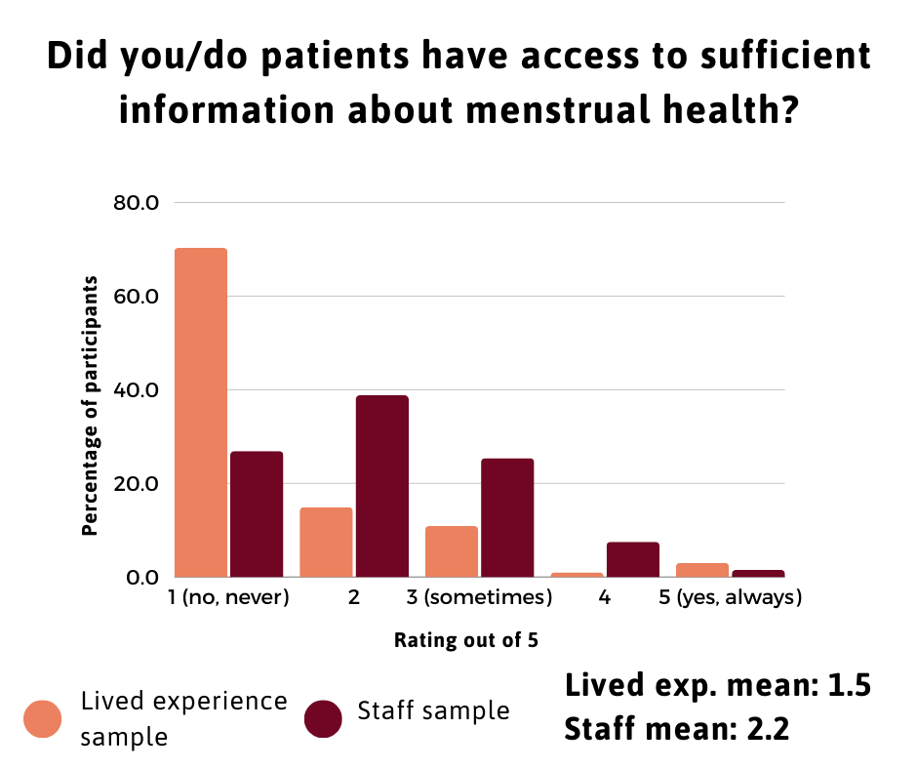

*Image description: bar graph of responses to “did you/do patients have access to sufficient information about menstrual health?” (Scale 1= no, never, 3= sometimes, 5= yes, always). Lived experience participants responses: 70.3% = 1, 14.9% = 2, 10.9% = 3, 1% = 4, 3% = 5. Staff respondents: 26.9% = 1, 38.8% = 2, 25.4% = 3, 7.5% = 4, 1.5% = 5. Lived experience mean: 1.5. Staff mean: 2.2.*

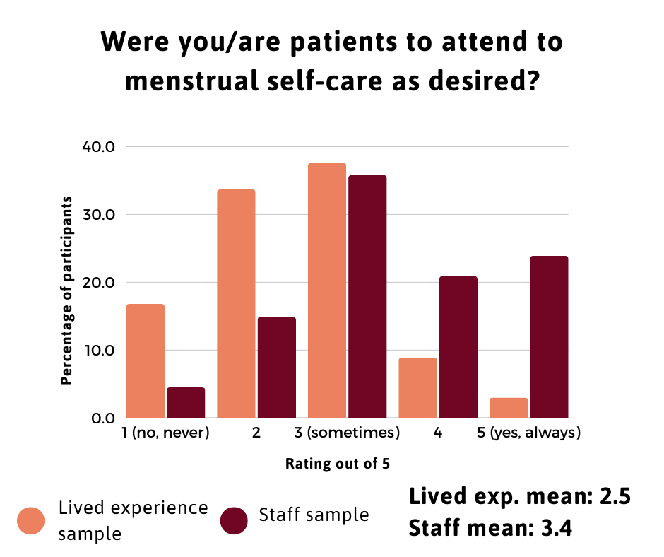

*Image description: bar graph of responses to “were you/are patients able to attend to menstrual self-care as desired?” (Scale 1= no, never, 3= sometimes, 5= yes, always). Lived experience participants responses: 16.8% = 1, 33.7% = 2, 37.6% = 3, 8.9% = 4, 2.5% = 5. Staff respondents: 4.5% = 1, 14.9% = 2, 35.8% = 3, 20.9% = 4, 23.9% = 5. Lived experience mean: 2.5. Staff mean: 3.4.*

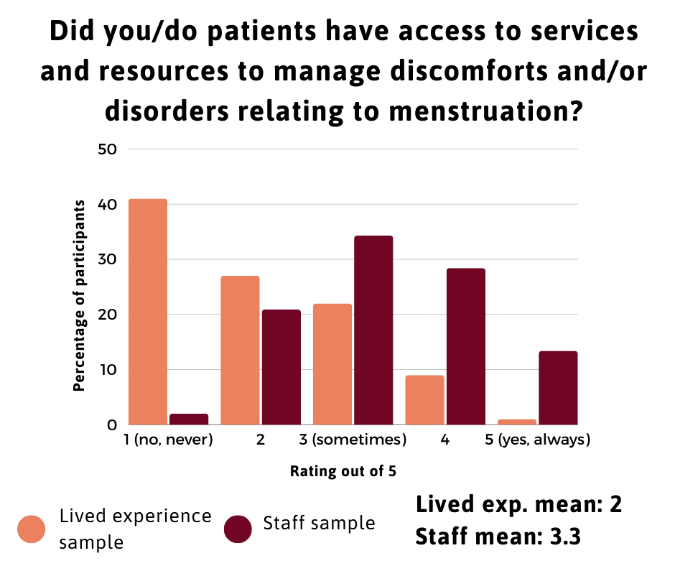

*Image description: bar graph of responses to “did you/do patients have access to services and resources to manage discomforts and disorders relating to menstruation?” (Scale 1= no, never, 3= sometimes, 5= yes, always). Lived experience participants responses: 40.6% = 1, 26.7% = 2, 21.9% = 3, 8.9% = 4, 1% = 5. Staff respondents: 3% = 1, 20.9% = 2, 34.3% = 3, 28.4% = 4, 13.4% = 5. Lived experience mean: 2. Staff mean: 3.3.*

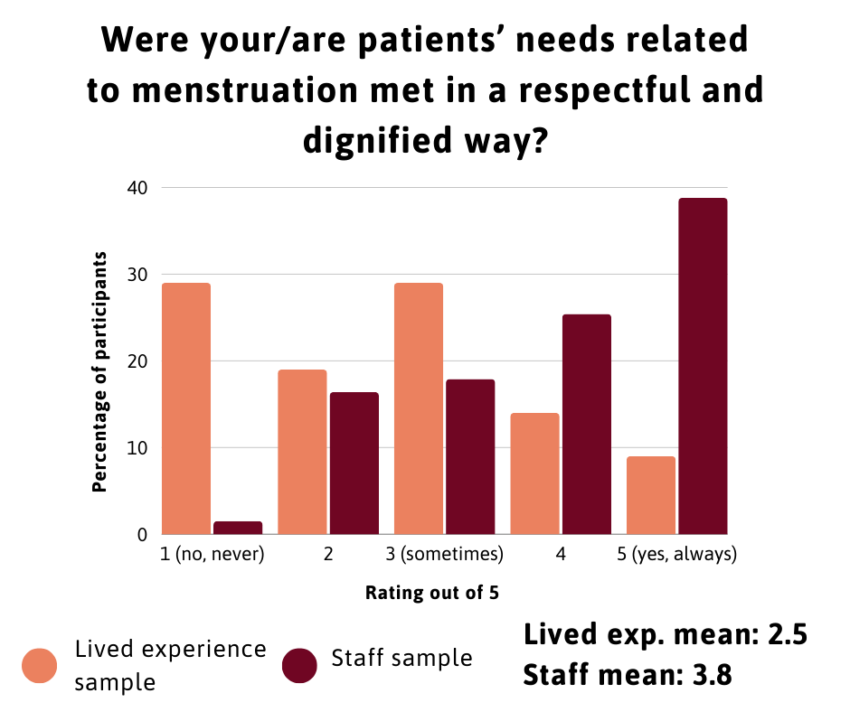

*Image description: bar graph of responses to “were your/are patients’ needs related to menstruation met in a respectful and dignified way?” (Scale 1= no, never, 3= sometimes, 5= yes, always). Lived experience participants responses: 28.7% = 1, 18.8% = 2, 28.7% = 3, 13.9% = 4, 8.9% = 5. Staff respondents: 1.5% = 1, 16.4% = 2, 17.9% = 3, 25.4% = 4, 38.8% = 5. Lived experience mean: 2.5. Staff mean: 3.8.*

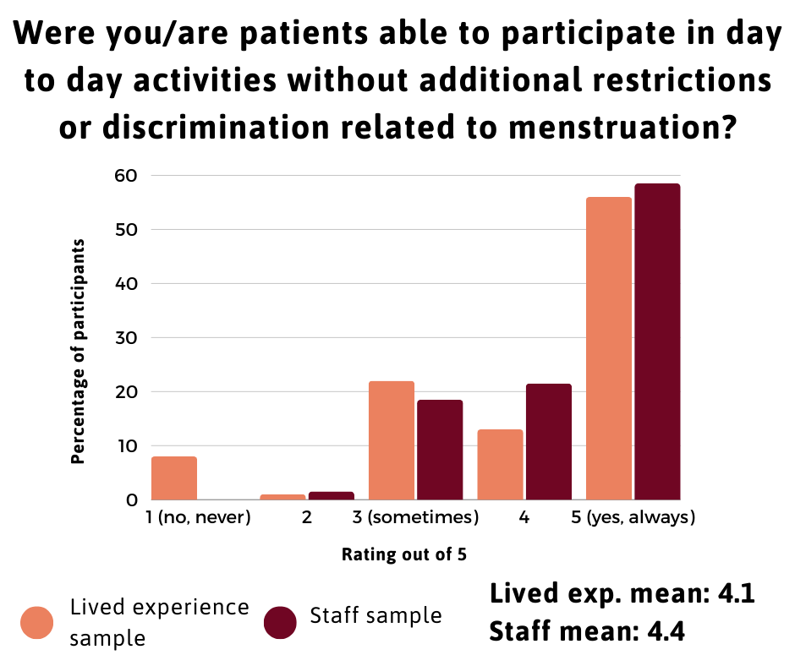

*Image description: bar graph of responses to “were you/are patients able to participate in day to day activities without additional restrictions or discrimination related to menstruation?” (Scale 1= no, never, 3= sometimes, 5= yes, always). Lived experience participants responses: 7.9% = 1, 1% = 2, 21.9% = 3, 12.8% = 4, 55.4% = 5. Staff respondents: 0% = 1, 1.5% = 2, 18.5% = 3, 21.5% = 4, 58.5% = 5. Lived experience mean: 4.1. Staff mean: 4.4.*

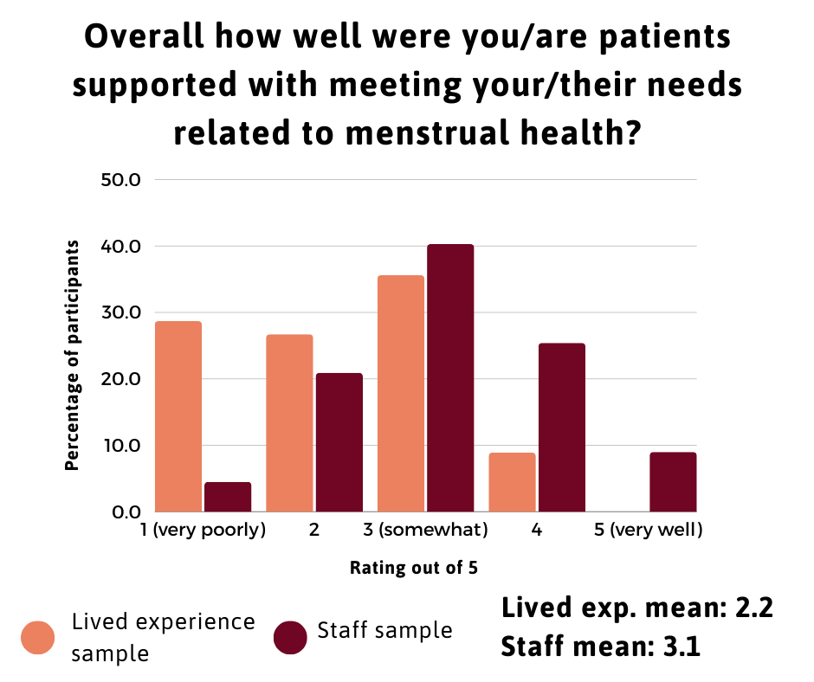

*Image description: bar graph of responses to “overall how well were your/are patients supported with meeting your/their needs related to menstrual health?” (scale 1= very poorly, 3= somewhat, 5= very well). Lived experience participants responses: 28.7% = 1, 26.7% = 2, 35.6% = 3, 8.9% = 4, 0% = 5. Staff respondents: 4.5% = 1, 20.9% = 2, 40.3% = 3, 25.4% = 4, 9% = 5. Lived experience mean: 2.2. Staff mean: 3.1.*

Both staff and patient participants rated access to information about menstruation as the area patients were mostly poorly supported with. Notably, no patient participants and only 9% (n=6) of staff participants felt services supported patients’ needs related to menstruation “very well”. In all categories, the mean staff ratings of their service were higher than the mean rating of the lived experience sample, indicating staff perceived their services as supporting patients’ menstrual health better than patients felt this was supported. Staff participants may have also felt a desire to represent their service positively, especially participants who were ward managers or had greater responsibility for the running of the service than more junior staff. However, staff and lived experience samples related to a wide range of services across England so accounts of experiences may not relate to the same hospital settings.

***Quantitative and qualitative data: staff questionnaire***

The staff and lived experience questionnaires were similar, with wording changed to reflect the positionality of the respondent. However, the staff questionnaire also included additional questions related to whether they had received any training around mental and menstrual health and how often they initiate discussions with patients about this topic: the responses to these questions are summarised below.

**What training had staff received related to menstrual health?**

Staff reported a lack of training about menstrual health with 84% (n=56) having received no training related to menstruation, whilst others referenced training which was adjacent — but not directly related — to the menstrual cycle. However, one participant had received education as part of her nurse training. Some participants described doing their own research due to a lack of formal training, whilst others relied on knowledge of menstrual health through their own experiences. Many respondents felt they would benefit from further training around supporting patients with their menstrual health, understanding how psychiatric medications can influence the menstrual cycle and how mental and menstrual health interact.

**How often do staff initiate conversations with patients about menstrual health?**

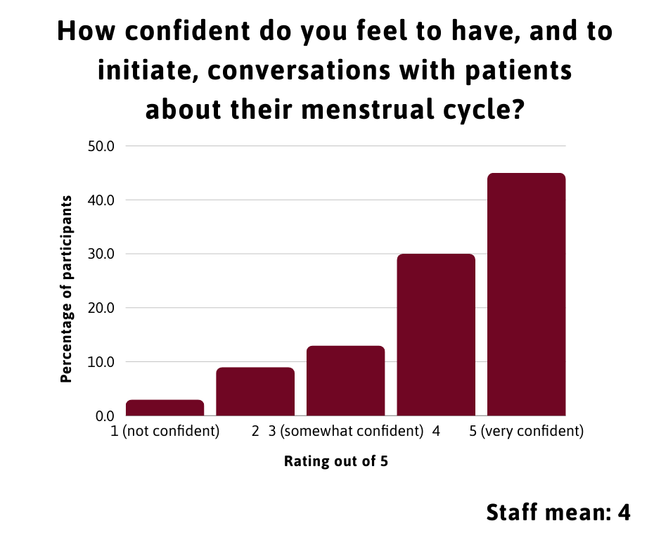

*Image description: bar graph of responses to “how confident do you feel to have, and to initiate, conversations with patients about their menstrual health?” (scale 1= not confident, 3= somewhat confident, 5= very confident). Staff respondents: 3% = 1, 9% = 2, 13.4% = 3, 29.9% = 4, 44.8% = 5. Staff mean: 4.*

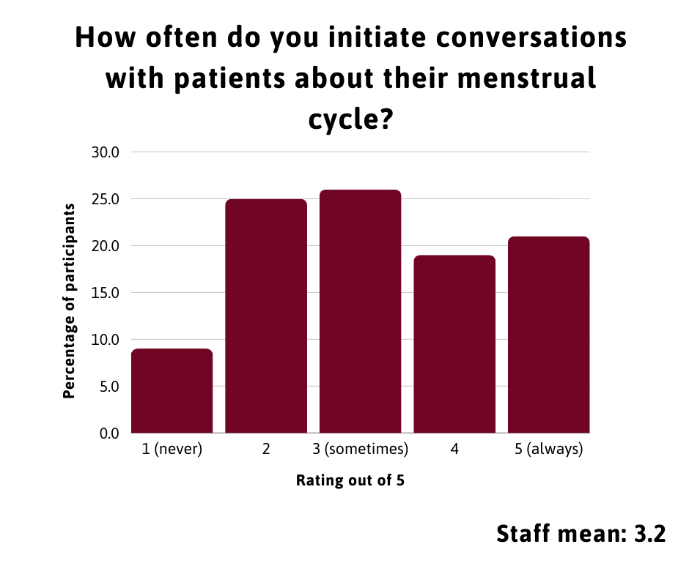

*Image description: bar graph of responses to “how confident do you feel to have, and to initiate, conversations with patients about their menstrual health?” (scale 1= never, 3= sometimes, 5= always). Staff respondents: 8.8% = 1, 24.6% = 2, 26.3% = 3, 19.3% = 4, 21.1% = 5. Staff mean: 3.2.*

Staff participants were asked how confident they feel initiating conversations about menstrual health with patients and the mean response was 4/5 (n=67). This suggests that, on average, participants felt fairly confident initiating conversations about menstruation. However, when asked how frequently they initiate conversations, the mean response was lower, at 3.2/5 (n=57) — responses from participants who appeared to work in non-clinical roles, such as ward managers, were excluded. Some participants described routinely initiating conversations about menstruation, for example, a CAMHS occupational therapist includes questions about menstrual health as part of standard assessments. Staff felt their personal experiences of menstruation helped them to relate to patients and provide relevant information. However, other participants felt time pressures limited the amount they were able to discuss menstrual health with patients. A mental health nurse on an acute ward shared, “[menstrual health is] not something I often think about unless someone asks me or have brought it up themselves”. Some staff participants also expressed concern about how patients may perceive questions about their menstrual cycle.

“*With patients that I feel aren’t comfortable with me, I worry that they may find including their menstrual cycle and hormones in their difficulties might feel like I am minimising how they are feeling.*” —⁠ Support Worker, personality disorder rehabilitation wards

***Qualitative data***

Inductive reflexive thematic analysis was used to analyse the qualitative data obtained in questionnaires and interviews. This method is used to identify recurring patterns within the data; data are analysed in line with the meaning participants give to their experiences, rather than using pre-identified frameworks (Braun and Clarke, 2006). Qualitative data from questionnaires and interviews were analysed together.

Thematic analysis follows a process beginning with reading the questionnaire responses and interview transcripts multiple times to allow the researcher to become familiar with the data. Patterns and similarities within the data are then identified and placed into codes (groups of participant quotes which relate to a single idea or experience). These codes are then rearranged into sub-themes and themes until each theme represents significant categories of experiences shared by participants; a theme may consist of multiple codes which relate to distinct experiences but have similarities connecting them.

Reflexivity refers to the process of a researcher examining their positionality and how their beliefs, reactions and feelings influence their data analysis (Braun and Clarke, 2019). Throughout this research I engaged in active questioning of my reactions to the research and data obtained and documented these reflections. This was also valuable for navigating the emotionally challenging nature of the research, especially where participants’ experiences strongly resonated with my own.

The themes were placed into two overarching categories of institutional and interpersonal contexts. Institutional contexts related to the rules and restrictions in place in inpatient settings and how these influenced patient experiences of menstrual health within hospital as a restrictive and institutional environment. Interpersonal contexts related to how the interactions and relationships between staff and patients shaped patient experiences.

Participants’ quotations are provided verbatim. Quotations from questionnaire responses may include spelling or grammatical mistakes. Square brackets indicate text which is added for clarity. Where sections of the quotations are shortened for brevity and clarity, this is indicated by ellipses in square brackets. Ellipses in interview quotations indicate where the participant paused or hesitated.

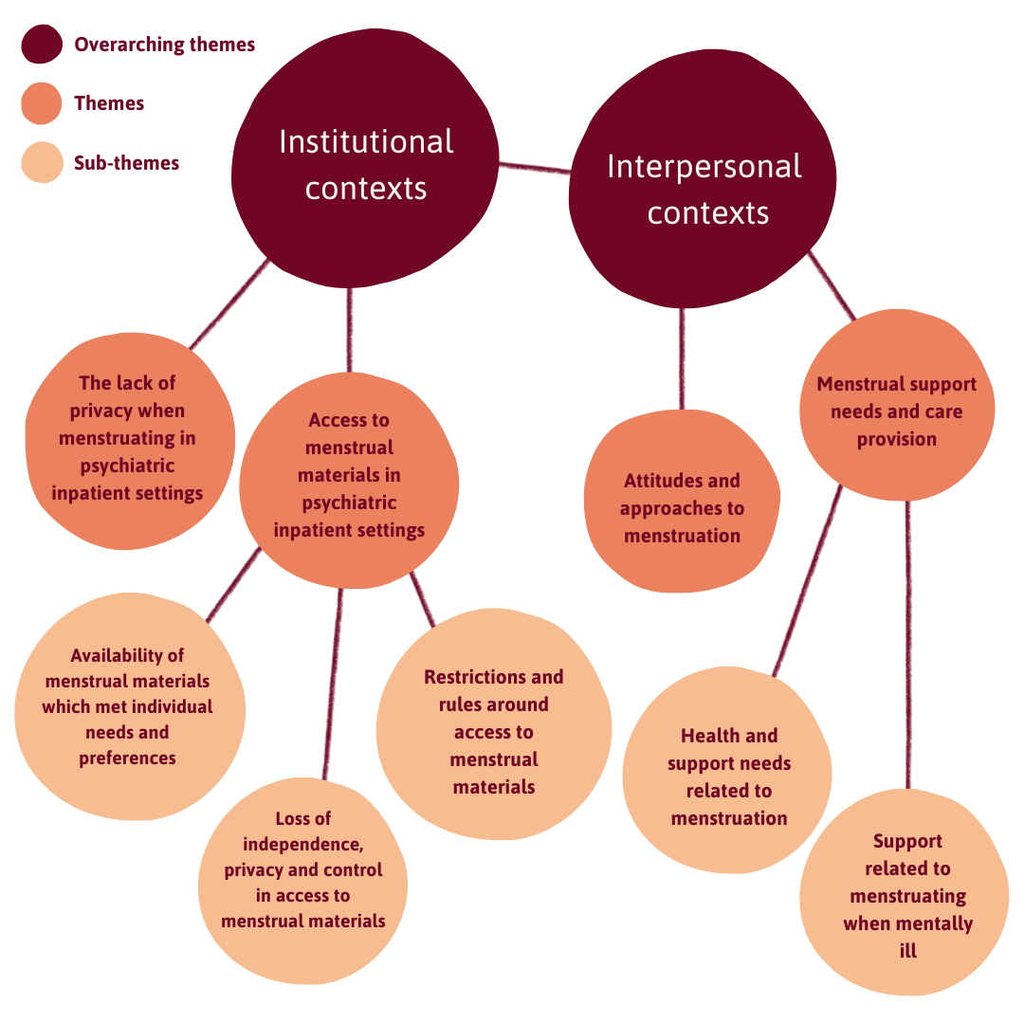

*Image description: chart illustrating overarching themes, themes and subthemes.*

*(Overarching theme 1) Institutional contexts, (theme 1.1) the lack of privacy when menstruating in psychiatric inpatient settings, (theme 1.2) access to menstrual materials in psychiatric inpatient settings, (subtheme 1.2a) availability of menstrual materials which met individual needs and preferences (subtheme 1.2b) restrictions and rules around access to menstrual materials, (subtheme 1.2c) loss of independence, privacy and control in access to menstrual materials.*

*(Overarching theme 2) Interpersonal contexts, (theme 2.1) attitudes and approaches to menstruation, (theme 2.2) menstrual support needs and care provision, (subtheme 2.2a) health and support needs related to menstruation, (subtheme 2.2b) support related to menstruating when mentally ill).*

**Institutional contexts**

***Access to menstrual materials in psychiatric inpatient settings***

**Availability of menstrual materials which met individual needs and preferences**

Although some lived experience participants had access to menstrual products which met their needs and preferences, many patients did not. Many staff and patient participants reported that menstrual products were not supplied by wards and patients were not able to leave hospital to purchase these. Often, patients didn’t have friends or family who were able to bring items in. Whilst some wards held a supply of menstrual products to provide patients with, in other services these were kept for ‘emergencies’ only. In some cases, staff resorted to giving patients their own menstrual products.

*“It felt a little disrespectful to be reluctantly provided with a less-than-adequate supply of menstrual products and told I should really be bringing my own, when I was in hospital against my will, mentally unwell, and unable to leave the premises to purchase products for myself.” — questionnaire participant, experience of NHS acute wards*

Where menstrual products were available, these were sometimes described by both staff and lived experience samples as poor quality, and the limited choice of options available often did not meet patients’ individual needs or preferences. In some cases, patients were given maternity pads or incontinence pads.

*“I was given enormous incontinence knickers that were really rigid and were fixed at the side by two sort of flaps, […] [they] did not absorb the blood and were totally undignified.” — questionnaire participant, experience of 136 suite and acute ward*

“*[There was] only 1 option of uncomfortably large sanitary towel, [I am] autistic and [it] did not meet my sensory needs. Would ask for it and often have to remind, embarrassing and scary to ask, used tissue instead at times*.” *— questionnaire participant, experience of eating disorder unit and an NHS acute ward*

Some patients reported ‘making do’ with poor quality menstrual products or using toilet paper to absorb menstrual blood, “free-bleeding”, or delaying changing menstrual products. Participants who described having a heavy menstruation were severely restricted or unable to leave their bedrooms due to not having access to adequate menstrual products. This resulted in patients missing meetings, being unable to join in therapeutic activities, and feeling isolated from other patients on the ward.

“*The pads they gave me were rubbish, to put that out there. Bleed throughs would mean my clothes would then get covered in blood and then I wouldn't have a way of getting them clean again. I would like… literally clothes had to go in the bin because they're covered in blood and shit and I was literally sitting curled up in a ball in the corner of the room and couldn't deal with it myself*.” —⁠ interview participant, experience of 136 suite and acute wards

Lived experience participants also reported sometimes not having access to medications they were prescribed related to their menstrual cycle as these weren’t in stock, including pain medications and oral contraception. This was described as having an impact on patients’ physical and mental health.

*“I was prescribed mefenamic acid by my gp and the psych had this information.  However, trying to get hold of it during 2 of 3 cycles was so difficult it left me in unnecessary pain and distress.” —* questionnaire participant, experience of NHS female secure ward

*“They messed up my pill regularly, ran out of it, forgot to order, causing my PMDD to hugely worsen which led to suicide attempts.”* — questionnaire participant, experience of CAMHS, low secure and eating disorders wards

Participants also reported that bins were not provided in bathrooms, or where these were available, they were not emptied regularly. Transgender participants also reported challenges with men’s bathrooms not having bins.

“*The sanitary bins were always overflowing, they stunk. They were not replaced often enough, […] you'd have an ensuite and that would have cardboard boxes as a bin but it was a wet room so if you forgot to take out the cardboard box, it would just dissolve.*” — interview participant, experience of CAMHS, adult acute, PICU and specialist wards

“*I wasn't allowed to dispose them myself as a clinical waste bag was needed and I wasn't allowed them. More often that not, my used pull ups would end up piled into my bathroom for days on end,which was grim! And it made my bathroom smell. Once the smell got really bad the staff would finally dispose of them*.” — questionnaire participant, experience of PICU ward

**Restrictions and rules around access to menstrual materials**

Participants in both the staff and patient samples described wards having restrictions on access to menstrual materials due to the perceived risks of these items. Frequently, tampons and hot water bottles were prohibited, and the decision to prohibit these items was often described as a blanket rule, rather than risk assessed on an individual basis. However, many lived experience participants expressed being unsure how these items could pose a risk to them. Only one lived experience participant reported having used menstrual products in self-harm, though others may have done so but chose to not disclose this.

*“Many of my patients use sanitary protection products in self harm [...] so access to some types of product is limited, as can privacy be at times for safety reasons.” —* questionnaire participant, hospital doctor

In some cases, this was described by participants as “cruel” and punitive, especially where rules were not implemented consistently by staff. For example, one participant who has endometriosis and experiences severe chronic pain, particularly when menstruating, described some staff not allowing her to have a hot water bottle despite this being important for pain management and her having never used this in self-harm.

*“I understand why they were concerned about the self harm. But that was taking away a main way of managing my pain at that time, and it felt like I was being punished. […] I felt very isolated because I was in so much pain that I couldn't leave my bed […] one staff member on shift would say it was okay [to have a hot water bottle]. And the next person on lead on the shift would say ‘no, it's not okay’. So there was… there was no rhyme or reason […] it felt a bit cruel.”* —⁠ interview participant, experience of NHS acute wards

One interview participant discussed being forced to prove to staff members that she was menstruating in order to be given a menstrual pad.

“*I needed a pad and I did ask if I could have one because my room had just been stripped and I had to prove I was on my period to two female members of staff by pulling my knickers down and showing I already had a pad in.*” *—* interview participant, experience of CAMHS, acute, specialist and PICU wards

Other restrictions described included access to soap and toilet paper, seemingly due to the perceived risks of these items if used in self-harm. Some of the rules appeared arbitrary and were described as “ridiculous”. One participant reported that a staff member had withheld her menstrual cup due to his confusion about the item.

*“I ordered a moon cup in the post. […] The matron decided that this item is immediately to be confiscated. He didn't know what it was, and when I told him, he did not believe me. He refused to believe me.”* — questionnaire participant, experience of adult acute ward

Some lived experience participants also described restrictions which were reportedly related to “infection control” risks. This included being able to use washcloths and in one case, being prohibited from washing reusable menstrual pads or underwear in the communal washing machines.

Many lived experience participants discussed their experiences of menstruating whilst they were secluded and/or when their clothing had been removed and they were required to wear anti-ligature clothing. In some cases, they described having underwear and period products removed.

*“They gave me an anti-lig[ature] blanket and was just like ‘cover up with that’. But I had like literally no, um like nothing for like, my period or anything […] I was literally just bleeding on the floor like it was, it was awful. […] they didn't even have toilet roll or anything, […] it was just… it was just awful. And being on my period at the time it was, it was just an absolutely horrendous experience.”* — interview participant, experience of CAMHS low secure, adult acute, PICU and rehabilitation units

One interview participant drew parallels between her experiences of sexual assault, significant pain and discomfort during menstruation, and not having adequate access to menstrual products in hospital.

*“So I have been sexually assaulted in the past. Um so I don't have the best body image, shall we call it and it was just like, why am I fucking female? Yeah, it kind of is a bit like Yeah. Yeah, it made me really... so I just felt like I was made wrong.”* — interview participant, experience of 136 suite and acute wards

**Loss of independence, privacy and control in access to menstrual materials**

Many staff participants stated that patients will request any items they need from staff, however this contradicted the ways in which lived experience participants described how needing to request menstrual materials from staff, rather than these being freely available, presented significant challenges and compromised their independence.

*“You have to go through other people to like to get what you need or like, if you don't have access to stuff from like… people who can bring it into you from outside like there's not always the stuff available and so it will just feel pretty invasive.”* — interview participant, experience of CAMHS eating disorder and adult acute wards

*“I bled into tissue in my underwear for my first two menstrual cycles in my first admission to an acute ward as I was too anxious to ask staff for period products.”* — questionnaire participant, experience of NHS acute ward

As well as needing to request period products from staff, one participant described how the toilets were kept locked, meaning she needed to ask staff to open the door each time she needed to use the toilet. She described this as having greater impacts when she was menstruating.

*“It was just really inconvenient sometimes and it really… being in that place really did strip me of my dignity, you know, my independence, like I just felt like a shell of a human like I felt like I was treated like a child.”* — interview participant, experience of an eating disorder unit

The restrictions imposed on patients placed them in a position of dependence on staff and made them vulnerable to the possibility of staff abusing their authority. For example, this was evident in some reports of staff mocking patients.

*“On my PICU, a blanket rule was if you were on 1:1 and had no bathroom privacy, (which was my situation) you were only allowed two squares of toilet paper at a time, which was ridiculous at the best of times but when I was on my period it was awful, because I was only allowed 2 squares and I bled heavy, the blood would soak through the sheets and I would end up with my hand covered in period blood. Some of the staff that witnessed this laugh[ed] whilst I was mortified.”* — questionnaire participant, experience of PICU ward

*“It was humiliating, they [staff] were obstructive, and rather seemed to enjoy my embarrassment.”* — questionnaire participant, experience of PICU, low secure unit and mother and baby units

Participants described embarrassment, shame, and a lack of dignity in needing to share — explicitly or implicitly through expressing a need for menstrual materials — that they were menstruating in order to have their needs met, especially when needing to request items from male staff members.

*“I wanted it to be more private, like I didn't… I didn't particularly want everybody to know that… I was on my time… like, especially because there is still a lot of stigma around it as well.” —* interview participant, experience of 136 suite and acute wards

This was described as especially challenging for patients who experience heavy menstruation. One participant spoke about how needing to regularly request period products due to heavy menstruation associated with polycystic ovarian syndrome (PCOS) made her feel like an “inconvenience” to staff. Another participant described having to explain and justify why she needed another menstrual pad.

*“The pads they did give you… you had to ask each time and go into a room of people and going ‘Hey, can I have a pad please?’ And then they do you know what I mean, look at you and like, ‘hang on a minute… um didn't I just give you one?’ like ‘yes, it's gone through’. It's just really embarrassing.” —* interview participant, experience of NHS acute wards

A lack of private spaces on wards, such as nurse’s stations being located nearby or within communal areas, was described as adding to challenges with requesting menstrual materials, as other staff members and patients would overhear these requests, and staff unavailability due to busyness made it difficult to speak privately to someone.

“*If you ever wanted to ask a nurse something, it's probably likely that at least four others were going to hear it. […] So you really weren't kind of privately asking someone you were… you were kind of asking the ward.*” — interview participant, experience of 136 suite and acute wards

*“You say ‘I want to ask you a question in private’. They're a bit like well, ‘yeah, I don't have time’ because they expect it to be a half an hour conversation not a two minute ‘please can you give me some period pads’.” —* interview participant, experience of NHS acute wards 

Additionally, lived experience participants described being left to wait for long periods of time for staff to provide the items they needed due to staff being busy. Participants in the staff and lived experience samples reported challenges with access to medications as even over the counter medications needed to be prescribed by a doctor, who was often busy. In some cases, participants emphasised a feeling that these delays were exacerbated by their menstrual health needs being viewed as a lesser priority.

*“I asked for sanitary products on one occasion and was waiting almost 4 hours for them.” —* questionnaire participant, experience of NHS female acute ward

*“In one unit because I was on a medication to do with my menstrual cycle I wasn't given it for 2 days as it wasn't deemed as important as psychological medication despite me telling them I needed it.”* — questionnaire participant, experience of private and NHS CAMHS and adult acute wards

However, some participants were more comfortable with requesting items and support from staff members or family and friends in order to meet their needs. For example, one participant reported feeling staff respected her dignity when providing menstrual products by ensuring this was discreet. Another participant discussed having support from her family to meet her practical and cultural needs around menstruation by taking used menstrual products away to burn.

*“It was easy for me to communicate actually because it was a need at the moment […] where I’m from, my family we consider a cultural, cultural beliefs so family took it, we regularly burn every pad we use, it wasn't actually allowed to be disposed of in the hospital. My mum took it home to burn it.”* — interview participant, experience of a mental health ward

***The lack of privacy when menstruating in psychiatric inpatient settings***

Closely related to the above subtheme of ‘loss of independence, privacy and control in access to menstrual materials’, but extending beyond access to menstrual materials, lived experience participants discussed inpatient settings as compromising their privacy.

This included a lack of bins to dispose of menstrual products in a way participants felt comfortable with. Some participants described feeling uncomfortable with disposing of used menstrual products in an open bathroom bin rather than a lidded ‘sanitary’ style bin, which made their menstruation more visible to those around them.

*“On the PICU Ward, they wouldn't have any bins [...] you would have to ask for a brown paper bag and you dispose of a day's worth of pads in there. And then you'd have to leave it on your floor and just hope that the domestic would remove it the next day. And it was quite obvious. And you know, sometimes people will say ‘oh, what's that?’ And you'd be like ‘errrr, please don't look in’.”* — interview participant, experience of CAMHS, adult acute, PICU and specialist wards

Some participants also described experiences of being strip searched whilst menstruating and staff members searching menstrual products when these were brought onto the wards.

*“The CAMHS provided free menstrual care products and bins to dispose of them, however you had no privacy when changing and strip searches would still occur even on your period.”* — *questionnaire participant, experience of CAMHS PICU and adult acute wards*

Those who had been on continuous observations often described distress and embarrassment when they were menstruating. Some participants reported having to change menstrual products in front of male staff. Participants reported sometimes avoiding changing menstrual products due to having to do this in front of staff. When patients were not on continuous observations, frequent checks from staff also negatively impacted their privacy when menstruating.

*“I would have to like… change your products in front of people. And again, it was really degrading, really dehumanising, embarrassing, not just for me, but for them as well. Um so that's just not a normal human experience like watching someone change their pad and being watched changing your pad so it was just really unnatural.”* — interview participant, experience of an eating disorder unit

*“[when on 1:1] I was too embarrassed to use [or] change sanitary wear so would go for days without changing.”* — questionnaire participant, experience of acute ward and personality disorder unit

Participants also described the layouts of wards and the nature of shared spaces, such as communal bathrooms or dormitory bedrooms, as compromising their privacy and rendering their menstruation very visible.

*“It was always incredibly awkward & I was hyper-aware of the sight & smell. Having to carry a pad down the hall from the storage lockers to my room in front of all the other patients was embarrassing.”* — questionnaire participant, experience of NHS and private acute wards

One lived experience participant referred to “covert surveillance” and the impact of bathrooms without doors regarding the potential to be viewed, both in person and on a camera, when changing menstrual products. Many participants described bathroom doors being removed or replaced with curtains, magnetic doors or partial doors, compromising their privacy and dignity. Drawing parallels between her experiences of trauma and the lack of privacy on wards, one participant emphasises how a lack of bathroom doors impacted her psychological safety.

*“I think for me, the top thing was like, there was just no privacy at all. Like, I think my period connects a lot with my like, history and my trauma […] in the hospital space you had like no ability to be private at all, like, people would walk into your room. Or like, walk into the bathroom. Well, the bathroom never had a door, so they… if they walked into your room they were in the bathroom basically.” —* interview participant, experience of acute wards

**Interpersonal contexts**

***Attitudes and approaches to menstruation***

Participants in both samples discussed attitudes and approaches towards menstruation. This related both to how individual staff members viewed menstruation, as well as a broader context of the ward culture. Many lived experience participants described how these attitudes, as well as restrictive practices, also influenced their own feelings about menstruation and their bodies.

*“Staff finding it awkward made it very hard. I think their embarrassment to myself having periods left myself being embarrassed to have one which then led to me not looking after myself such as cleaning myself.” —* questionnaire participant, experience of acute ward and personality disorder unit

Many participants in both staff and lived experience samples described feeling that inpatient wards did not adequately consider patients’ needs around menstruation. For example, one participant discussed how having inadequate access to menstrual products whilst in hospital not only failed to meet her needs but also conveyed a sense that menstruation was overlooked and considered a “huge inconvenience” to staff.

*“All of this gave the impression that the ward for women of working age was surprised at menstruation and found it a huge inconvenience, and that this should be taken care of by the women patients themselves no matter how mentally unwell they were” —* questionnaire participant, experience of 136 suite and acute ward

*“It was like it was embarrassing to be female and um… like I said like the place was set up by a bunch of blokes who didn't have a scoobydoo.” —* interview participant, experience of 136 suite and acute wards

Indeed, some staff participants — despite menstruating themselves — reported that menstruation is not something they had considered before.

*“[Menstruation is] just not something I had thought about before this survey!”* — questionnaire participant, Nurse on acute admissions ward

“*[It] never enters my head to ask […] [about menstrual health]. I’d only have a conversation about menstruation if a patient brought it up first.” —* questionnaire participant, Nurse on female acute ward

In addition to menstruation being overlooked, participants described how their experiences of the restrictive practices and the invasion of privacy they suffered impacted their own perceptions of menstruation and attitudes towards their bodies, including feeling “dirty” and “embarrassed”.

“*Menstrual health shouldn't be tabboo and I shouldn't have felt ashamed. [...] It also made me embarrassed when strip searched. Another tabboo that shouldn't be there. I was made to feel dirty.*” *—* questionnaire participant, experience of adult acute wards and BPD specialist unit

*“It was made to seem like I was being like an inconvenience for having a period […] It made me hate my body. Like it made me like really angry towards myself.” —* interview participant, experience of CAMHS low secure, adult acute, PICU and rehabilitation units

Some lived experience participants were clear that their feelings of shame and embarrassment around menstruation were increased in hospital and heightened by menstruation being overlooked, and staff reacting negatively towards discussion of menstruation.

*“I always felt anxiety and shame around getting my period while in a number of different wards, which is not something I experience in normal home life.”* —⁠ questionnaire participant, experience of NHS acute ward

*“Staff always spoke with disgust when menstruation was mentioned. Male staff members would make faces or refuse to talk about or refuse requests about menstruation.”* — questionnaire participant, experience of acute wards

Transgender participants described experiencing additional challenges due to their menstrual health being particularly overlooked. They also described staff lacking awareness and knowledge about the needs of transgender people who menstruate, or staff asking intrusive questions.

*“It felt even more taboo than usual due to me being trans, when I asked for sanitary products when I arrived on the ward (unplanned admission) they seemed confused and unwilling to provide any despite knowing I’m trans […] it felt so degrading.”* —⁠ questionnaire participant, experience of acute ward

Another interview participant described feeling that there was a lack of compassion and understanding from staff, with interactions becoming more transactional, providing medications but no further support or empathy. This emphasises patients’ needs for emotional and relational support around menstruation, in addition to practical support.

*“[the staff] didn't think, ‘oh actually when I have my period, I really love a massive bar of chocolate, I wonder if she would like one?’ […] it wasn't very like… like human. There was like a structure in the hospital and they have to keep to it, and of course, they have to keep people safe […] I just kind of wished that they… they had thought about that for me because I couldn't think about that myself at that time.”* —⁠ interview participant, experience of 136 suite and acute wards

However, many staff respondents described how their wards try to support patients respectfully, and challenge shame and stigma. This was also described by some lived experience participants, often in the context of staff being candid about their own menstruation, creating empathy and “normalising” discussion of the topic. One participant described the positive attitudes from staff towards menstruation as not only supporting her to speak about the topic, but also helping her with the process of unlearning shame around menstruation. She described being met with a calm and supportive approach after getting menstrual blood on a chair in an occupational therapy session.

*“I was just kind of like really embarrassed and crying and like horrified […] she was like the one reassuring us, because we were just like horrified and the OT [occupational therapist] was absolutely, just chill and was just like, ‘I’ll just get a wipe, it's fine’ […] I think we kind of unlearned a little bit of shame around it [menstruation]. It's still something difficult. But um… it’s just the way staff approached it to make it feel less shameful.”* — interview participant, experience of an adult acute ward (uses we/us pronouns when speaking about themselves)

***Menstrual support needs and care provision***

**Health and support needs related to menstruation**

Lived experience participants often described their needs around the physical aspects of menstrual health being overlooked and dismissed by staff. For example, participants described staff having a lack of knowledge about menstrual-related side effects of psychiatric medications. Participants in both samples also reported that staff would deny patients access to medications.

*“I asked for pain killers and was denied many time by male staff because it wasn’t that ‘bad’”* — questionnaire participant, experience of CAMHS acute wards, CAMHS eating disorder units and CAMHS PICUs

*“Patients are often seen as ‘drug seeking’ if they ask for lots of pain medication”* — questionnaire participant, Mental Health Nurse on adult acute ward

This was especially pertinent where patients also experienced menstrual health-related conditions, severe pain, or heavy menstrual bleeding, as staff lacked knowledge around this and were sometimes described as dismissing the impact of physical conditions on patients’ mental health. One participant reported becoming unwell as staff had not responded to the concerns she had raised, demonstrating the significant health risks which may be posed by inadequately supporting patients’ physical and menstrual health.

*“I had to ask repeatedly again and again to be taken seriously. I asked my doctor for leave to go to the gp for implant removal after really painful periods, this took weeks to arrange whilst I was remaining in pain. By the time I got seen, I had fallen unwell with anemia due to blood loss.” —* questionnaire participant, experience of CAMHS, locked rehabilitation and low secure wards

An assumed separation of mental health from the physical body and menstrual health, and a view that wards thought of patients’ physical health as ‘someone else’s responsibility’ was highlighted by many lived experience participants.

*“What I realised was mental health deal with brains and brains alone. They do not do physical bodies whatsoever […] they don't get that the two of them actually affect each other and they're of the same person.”* —⁠ interview participant, experience of 136 suite and acute wards

*“If I approached the subject of periods then they would dismiss it and ask me to see my own GP when discharged.”* — questionnaire participant, experience of an NHS acute ward

Lived experience participants also described how the lack of consideration staff gave to their physical and menstrual health sometimes led to staff misinterpreting their pain as being related to mental health. One interview participant who has undiagnosed endometriosis described how staff did not understand that when she was in pain it was hard to join groups or finish meals.

*“They would always be so quick to assume that you were skipping therapy or meals or socialising because of mental health when it wasn't, it was physical health. Like they didn't seem to understand the connection between the two.”* —⁠ interview participant, experience of eating disorder unit

However, some staff and lived experience participants described staff taking a proactive approach in supporting patients with their menstrual health.

*“[We] keep a record of cycles for those unable to do this independently and so are aware of when [the] next period is due and observe for behaviour change which could indicate pain and offer pain relief, hot water bottles, heated cushion pads, baths. Any changes would be flagged to GP.”* —⁠ questionnaire participant, nurse on a learning disabilities ward

*“I was [given] paracetamol to begin with to deal with the pain but that didn’t help so I was put on a medication they did [their] research and made sure that it wouldn’t have an effect on my other psychiatric medication.” —* questionnaire participant, experience of NHS acute and private rehabilitation wards

**Support related to menstruating when mentally ill**

Many participants in both the staff and lived experience samples described staff lacking knowledge about how the menstrual cycle may impact patients’ mental health and lacking knowledge and awareness of premenstrual dysphoric disorder (PMDD), sometimes resulting in patients being dismissed when they brought up the topic.

*“Quite often, when I've ended up in A&E in crisis, I've had an incident the next day or a couple days after I get my period, and I suddenly feel a bit better. And my mum has always tried to talk about it with doctors about my hormones and whether it's affecting my mental health and it's always, always dismissed. It's never taken seriously.”* —⁠interview participant, experience of CAMHS, acute, specialist and PICU wards

*“Many staff, including consultants, had never heard of PMDD.”* - questionnaire participant, experience of CAMHS, low secure and eating disorders wards

One interview participant discussed feeling she had been misdiagnosed with a personality disorder as her fluctuations in mood had not been considered within the context of cyclical mood changes or her menstrual cycle.

“*That stay I was diagnosed with a personality disorder that I completely disagreed with and I kept explaining that actually, [...] my moods change a bit more rapidly while I'm on my period. [...] I think if they had asked like… I don't know… like, ‘what's the impact of your period on your mental health?’, then I think I would have been able to say like, quite clearly [...] But um yeah, that conversation was never… it was never offered so therefore I never had it.*” — interview participant, experience of acute wards and a 136 suite

Participants also described instances where their distress was dismissed as being related to periods, without having further discussions about the interaction between mental and menstrual health. However, one participant shared a more positive experience of staff observing patterns in their mental health around their menstrual cycle and supporting them to consider treatment options.

“*Nurses and staff on the ward noticed I became more unwell and had increased risk around once a month and so I was encouraged to start the contraceptive pill to help with this.” —* questionnaire participant, experience of CAMHS low secure and adult acute wards

Participants also reported not receiving the support they needed related to autism, neurodivergence and sensory needs when menstruating.

“*[I] had no help after asking for support with being autistic and experiencing sensory problems and physical reactions & pain with periods.*” *—* questionnaire participant, experience of CAMHS acute and CAMHS PICU wards

Many lived experience participants described how experiences of trauma have impacted the ways they relate to their menstrual cycles and menstruation. For example, multiple lived experience participants mentioned they find using tampons difficult due to trauma, though they did not provide further details. Although the impact of trauma on their menstrual experiences was frequently raised by the lived experience sample, this was not discussed by any staff respondents, suggesting a possible lack of knowledge and awareness of these experiences.

*“I've had a lot of trauma so when I have been on my period, and I've been in so much pain, like, I felt like the pain that I couldn't control, like, triggered a lot of flashbacks for me. […] I was on one to one at a time and my one to one was just like ‘why are you crying?’ […]  the pain is making me think about it, like the pain is causing the flashbacks, like… and they just didn't understand.”* — questionnaire participant, experience of CAMHS, locked rehabilitation and low secure wards

Another interview participant discussed experiencing complex trauma and associated “menstrual neglect”, and not having been taught about menstruation or how to use menstrual products. Her outpatient therapist supported the ward to deliver an education session which was hugely beneficial for her both practically and psychologically.

*“Having someone go through everything like really simply was so helpful […] they did a full demonstration with different products as well. And that was, I think, something that just people hadn't thought of before, because it seems too basic.”* — interview participant, experience of NHS acute wards

Many participants who had experienced anorexia or eating disorders described challenges related to their menstrual cycles, sometimes in the context of having stopped menstruating (secondary amenorrhea) due to weight loss or malnutrition. In some hospitals, patients explained that their menstruation was viewed as a sign of their health, meaning their ‘target’ weight would be adjusted when menstruation had resumed. In order to prove they were not ‘faking’ menstruation, some participants reported being forced to show staff their menstrual blood on menstrual products or underwear.

“*You didn't have that [menstruation] as like a private thing that could happen to you, […] on eating disorder units especially, like… it'd be like ‘you need to show us your pad like to prove that you're not like faking it [menstruation]’ […] like it still feels really… like no one trusts you. […] I think like because of the way that they used to [focus on menstruation] really reinforced the like… ‘Oh, I must be like better now.’ […] Everyone was so like, focused on like that being a marker of like… ‘we can change what you're eating’, ‘let’s think about plans for discharge [from hospital]’.*” — interview participant, experience of eating disorder units

This focus on menstruation was described as having significant negative impacts on how participants related to their menstruation, enhancing difficult feelings around gaining weight during inpatient treatment. However, respondents expressed feeling that they were not adequately supported with the emotional aspects of this experience, which in some cases was in turn described as leaving people with continued emotional challenges around their menstruation even after leaving hospital.

*“I still get mortified and feel disgusting on my period and I do believe a lot of this shame and negative associations with getting my period was internalised from my time inpatient.” —* questionnaire participant, experience of CAMHS and adult eating disorder units

Some lived experience participants also referred to experiencing challenges with changing menstrual products whilst unwell or in a mental health crisis but not having support from staff around this.

*“I had left a tampon in there for 7 days without noticing. […] I was at this time very mentally unwell indeed and could not manage my own health. I needed help and protection, and had been sectioned. All the nurse did was write down ""Retained tampon"" on my chart. I was never offered a medical consultation with a doctor. I was never examined. There was never any follow-up.” —⁠* questionnaire participant, experience of 136 suite and acute ward

*“I was unwell enough that when I had my period it didn’t stop me doing anything. However, the fact I was doing everything while free bleeding when I think about it later is horrible and I wish someone had taken me aside and given me the products and helped me out a little.”* — questionnaire participant, experience of acute admissions ward

However, some staff participants mentioned they support patients who aren’t able to manage their menstruation independently.

*“[Patients are] supported in self-care when they are unable to themselves.”* — questionnaire participant, assistant psychologist on urgent and acute adult wards

**Freedom of information requests**

Freedom of information requests were made to request NHS mental health trust policies — and associated Equality Impact Assessments — related to patient observations; restricted and prohibited items; and, in the context of eating disorder services, ‘weight restoration’ policies. Trusts were also asked if they supply menstrual products to patients and how these are ordered or purchased; whether they prohibit access to tampons or hot water bottles; and if they have any posters informing patients of how to access menstrual products. The content of the information requests was informed by the questionnaire and interview stages of the research.

Additional information was requested relating to access to toilet facilities in seclusion rooms; the number of incident reports in which menstrual products had been used in self-harm; the percentage of wards with en suite bathrooms; and provision of bins in bathrooms. However, this information was not returned in a way which could be analysed meaningfully. For example, numerous trusts reported not having incident reporting systems which had the facility to search for key terms or review incident type.

The documents obtained were analysed using qualitative content analysis which involved counting and comparing the discussion of keywords and topics between documents. Discussion of themes related to menstrual health within the documents was noted and the content was reviewed and interpreted.

Of 37 'therapeutic observations’ policies reviewed, none of these included considerations of patients’ needs when menstruating and being monitored on enhanced or intermittent observations. The policies generally expressed the need for consideration of patients’ privacy when getting changed, using the toilet or showering. In some cases, patients’ care plans may allow for them to be able to use the bathroom unsupervised for short periods of time when on enhanced observations. Policies also identified that the gender of the staff member on a patient’s observations should be considered and that patients should be observed by a staff member of the same gender when using the bathroom. However, this was not always reported to be the case by lived experience participants in the previous stages of this research.

Although many trusts had not completed these documents, 28 Equality Impact Assessments associated with ‘therapeutic observations’ policies were obtained and analysed. Equality Impact Assessments are a tool designed to support public authorities to consider — and evidence that they have considered — how their policies may inadvertently discriminate against people on the basis of nine protected characteristics. Equality Impact Assessments are not mandatory but can support a public authority to adhere to their statutory [**Public Sector Equality Duties**](https://www.gov.uk/government/publications/public-sector-equality-duty-guidance-for-public-authorities/public-sector-equality-duty-guidance-for-public-authorities#are-you-bound-by-the-duty). Of the 28 documents analysed, 20 documents stated that the policy would have no differential or negative impact based on a patients’ sex or gender reassignment or for any other protected characteristics including religion or disability. The remaining documents identified some differential impacts but none of the 28 documents considered the impact of policies for patients who menstruate. This does not appear to reflect the reality of the inherently intrusive nature of enhanced and continuous observations which could pose specific challenges for example for patients who hold cultural and religious values around privacy. Although not a protected characteristic in itself, [**menstruation could be viewed as a protected characteristic under ‘sex’**](https://www.wellbeingofwomen.org.uk/what-we-do/health-information/your-rights-at-work-when-you-have-painful-or-heavy-periods/#:~:text=The%20Equality%20Act%20protects%20you,basis%20of%20age%20or%20sex.).

None of the 33 restricted item or patient search policies obtained and reviewed mentioned menstrual products, hot water bottles or other menstrual materials. This contrasts with the reports of patients and staff in the previous research stages.

Nine ‘weight restoration’ policies — in the context of inpatient eating disorder treatment — were reviewed. Of these, two policies outlined resumption of menstruation as an indicator of a healthy weight.

*“The best indicator of healthy weight in females is the resumption of menstrual periods. If these return before a young person achieves the predetermined weight range then weight may be held at the closest Tuesday or Friday weight whilst hormone profiles are checked using blood tests. If these show that results are in keeping with ovulation, the weight at which periods commenced will be the mid-point of a new, lowered healthy weight range” —* Leigh House Eating Disorders Programme May 2021, Southern Health NHS Foundation Trust

Trusts were asked whether they provide menstrual products to patients and how these are ordered. 36 trusts responded to this question, of which 28 trusts said they order menstrual products through the NHS supply chain. Though generally order sheets were not provided, six trusts either stated or provided order sheets demonstrating that no tampons were ordered, only menstrual pads. Two trusts reported that they rely on donations from charities or companies for supplies of menstrual products. Five trusts indicated that they do not provide menstrual products on some or all their wards but may support patients to go to a shop or liaise with their family to bring these in.

*“GMMH would support people to purchase these from local shops etc where they needed them or go home /liaise with family”* — Greater Manchester Mental Health NHS Foundation Trust

*“We ask that women provide their own supplies of menstrual products. We do hold some emergency supplies on our female wards for ad-hoc situations where service user’s supplies have run out, or they forget to bring supplies, but this is simply a mix of brands, held for emergencies, bought from the local supermarket from petty cash, supplied on a need basis”* — Leeds and York Partnership NHS Foundation Trust

The ordering sheets reviewed demonstrated limited variety in the menstrual products ordered with often only one type of menstrual pad available. For example, Pennine Care NHS Foundation Trust’s order sheets indicated that between October 2022 and July 2023, 1,728 menstrual pads were purchased at a cost of £198. However, these were all from the same brand and absorbency level (Essence Ultra Plus). However, it is unclear whether trusts purchase additional products elsewhere.

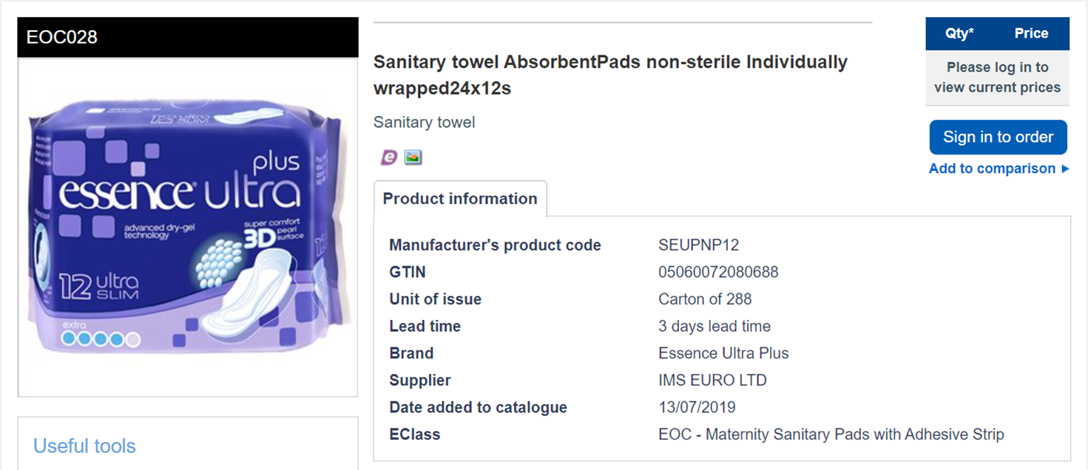

*Screenshot from* [***NHS Supply Chain website***](https://my.supplychain.nhs.uk/catalogue/product/eoc028) *showing ‘Essence Ultra Plus’ menstrual pads. Image description: an image of a purple packet of menstrual pads is shown. The packet is labelled with “essence ultra plus” and an image of the pad. The item is listed as “Sanitary towel AbsorbentPads non-sterile Individually wrapped24x12s”. Text below includes the product code.*

Trusts were asked whether they permit tampons and hot water bottles — both items which were regularly reported by staff and patients in the questionnaire and interview phases of this research as being prohibited. 34 trusts responded, 33 permitted tampons and one trust, Devon Partnership NHS Trust, reported that tampons are not permitted on their eating disorder unit but did not supply a rationale for this. 35 trusts responded regarding the question of whether patients are permitted to have hot water bottles. 17 trusts stated hot water bottles are not permitted on wards though patients may be allowed ‘wheat bags’. A further three trusts reported permittance of hot water bottles varies by ward. 12 trusts stated these are permitted but may be risk assessed on a case-by-case basis and a further three trusts reported a hot water bottle has never been requested by a patient. This is in contrast to the reports of staff and patients within the other stages of this research highlighting that menstrual materials, especially tampons and hot water bottles, are often prohibited.

Trusts were asked about whether they display posters to inform patients about how to access menstrual products. This was asked as participants in the questionnaires and interviews had expressed both surprise and frustration at the lack of posters or other information to advise them of how to access menstrual products. 39 trusts responded to the question, of which only three provided posters. Another trust reported this information is provided in ward ‘welcome packs’ whilst a further trust indicated that they have posters but these are not available in a form which could be supplied in response to the request. It is possible that other trusts have posters which are handmade or have been printed and not saved centrally and would therefore not be identified.

*Herefordshire and Worcestershire Health and Care NHS Trust poster. Image description: poster with decorative illustrations and text reading “Got your Period? Please ask staff if you need any period products. Please do not flush Sanitary pads down the toilet. Please use the sanitary bins provided”.*

*North Staffordshire Combined Healthcare NHS Trust poster. Image description: poster with decorative illustrations and text reading “Got your period? We’ve got you. Speak to a member of staff if you need sanitary products”.*

*Leicestershire Partnership NHS Trust poster. Image description: poster with photograph of toiletries including menstrual products, text reading “Dignity box: We have an emergency supply of toiletries and sanitary products available on the ward. Please speak to a member of staff if you need anything”.*

All of the posters reviewed informed patients that they need to ask staff members if they require menstrual products, but do not identify what products may be available or where these are stored. The three posters all include the term “sanitary”, a menstrual euphemism which is widely used but criticised for its associations and implications of menstruation as dirty and unsanitary.

The policies lacked explicit consideration of patients’ needs related to menstruation. Where equality impact assessments had been completed for observations and restricted items policies, these generally did not identify any differential impacts based on patients’ protected characteristics. Whilst organisational policies cannot be expected to include explicit discussion of everything, a failure to consider how restrictive practices — such as continuous or intermittent observations — may have differential impacts for patients who are menstruating may convey a sense that this is overlooked and not considered within the way services operate.

**Discussion**

Although experiences varied, for the majority of participants, psychiatric inpatient services provided inadequate support around patients’ needs related to menstruation, hindering their ability to attain menstrual health. This appeared to occur at institutional and interpersonal levels, where patients’ experiences were shaped by the policies and practices of hospitals as well as by staff and patient interactions and relationships.

As psychiatric hospitals have a duty of care to patients, I suggest failure to meet their needs in relation to menstrual health amounts to neglect and may pose iatrogenic harms. This could further be seen as a form of menstrual injustice, which is defined by Johnson (2019) as the oppression of individuals based on their menstrual cycle, encompassing discrimination, humiliation, disadvantage, or exclusion. Comparisons of Likert scales between staff and lived experience samples suggest that staff perceived their services as providing greater support to patients than was reported by the lived experience sample. The discrepancies between the reports from a staff or patient perspective may be reflective of staff lacking awareness of the extent to which patients’ needs are unmet. However, there was also variation in the experiences discussed by patients. This may emphasise the injustice of the poor treatment received by some participants whilst also demonstrating that it is imperative — and possible — for psychiatric inpatient settings to provide compassionate support for patients who menstruate.

***The availability of, and access to, menstrual materials in psychiatric inpatient settings***

Many participants in both samples reported that patients face inadequate, restricted, or controlled access to menstrual products. This included restrictions prohibiting access to tampons, hot water bottles, bins and in some cases, toilet paper, soap, washcloths, and opportunities to wash reusable period products. Even where wards did supply menstrual products, patients often had a lack of choice around these, with the items that were available being described as poor quality and not meeting their needs and preferences, including sensory needs. Patients also needed to ask staff for menstrual products, with items often being given out one at a time. This had significant impacts on patients’ independence, choice, and privacy around menstrual management.

In some instances, the lack of routinely provided, good quality menstrual products resulted in patients needing to use makeshift products, “free bleeding” into their clothing, and delaying changing menstrual products. Therefore, a lack of free access to menstrual products — whether due to items being prohibited, not available or supplies being controlled by staff — should be understood as [**restrictive practice**](https://www.skillsforcare.org.uk/resources/documents/Developing-your-workforce/Care-topics/Behaviours-which-challenge/A-positive-and-proactive-workforce.pdf). This refers to routine or reactive elements of treatment which [**restrict an individual’s freedoms or require them to do something against their wishes**](https://restraintreductionnetwork.org/wp-content/uploads/2023/03/RRN-Ensuring-hospital-care-is-safe-and-supportive-information-booklet.pdf) (Department for Health, 2014; Restraint Reduction Network, 2020).

In response to Freedom of Information requests, most trusts reported that tampons are permitted on wards. This contradicted the reports of many participants from both staff and lived experience samples, perhaps indicating that rules and restrictions are imposed at the discretion of individual staff or wards rather than in line with official trust policies. This may contribute towards inconsistencies in how staff members implemented rules which was described by participants in the present study — [**and wider research**](https://restraintreductionnetwork.org/wp-content/uploads/2021/10/RRN_PL_tool.pdf) — as enhancing frustration and distress around restrictions (Restraint Reduction Network, 2021).

Research by Scholes and colleagues (2021) highlighted that women who had experienced seclusion reported that menstrual products and toilet facilities were withheld from them. They identified that their research was the first to report on patients’ experiences of having menstrual products withheld when in seclusion. Given that present research highlights widespread imposition of restrictive practices which relate to — or negatively impact patients during — menstruation, it is notable that this has been under-recognised in previous research. Therefore, future research considering restrictive practices in psychiatric hospitals should be explicit in addressing and asking participants about menstruation in order to ensure this is not overlooked.

Some lived experience participants described the restrictions imposed on them as cruel, punitive and dehumanising, particularly where the person had never attempted to use menstrual materials in a way which would put them at risk. This is consistent with findings from research on women’s experiences of psychiatric hospitals where restrictive practices were considered punitive and infantilising (Tully, Bucci and Berry, 2022) and can risk replicating previous experiences of abuse (Fish and Hatton, 2017). Furthermore, in line with Scholes and colleagues’ research (2021), participants who had been placed in seclusion reported distressing experiences of being left without clothing, period products, underwear or access to toilet facilities. One participant in the present study described being forced to prove she was menstruating in order to be provided with a menstrual pad by removing her underwear, whilst other participants had been subjected to strip searches whilst menstruating. In some cases, participants discussed the restrictions around menstrual materials in parallel with experiences of trauma and sexual abuse, suggesting an intimate and gendered nature of such restrictions. I suggest these experiences may also represent iatrogenic harms and risk retraumatisation where the failure of services to adequately meet patients’ needs, and infringement of their privacy, creates profound distress and humiliation.

An overreliance on disproportionate and blanket restrictions has been described as ‘safety cultures’ where psychiatric inpatient settings place focus on the patient's physical safety at the expense of their psychological safety (Slemon, Jenkins and Bungay, 2017). Similarly, in discussing their experiences of often arbitrary and unnecessary [**restrictive practices in psychiatric wards**](https://madcovid.wordpress.com/2020/12/14/how-can-i-speak-up-when-you-can-hold-me-down-restrictive-practice-on-an-acute-ward-an-inpatient-perspective/), @MiserySquid (2020) urges staff to question the policies, rules and restrictions imposed on patients rather than accepting these as ‘just the way things are’. Although withholding access to menstrual materials as potential ‘risk’ items may be viewed in the interest of patients’ physical safety, lived experience participants in this research highlighted how this compromised their dignity and caused significant distress.

Although the use of menstrual products in self-harm was mentioned by some staff, only one participant reported having used menstrual products in self-harm (though other participants may have chosen not to share this), and many participants expressed being unsure about how such items could present a risk. This further suggests the perceived risk of menstrual products may exceed the actual risk. In research by Bartlett and Somers (2016) conducted in a secure hospital, staff members described feeling services were more risk-averse and implemented greater restrictions for female than male patients. Therefore, within the context of gendered approaches to restrictive practice, and societal views of women as ‘out of control’ when menstruating (Wood 2020), I suggest that the gendered associations of menstrual products may influence how services assess the risks they may pose and the paternalistic conclusion that patients can only be ‘trusted’ with one at a time.

In emphasising the intimate and gendered nature of their experiences, many lived experience participants in the present study discussed the restrictions and lack of support they had faced related to their menstrual cycle as part of a wider context of psychiatric inpatient settings as unsafe and unsupportive of their needs as women or as transgender people. This should be considered within a wider context of gendered harms within both mental health services and carceral spaces more broadly. There are striking similarities between lived experience participants’ reports of menstruating in a mental health ward and experiences of menstruating in prison, and the harms incarcerated women and transgender and non-binary people suffer.

Research in an English women’s prison highlighted how women felt observed and exposed when menstruating in prison; they reported a lack of access to period products which met their needs and had to ask prison staff when these were needed (Smith, 2009). This neglect of prisoners’ menstrual needs has been argued to represent a form of gendered control over prisoners’ bodies, enacting control over these intimate needs to enforce a sense of fear and powerlessness within prisoners (Shwaikh, 2022). This appears consistent with the reports of some participants in the present study, especially where restrictions were not proportionate and appeared to be used to mock and humiliate patients. This highlights the importance of experiences of menstrual health being addressed as part of the wider actions needed to address issues of safety, violence and discrimination for women and transgender people in psychiatric wards (Tseris, Hart and Franks, 2022; NSUN, 2023).

Period poverty refers to having limited access to sufficient menstrual materials and hygiene facilities and the ability to manage menstruation with dignity (Action Aid, 2023). Period poverty is known to have negative impacts on mental health (Rohatgi and Dash, 2023; Marí-Klose et al, 2023). Although period poverty is associated with economic barriers to accessing menstrual materials, this can also be considered more broadly to encompass situations in which other barriers, such as cultural taboos, gender roles, and precarious living situations deprive an individual of managing their menstruation adequately and as desired (Rohatgi and Dash, 2023; Sacca et al, 2023). There is a need for more research, policy development, and robust actions to be taken to consider period poverty globally. I suggest that the present research, in outlining the menstrual poverty, deprivation and injustices faced by patients in psychiatric hospitals, highlights the need to consider this context within actions taken to challenge period poverty and understand its impacts.

***The lack of privacy when menstruating in psychiatric inpatient settings***

Lived experience participants discussed feeling exposed and embarrassed due to the lack of privacy and independence they had in managing menstruation in a psychiatric ward. In addition to the shared spaces of a ward environment, restrictive practices enhanced this denial of privacy, for example, the use of partial or ‘safety’ doors for bathrooms which prohibit bathroom privacy, and the lack of provision of ‘sanitary’ bins.

Some lived experience participants described feeling embarrassed, humiliated and dehumanised by being observed when undressed or changing menstrual products whilst on continuous observations, sometimes in front of male staff. This is consistent with previous research on patients’ experiences of continuous observations has highlighted that patients face similar distress (Barnicot et al, 2017; Fish, 2022). Although the observations policies obtained through freedom of information requests generally expressed that both patients’ privacy and the gender of the staff member observing the person should be considered when they are using the bathroom, none of these policies mentioned the patient's needs around menstrual health. This may indicate that trusts have not given adequate consideration to the experiences of patients when menstruating, as was highlighted by many participants in both samples who felt menstrual health was overlooked.

Additionally, [**increases in the use of surveillance technology in inpatient settings,**](https://stopoxevision.com/) including implementation of CCTV or video recording equipment in patient bedrooms and within seclusion rooms or 136 suites, will further reduce patient privacy when attending to personal care during menstruation through being recorded and observed (Stop Oxevision, 2024; Simpson, 2023). This research has emphasised the need for patients’ dignity and privacy whilst menstruating to be considered as part of decision-making processes around restrictive practices, both at an individual level, and in decision making about the design and furnishings of a ward.

Patients' experiences of menstrual health within psychiatric inpatient settings occur within wider social contexts of continued stigma and taboo surrounding menstruation. In their research on menstrual experiences within high income countries, Barrington and colleagues (2021) discuss the behavioural expectations to conceal menstruation, with some people experiencing a constant mental burden due to the need to ensure menstruation is hidden. This has been described as the ‘menstrual concealment imperative’*,* referring to how the social stigma around menstruation creates an imperative for people who menstruate to engage in self-surveillance to ensure their menstruation is never visible; maintaining the body as clean, attractive and not an inconvenience for others (Johnston-Robledo and Chrisler, 2020; Wood, 2020).

Some participants experienced challenges in wanting to maintain menstruation as a personal and private matter, despite the lack of privacy and the restrictions of the hospital precluding the possibility of them from adhering to this etiquette. Whilst speaking openly about menstruating or revealing menstrual blood can be empowering or mundane (Bobel, 2010), where patients have their privacy removed without their consent or control, this was experienced as exposing.

Within the context of prison settings, Roberts (2020) describes an ‘ought-fallacy’: whilst there *ought* to be no shame in one’s menstruation and blood being viewed, in environments which enforce menstrual stigma, such feelings will be present. However, one participant described an experience of a staff member responding calmly and respectfully when cleaning menstrual blood from a chair; although she described feeling embarrassed by the experience, she felt the approach from the staff member had made the experience feel less shameful. This highlights that where restrictions which compromise a patients’ privacy in a hospital cannot be avoided, wards must foster attitudes towards menstruation which challenge stigma and taboos in order to minimise causing additional distress and iatrogenic harms.

***Attitudes and approaches to menstruation***

Participants in both staff and lived experience samples emphasised the significance of interactions with staff influencing patients’ attitudes towards and experiences of menstruation whilst in hospital, both positively and negatively. This related to both overt expressions of disgust as well as to how menstruation was often seemingly overlooked. Transgender participants described this as enhanced due to the impacts of staff transphobia. For some, being exposed to negative attitudes towards menstruation from staff increased their feelings of shame and stigma in comparison to what they experience outside of hospital. This echoes research by Barrington and colleagues (2021) which highlights the importance of social contexts in shaping attitudes towards menstruation.

In some cases, the language that lived experience participants used to illustrate their experiences appeared to reflect self-stigma, shame, and negative attitudes towards menstruation, such as describing menstruation as ‘embarrassing’ or referring to feeling ‘dirty’. One participant described feeling anger towards herself and hating her body for menstruating, whilst another participant spoke of it being embarrassing to be female. The responses of some participants suggest this led to an internalisation of unmet needs, placing anger, blame and hatred towards their bodies and not towards the injustices inflicted on them.

Research by Sveinsdóttir (2017) examined Icelandic women’s experiences of menstruation and self-objectification and identified that worse health-related quality of life was predicted by measures of secrecy of menstruation; body shame and pain; and greater negative views and attitudes towards menstruation. Whilst these associations are complex, Sveinsdóttir’s research highlights the significance of the impact that shame, secrecy, and objectification have on quality of life. Although further research is required to examine this link within the psychiatric inpatient context, it can be inferred that environments which increase menstrual shame may have negative impacts on health-related quality of life. This suggests that it is vital to challenge the ways psychiatric hospitals appear to reproduce and enhance menstrual shame and stigma in order to foster positive outcomes for patients.

Some participants in the present study discussed the value of staff referring to their own experiences of menstruation to build empathy around shared experiences within the patient and staff dynamic. However, in her interview, another lived experience participant suggested the relationships with staff were purely transactional; staff would provide the menstrual materials she requested but offered no additional compassion, empathy or proactive support. These contrasting experiences highlight the importance of recognising patients' emotional and relational needs in addition to their practical needs around menstrual health.

The building and maintenance of therapeutic relationships with staff is essential to ensuring safety for patients in psychiatric inpatient settings and this requires effective communication, cultural sensitivity and the absence of coercion and harmful practice (Gilburt, Rose and Slade, 2008). Therefore, efforts to improve patients' experiences of menstruation in psychiatric hospitals must address improving support from staff and promoting positive interactions.

***Menstrual support needs and care provision***

Staff teams were reported to lack knowledge, understanding and preparedness to support patients who experienced significant pain, heavy bleeding and/or conditions impacting their menstrual cycle such as PCOS and endometriosis. Some participants reported that their physical health and menstrual health were dismissed and seen as ‘someone else’s responsibility’, and their health and wellbeing was not considered holistically. Patients were also disbelieved and had pain medications withheld from them as their pain was not taken seriously, reflecting the issue of menstrual pain [**not being taken seriously**](https://www.wellbeingofwomen.org.uk/what-we-do/campaigns/just-a-period/just-a-period-survey-results/) by healthcare professionals more broadly (Wellbeing of Women, 2023).

Whilst it is important to not implicitly medicalise menstruation, the neglect of patients’ menstrual and physical health needs revealed in this study can be considered within a wider context of [**neglect of the health needs of disabled and chronically ill patients**](https://morningstaronline.co.uk/article/f/psychiatric-wards-are-not-suitable-those-disabilities) in psychiatric hospitals (Hunt, 2021). There is minimal research on the experiences of physically disabled people in mental health inpatient settings, however, [**a Joseph Rowntree Foundation report**](https://www.jrf.org.uk/services-for-people-with-physical-impairments-and-mental-health-support-needs) identified issues with patients accessing medications needed for physical conditions; staff misunderstanding the links between physical and mental health; and a lack of joined up working between different services (Morris, 2004). Similar experiences were highlighted within the present study — despite there being two decades between them — addressing the needs of disabled, chronically ill and otherwise physically unwell patients in psychiatric inpatient settings is an overdue priority.

Participants in both samples frequently expressed that staff lacked knowledge about, or failed to consider, the interactions between patients’ mental and menstrual health, including in relation to PMDD. One participant described how, although she was aware of the interaction between her menstrual cycle and mental health, she was never offered an opportunity to discuss this, leading to what she described as a misdiagnosis of a ‘personality disorder’.

This and other responses emphasises failings both in staff knowledge about mental health, menstruation, and premenstrual disorders, but also in recognising and providing space for conversations about this. This reflects experiences of inadequate consideration and knowledge about premenstrual disorders and PMDD across healthcare more broadly, where individuals with PMDD frequently experience a prolonged process of misdiagnosis and misunderstanding prior to accessing a PMDD diagnosis (Osborn et al, 2020). Indeed, improved diagnosis and improved psychological approaches and support around self-harm and suicide are highlighted as[**research priorities for PMDD**](https://www.pmddresearch.com/_files/ugd/7332f2_e600fe95fa37412aba5a9665973c882c.pdf)(Matthews and Riddell, 2023), and campaign efforts have prompted The Royal College of Psychiatrists to launch an [**online training**](https://elearninghub.rcpsych.ac.uk/products/Premenstrual_dysphoric_disorder) on the topic (Behrman, Elson and Di Florio, 2023). Nevertheless, some patients in the present study did receive assistance in tracking their menstrual cycles and comprehending the connections between their mental and menstrual health. As an inpatient admission may present a unique time for patients to receive a period of prolonged support and assessment — at least in theory — this may present a valuable time for patients to be supported with tracking their menstrual cycle and considering the relationship this has with their mental health (Barry, 2018).

***Support related to managing menstruation when mentally ill***

Some lived experience participants described how mental illness, distress, and trauma had influenced how they experience and relate to menstruation. This included experiencing challenges with managing menstruation during periods of mental illness. Furthermore, some participants reported difficulties with using tampons due to trauma, and another participant spoke of menstrual pains triggering traumatic flashbacks.

While trauma has profound and embodied impacts on survivors, including in relation to the menstrual cycle (Yang et al, 2022), there is a lack of qualitative research examining experiences of menstruation following trauma and how mental health services can best support patients in relation to this. Some lived experience participants described facing difficulties with managing menstrual self-care when mentally ill, for example, participants referenced retaining a tampon or being too unwell to remember to use menstrual products.

Similarly, some staff participants referenced supporting patients by prompting them about hygiene and personal care. However, minimal details around the nature of difficulties with these tasks were provided and as these were questionnaire responses, there was no opportunity to expand further. The brevity of responses may have reflected limitations of the questionnaire methods, although it is important to acknowledge that people often feel complex feelings of shame and stigma which surround experiences of challenges with personal care (Stewart, Judd and Wheeler, 2021). Birken and colleagues (2020) discussed the limited research into ways of supporting patients with severe mental illness to manage self-care, however, this paper did not consider self-care tasks related to menstruation, leaving a lack of research considering how people with mental illness experience menstruation and menstrual self-care (Milano et al, 2022). Further research is required to understand these experiences in more depth.

Psychological distress during menstruation was also described by participants who reported experiences of eating disorders. Due to the physiological impacts of starvation, people with anorexia or restrictive eating disorders may experience impacts on their sexual and reproductive functions, including secondary amenorrhea for those who menstruate (Saldanha and Fisher, 2022; Chen et al, 2023). Previously, the DSM-IV included secondary amenorrhea within the diagnostic criteria for anorexia nervosa, with those with otherwise equivalent symptoms but continued menses described as having an eating disorder not otherwise specified (EDNOS) (Dalle Grave, Calugi and Marchesini, 2008; Roberto et al, 2008). Secondary amenorrhea can occur due to restrictive nutritional intake amongst people who are not assessed as ‘clinically underweight’, whilst some people may continue menstruating despite having a very low body weight (Aygün Ari et al, 2024; Cacciatore et al, 2023). Menstrual irregularities are also associated with bulimia and binge eating disorders (Gendall et al, 2000; Ålgars et al, 2014).

For some participants in the present study with experience of eating disorder services, negative feelings towards menstruation were reported to be produced, or enhanced, through the ways in which services approached menstruation. Although menstruation was focused on as a marker of health, they felt inadequately supported with navigating the emotional significance this held.

Although further research is needed, the emotional and symbolic significance of menstruation for people with anorexia has been discussed (Warin, 2010; Eli, 2014). Psychodynamic approaches to eating disorders have considered whether amenorrhea may be a driving factor in the development of anorexia, for example a desire to shut off their menstrual cycle to remain ‘child-like’ due to a fear of fertility, or if this represents a trigger for trauma related to childhood sexual abuse (Ross, 2009; Redland, 2020). Additionally, some transgender people with anorexia have reported restricting their weight and food intake in the hope this would stop their menstruation and alleviate the gender dysphoria associated with this (Avila, Golden and Aye, 2019). The present research highlights a need for eating disorder services to provide greater support to address the emotional significance of menstruation for people with eating disorders.

**Conclusion**

This study has highlighted that patients' needs related to menstruation are frequently overlooked in psychiatric inpatient settings, which I suggest could be viewed as amounting to neglect, iatrogenic harm, and menstrual injustice. This seemed to arise from a combination of an overreliance on restrictive practices and an oversight of the importance of menstruation.

Participants' experiences were not only influenced by the restrictions and lack of privacy within secure settings but also by the quality of interactions and relationships with staff and the available support. Often, participants experienced a lack of availability of menstrual materials, as well as ways to dispose of these — a deprivation which can be understood as period poverty. This was described by patients as ‘cruel’, ‘confusing’, and ‘degrading’. The lack of proportionality of these restrictions reflected broader issues of ‘safety cultures’ in mental health settings where significant restrictions are placed on patients — often due to fearful and risk-averse services. This addresses physical safety but fails to address the impact of such restrictions on patients’ psychological safety.

When menstrual products were provided, patients had to make requests of staff in order to access these, which contributed to a sense of psychiatric wards being very visible places to menstruate due to the setup and layout of buildings, in addition to being closely observed by staff, sometimes on constant monitoring. Some participants described experiencing greater shame and stigma around menstruation whilst in hospital in comparison to what they would usually experience. This appeared to be influenced both by the institutional restrictions and experiences of their needs being unmet, as well as from the responses and attitudes of staff towards menstruation.

Self-stigma was also apparent in the way participants described how they felt about their menstrual cycle generally, as well as their bodies, gender, and self-esteem whilst in hospital. For some participants this was also referenced in the context of experiences of trauma and gendered violence, speaking to the intimate and gendered nature of patients' experiences.

Many participants spoke of their experiences of navigating menstruation whilst mentally ill and how experiences of illness, distress and trauma shaped the ways in which they related to menstruation. This appeared particularly relevant in relation to experiences of trauma, sexual abuse and eating disorders. Considering the intricate interplay between shame and trauma, mental health wards should strive to be environments that actively promote healing by addressing and challenging feelings of shame, including in relation to the body and menstruation.

***Limitations and future research***

As research on a novel topic, it is hoped this study will draw attention to the need for more consideration of the needs of patients who menstruate in psychiatric inpatient settings. This study is small in scale and focused on the experiences of people in English psychiatric hospitals; future research will be required to consider patients’ experiences within the rest of the UK and beyond as well as in general hospital environments. Further research should also consider the experiences of premenopausal patients in psychiatric hospitals.

Participants in both staff and lived experience samples had experience of a wide range of types of ward settings, so further research is required to consider patients’ needs in more depth in specific settings such as forensic wards or eating disorder services. Although efforts were made to support participation of people with learning disabilities, such as the availability of easy read information sheets and questionnaires, further research is required to consider the experiences of people with learning disabilities in hospital settings. Additionally, there was limited ethnic diversity amongst the lived experience samples, which may reflect insufficient efforts made at the recruitment stage.

This research contributes to understanding of how the menstrual cycle impacts patients’ experiences of restrictive practices. The subject of menstruation does not appear to be considered within the majority of research about restrictive practice; therefore, further research into experiences of psychiatric inpatient settings and restrictive practices should be explicit in the consideration of menstruation.

There is a need for further research to understand how deprivation of menstrual materials and experiences of menstrual injustice within a psychiatric inpatient context impact how people feel about their bodies, attitudes towards menstruation, and mental health. There is also a pressing need for more research considering the menstrual experiences of people with mental illness and those who have experienced trauma. Finally, this research has highlighted a need for the experiences of people in mental health settings to be considered within wider research, policy and campaigns around menstrual (in)justice and period poverty.

**Guidelines**

These guidelines were written by Hat Porter, Carina Andrews, Esther, Laura Richmond, Sophina Mariette, and Winnie Liu.

***Introduction***

These guidelines are intended to provide NHS mental health trusts and private providers of psychiatric inpatient services with an outline of actions which should be taken, and areas of consideration, to improve support for patients who menstruate. This guidance may also be used by patients to help to understand and to communicate their rights when in hospital.

Everyone’s needs and experiences of menstruation are unique, and principles of [**person centred care**](https://www.health.org.uk/sites/default/files/PersonCentredCareMadeSimple.pdf) should always be upheld.

These guidelines should be used in all mental health ward settings including in 136 suites. Different services may have additional considerations to meet the needs of their patient population.

***Process and development of the guidelines***

These guidelines have been informed by findings from survivor-led research into experiences of menstrual health in psychiatric inpatient settings.

Following the research phases of this project, including surveys for people with lived experience/staff, and a series of interviews with people with lived experience, a focus group was held with three individuals with lived experience of menstruation and treatment in psychiatric hospitals. The group discussed the research findings and used these, along with our experiential knowledge, to inform and develop guidelines outlining how mental health services should support patients’ needs relating to menstruation. A further two people with lived experience contributed to the development of the draft document via written contributions.

Subsequent engagement was held with stakeholders to ensure these guidelines are implementable and gather support for the guidance outlined.

***Limitations of these guidelines***

There is a need for more research considering mental and menstrual health. Further research into this area will help shape understanding of best practice and support implementation of training resources.

***Meeting patients’ needs***

It is the responsibility of all staff to ensure that patients’ needs related to menstrual health are met, and to ensure psychiatric hospitals do not exacerbate patients’ distress or increase feelings of shame or stigma related to menstruation.

Menstruation should not be a shameful or stigmatised experience, however taboos persist, and patients will have their own needs, feelings and beliefs about menstruation which should be respected. Staff should balance this by being led by patients’ choices, needs and preferences, for example if someone is comfortable speaking about their menstruation in a group context this should be supported, however a more discrete and sensitive approach may be more appropriate for others.

***Menstrual champions***

During the process of developing these guidelines, the adoption of ‘Menstrual Health Champions’ has been suggested. ‘Champions’ would be staff members with additional training who can take on some responsibilities for ensuring stocks of menstrual products are maintained and initiating conversations about menstruation with patients. This should include offering a private space for these conversations and supporting patients who may feel hesitant to initiate discussions about menstruation themselves. Patients must be able to easily recognise the 'menstrual champion', for example by displaying their photograph on a poster or the staff member wearing a badge or ribbon.

Posters may advise patients that they are able to discuss menstrual health with any staff member, but identify specific staff members who have additional knowledge and training. However, it is essential for staff to share these responsibilities so that patients’ needs aren’t left unmet when a ‘Menstrual Health Champion’ is away or unavailable.

***Involving family, friends and carers***

In some instances it may be important to the patient to involve family, friends, carers and/or support networks within an individuals' care, including with meeting their needs related to menstrual health. This should always be with the person's consent and control and with respect for their privacy and dignity.

***Guidelines for supporting with each aspect of menstrual health***

1. ***Ensuring patients have access to menstrual materials, including appropriate hygiene facilities which support their individual choice, safety, privacy and comfort***

**Provision of menstrual materials**

● [**In line with NHS England guidance**](https://www.england.nhs.uk/2019/03/the-nhs-in-england-will-offer-free-tampons-and-other-sanitary-products-to-every-hospital-patient-who-needs-them-simon-stevens-announced-today/), menstrual products should be provided to patients free of charge along with additional materials patients require to support management of menstruation.

● In addition, the following should be provided as a minimum:

○ A wide range of good quality menstrual products to meet a range of individual needs and preferences (e.g., provision of tampons and menstrual pads in a range of sizes and absorbencies).

○ Reusable menstrual products such as menstrual cups and underwear if these are more suited to patients’ needs and preferences (it is essential to ensure that a full range of sizes are available and procure the appropriate size rapidly).

○ Hot water bottles or microwavable alternatives such as ‘warmies’ and ‘wheat packs’.

○ Appropriate hygiene items such as soap, cloths and wipes.

○ Access to required medications including prescription and ‘over the counter’ medications and oral contraception.

● Ensure these supplies are maintained and items are kept in stock.

● Ensure bins are provided in bathrooms (including for male and non-binary patients who menstruate). Ensure bins are emptied regularly.

**Risk assessing access to menstrual materials**

● Withholding access to menstrual products — even if these are available upon request — constitutes restrictive practice.

● It is recognised that menstrual products may be a risk item for some very unwell patients. However, it is unacceptable to have blanket bans and restrictions on access to menstrual products (or items such as hot water bottles and hygiene items). Risk should be assessed on an individual basis and reviewed regularly. The risk posed by menstrual materials must be balanced with the risk that withholding such items would have on a patient’s physical and mental wellbeing, dignity and safety.

● If menstrual products present a significant risk to an individual, staff must ensure that an alternative is available to them, rather than removing the patient's access to essential menstrual items. For example, period underwear may be an appropriate choice in the instance that a patient is menstruating while using anti-ligature clothing. In order to avoid compromising patients' dignity and autonomy, underwear should never be withheld in the name of risk.

● Consider patients’ needs if menstruating when in seclusion or 136 suites, including ensuring they have access to a toilet and hygiene facilities.

● If standard bins present a risk, ensure alternative provisions are available, such as paper bags or cardboard bins. Some patients may find it upsetting having to dispose of used menstrual products in open bins (as opposed to closed ‘sanitary style’ bins). Cardboard bins are not suitable for use in wet rooms.

● When on continuous observations, staff should be consistent but consider whether a patient may have some privacy when using the bathroom, getting changed, or when washing.

● Rules and approaches should be implemented consistently between staff members and across the trust or organisation.

**Accessing menstrual products**

● Where possible, menstrual products should be available freely (rather than being locked away in a store cupboard and thus forcing patients to request them from staff) in both en suite and shared bathrooms. However, in some situations it is recognised that these items may pose a risk of being misused by very unwell patients, and potentially cause distress or mess in communal spaces. In these cases, patients should be provided with a supply of menstrual products on a regular basis to be kept in their room.

● It should be made clear to patients how they can access menstrual products. For example, by providing posters which clearly state how patients can access menstrual products, where these are stored, and outlining the resources which are available.

● However, some patients may still find it difficult and undignified having to ask staff for period products, so it is essential to ensure there are ways for patients to ask staff more discreetly (for example a form with a list of toiletries as well as menstrual products where they can tick what they need and pass it to staff). Staff should also use opportunities — such as when administering medication and on admission — to offer patients menstrual products or ensure that they have all the items they require.

1. ***Ensuring patients have access to accurate and age-appropriate information about the menstrual cycle, including relevant changes through the life cycle***

● Patient-facing staff should have training on menstrual health, including awareness of the needs of transgender patients, cultural needs, menstrual health conditions, the impact of psychiatric medications on menstruation, premenstrual dysphoric disorder (PMDD), menstrual psychosis and the links between mental and menstrual health. Ensure this training is meaningful and involves trainers with lived experience of treatment in psychiatric hospitals and/or menstruation related conditions.

● Where appropriate, patients should be provided with support and education about menstruation. For example, consider facilitation of patient education groups tailored to the patient population, as information and education needs may differ between patient groups.

1. ***Ensuring patients have access to appropriate diagnoses, treatment and support for menstrual pain, discomfort and disorders***

**Considering physical health needs**

● Patients should be routinely asked about menstrual health as part of physical health assessments. The process of staff initiating these conversations is important to help patients to feel comfortable discussing this topic. However, it is important to ensure discussions are held sensitively (e.g., some patients will not feel comfortable speaking about menstruation to a male staff member or in a meeting with multiple staff members or patients present).

● Ensure patients’ physical health needs related to menstruation are considered as a priority. This may be especially important for patients who experience significant pain or heavy bleeding, or have conditions which impact menstruation.

● Complete referrals to specialist services as required.

**Provision of medications**

● Ensure over the counter pain management medications are available. Either routinely ensure these are on patients’ medication charts or ensure these can be offered by a nurse. Proactively offer medications.

● Ensure patients’ prescription medications are available (e.g., oral contraception or pain medications) or access these from a pharmacy as a priority.

● Ensure patients are informed of and, if appropriate, supported to monitor for any side effects when taking medications which have known adverse effects related to menstruation.

1. ***Creating respectful environments free from stigma and psychological distress, and ensuring patients have the support they need to confidently take care of their bodies***

**Dignity and respect**

● Staff should always treat patients with dignity and respect, and challenge menstrual stigma rather than enhance it. This includes respecting patients’ cultural beliefs and practices, and supporting transgender patients who menstruate.

● [**Use clear and appropriate terms**.](https://www.bloodygoodperiod.com/bloodylanguage) Euphemisms can cause confusion and contribute towards shame around menstruation.

● Patients should never be forced to show staff used menstrual products to prove they are menstruating.

**Supporting patients with menstruation and mental health**

● Staff should be aware that many patients may struggle with menstruation and need practical or emotional support with this. However, it may be difficult for patients to request this support.

● Some patients may experience an exacerbation of distress and illness related to their menstrual cycle or experience PMDD. Staff should support patients to consider, identify and manage these interactions.

● Where appropriate, staff should initiate conversations with patients about how their menstrual and mental health may be linked. This includes hormonal links and cyclical mood or behaviour changes, as well as how menstruation may be challenging for people if this presents emotional and symbolic meanings, for example patients who have experienced trauma or for transgender patients.

● Consider management of menstruation as part of occupational therapy assessments to identify any support patients may require in this area.

● Different patient groups may have additional needs around managing menstruation when unwell. Care must be individual and person-centred.

○ Eating disorder services should provide education and practical and emotional support to patients around menstruation, particularly if they are resuming menstruation during treatment.

○ Patients in perinatal services may have specific needs following pregnancy.

○ Patients experiencing perimenopause may have additional physical and mental health needs.

○ Menstruation may cause distress for patients who have experienced trauma.

1. ***Ensuring patients are able to participate in all spheres of life, free from menstrual-related exclusion, discrimination, coercion, or violence***

● Trusts should ensure there is meaningful consideration and patient involvement within policy development to consider how policies may impact patients when menstruating.

● The needs of patients who menstruate should also be taken into account when considering the design and layout of services by involving patients within service design and planning (for example if removing bathroom doors or installing partial doors).

● Consider the impact of restrictive practice on patients when menstruating (for example keeping bathroom doors locked; removing bathroom doors; and the use of CCTV or video monitoring within bedrooms and bathrooms). Restrictive practice should be avoided. [**The ‘least restrictive option’ should always be used**](https://www.cqc.org.uk/publications/monitoring-mental-health-act/2022-2023/restrictive-practices).

● Consider ways to minimise patients being excluded from activities, using leave from the hospital or attending meetings due to their menstruation by ensuring appropriate provision of menstrual products and pain management.

***These guidelines have been endorsed by:***

[**Bloody Good Period**](https://www.bloodygoodperiod.com/)

[**Centre for Mental Health**](https://www.centreformentalhealth.org.uk/)

[**Cysters**](https://cysters.org/)

[**Mind**](https://www.mind.org.uk/)

[**Restraint Reduction Network**](https://restraintreductionnetwork.org/)

[**Rethink Mental Illness**](https://www.rethink.org/)

[**Royal College of Occupational Therapists**](https://www.rcot.co.uk/)

[**WISH**](https://www.womenatwish.org.uk/)

You can read and download a document that contains the guidelines only (separate from this full report) from [**this page on the NSUN website**](https://www.nsun.org.uk/resource/menstrual-health-in-psychiatric-inpatient-settings-2024/).

**References**

@Miserysquid (2020). How can I speak up when you can hold me down? Restrictive practice on an acute ward – an inpatient perspective. *Mad Covid.* Available at:<https://madcovid.wordpress.com/2020/12/14/how-can-i-speak-up-when-you-can-hold-me-down-restrictive-practice-on-an-acute-ward-an-inpatient-perspective/>

Allberry, H., Jones, L., Wilson, C. A., Boyce, P., and Ciufolini, S. (2023). Exploring the relationship between the menstrual cycle and women’s mental health in a female inpatient ward. *BJPsych Open*. 9(1). <https://doi.org/10.1192/bjo.2023.176>

Aygün Ari, D., Pehlivantürk Kizilkan, M., Derman, O. and Akgül, S. (2024). Menstrual characteristics of atypical anorexia nervosa. *European Eating Disorders Review*. 32(3), 493–502. <https://doi.org/10.1002/erv.3065>

Action Aid (2023). Period Poverty. Available at:<https://www.actionaid.org.uk/our-work/womens-rights/period-poverty#footnote4_pt2efqm>

Anonymous (2022). I Have Never Been In A Place More Indifferent To Suffering Than A Psychiatric Ward. *Recovery in the Bin.* Available at:<https://recoveryinthebin.org/2019/03/18/i-have-never-been-in-a-place-more-indifferent-to-suffering-than-a-psychiatric-ward/>

Avila, J., Golden, N. H. and Aye, T. (2019). Eating disorder screening in transgender youth. *Journal of Adolescent Health*. 65(6):815-817.<https://doi.org/10.1016/j.jpsychores.2013.11.011>

Barnicot, K., Insua-Summerhayes, B., Plummer, E., Hart, A., Barker, C., and Priebe, S. (2017). Staff and patient experiences of decision-making about continuous observation in psychiatric hospitals. *Social psychiatry and psychiatric epidemiology*. 52(4), 473–483.<https://doi.org/10.1007/s00127-017-1338-4>

Barrington, D., Robinson, H., Wilson, E. and Hennegan, J. (2021). Experiences of menstruation in high income countries: A systematic review, qualitative evidence synthesis and comparison to low- and middle-income countries. *PLOS ONE*. 16(7):e0255001.<https://doi.org/10.1371/journal.pone.0255001>

Barry L. (2018). A tool to track links between menstruation and mental health. *Mental Health Practice*. 21(10):42-45.<https://doi.org/10.7748/mhp.2018.e1318>

Bartlett, A. and Somers, N. (2016). Are women really difficult? Challenges and solutions in the care of women in secure services. *Journal of Forensic Psychiatry & Psychology*. 28(2):226-241.<https://doi.org/10.1080/14789949.2016.1244281>

Behrman, S., Elson, E. and Di Florio, A. (2023). Premenstrual dysphoric disorder (PMDD). Available at:<https://elearninghub.rcpsych.ac.uk/products/Premenstrual_dysphoric_disorder>

Birken, M., Wong, H. T., McPherson, P. and Killaspy, H. (2020). A systematic review of the published literature on interventions to improve personal self-care for people with severe mental health problems. *British Journal of Occupational Therapy*. 84(4):200-211.<https://doi.org/10.1177/0308022620979467>

Bobel, C. (2010). New Blood: Third-Wave Feminism and the Politics of Menstruation. *Rutgers University Press*.

Braun, V. and Clarke, V. (2006). Using thematic analysis in psychology. *Qualitative Research in Psychology*. 3(2):77-101.<https://doi.org/10.1191/1478088706qp063oa>

Braun, V., and Clarke, V. (2019). Reflecting on reflexive thematic analysis. *Qualitative Research in Sport, Exercise and Health*. 11(4):589–597. <https://doi.org/10.1080/2159676x.2019.1628806>

Cacciatore, C., Cangiano, B., Carbone, E., Spagnoli, S., Ramírez, M. M., Polli, N., Bonomi, M., and Persani, L. (2023). Body weight variation is not an independent factor in the determination of functional hypothalamic amenorrhea in anorexia nervosa. *Journal of Endocrinological Investigation*. <https://doi.org/10.1007/s40618-023-02207-z>

Chen, L., Lu, Y., Zhou, Y., Wang, Y., Zhan, H., Zhao, Y., Wang, Y., Zhang, F., Chen, H., & Li, X. (2023). The effects of weight loss-related amenorrhea on women’s health and the therapeutic approaches: a narrative review. *Annals of Translational Medicine*. 2023;11(2):132.<https://doi.org/10.21037/atm-22-6366>

Dalle Grave, R., Calugi, S. and Marchesini, G. (2008). Is amenorrhea a clinically useful criterion for the diagnosis of anorexia nervosa?. *Behaviour Research and Therapy*. 46(12), 1290–1294.<https://doi.org/10.1016/j.brat.2008.08.007>

Department for Health and Skills for Health (2014). A positive and proactive workforce – A guide to workforce development for commissioners and employers seeking to minimise the use of restrictive practices in social care and health. Available at:<https://www.skillsforcare.org.uk/resources/documents/Developing-your-workforce/Care-topics/Behaviours-which-challenge/A-positive-and-proactive-workforce.pdf>

Eli, K. (2014). An embodied belonging. *Medicine Anthropology Theory*, 1(1). <https://doi.org/10.17157/mat.1.1.200>

Fish, R. (2022). Women’s experiences of special observations on locked wards. *Disability & Society*, 37(3), 528–533.<https://doi.org/10.1080/09687599.2022.2034112>

Fish, R., and Hatton, C. (2017). Gendered experiences of physical restraint on locked wards for women. *Disability & Society*, 32(6), 790–809.<https://doi.org/10.1080/09687599.2017.1329711>

Geertz, A., Lyer, L., Kasen, P., Mazzola, F. and Peterson, K. (2016). An Opportunity to Address Menstrual Health and Gender Equity. *FSG.* Available at:<https://www.fsg.org/resource/opportunity-address-menstrual-health-and-gender-equity/#download-area>

Gendall, K. A., Bulik, C. M., Joyce, P. R., McIntosh, V. V. W. and Carter, F. A. (2000). Menstrual cycle irregularity in bulimia nervosa. *Journal of Psychosomatic Research*, 49(6), 409–415.<https://doi.org/10.1016/s0022-3999(00)00188-4>

Gilburt, H., Rose, D. and Slade, M. (2008). The importance of relationships in mental health care: A qualitative study of service users’ experiences of psychiatric hospital admission in the UK. *BMC Health Services Research*. 8(1).<https://doi.org/10.1186/1472-6963-8-92>

Handy, A. B., Greenfield, S. F., Yonkers, K. A. and Payne, L. A. (2022). Psychiatric Symptoms Across the Menstrual Cycle in Adult Women: A Comprehensive Review, *Harvard Review of Psychiatry*, 30(2), 100–117.<https://doi.org/10.1097/HRP.0000000000000329>

Hawkins, B., Brooks, E., Ralston, R., Lauber, K., Karreman, N. and Steele, S. (2023). The law of diminishing returns? The challenge of using freedom of information legislation for health policy research. *Critical Public Health*. 2023;33(4):383-386.<https://doi.org/10.1080/09581596.2023.2220134>

Hennegan, J., Winkler, I. T., Bobel, C., Keiser, D., Hampton, J., Larsson, G., Chandra-Mouli, V., Plesons, M. and Mahon, T. (2021) Menstrual health: a definition for policy, practice, and research. *Sexual and Reproductive Health Matters*. 29(1):31-38.<https://doi.org/10.1080/26410397.2021.1911618>

Hughes, L., Lambert, N., Hart, T., @BipolarBlogger, @Sectioned_, Gamble, C., and other members of MHNAUK and Twitter community (2019). "Seeing Red!": Why We Need Menstruation Awareness in Mental Health Services. Mental Health Nurse Academics Briefing Paper 2019.

Hunt, N. C. (2022). Through the Glass Doors. *Recovery in the Bin.* Available at:<https://recoveryinthebin.org/2022/10/27/through-the-glass-doors/>

Hunt, R. (2021, October 21). Psychiatric wards are not suitable for those with disabilities. *Morning Star*. Retrieved from<https://morningstaronline.co.uk/article/f/psychiatric-wards-are-not-suitable-those-disabilities>.

Jang, D. and Elfenbein, H. A. (2018). Menstrual Cycle Effects on Mental Health Outcomes: A Meta-Analysis. *Archives of Suicide Research*. 23(2):312-332.<https://doi.org/10.1080/13811118.2018.1430638>

Johnson, M. E. (2019). Menstrual justice. *Social Science Research Network*. 1. <http://doi.org/10.2139/ssrn.3389773>

Johnston-Robledo, I., & Chrisler, J. C. (2020). The Menstrual Mark: Menstruation as Social Stigma. In: Bobel, C., Winkler, I. T., Fahs, B., Hasson, K. A., Kissling, E. A., and Roberts, T. A. (pp. 181–199). *Palgrave Macmillan*.

Joseph Rowntree Foundation. (2004, June 25). Services for People with Physical Impairments and Mental Health Support Needs. Available at:<https://www.jrf.org.uk/services-for-people-with-physical-impairments-and-mental-health-support-needs>.

Lyons, P., and Sullivan, V. (2021). Exploring patients' experiences of menstruation in secure services. Royal College of Psychiatrists Forensic Poster Gallery 2021. Available at:<https://www.rcpsych.ac.uk/docs/default-source/events/faculties-and-sigs/forensic/poster-gallery-2021/forensic---lyons-poster---2021.pdf?sfvrsn=3dc0b751_2>

Marí-Klose, M., Julià, A., Escapa, S., and Gallo, P. (2023). Period poverty and mental health in a representative sample of young women in Barcelona, Spain. *BMC Women's Health*, *23*(1), 201.<https://doi.org/10.1186/s12905-023-02328-w>

Matthews, L. and Riddle, J. (2023). Premenstrual Dysphoric Disorder (PMDD): The UK Research Agenda. Available at:<https://www.pmddresearch.com/_files/ugd/7332f2_e600fe95fa37412aba5a9665973c882c.pdf>

Milano, W., Ambrosio, P., Carizzone, F., De Biasio, V., Foia, M. G., Saetta, B., Milano, M. F., and Capasso, A. (2022). Menstrual disorders related to eating disorders. *Endocrine, Metabolic & Immune Disorders*. 22(5):471-480.<https://doi.org/10.2174/1871530321666210625145345>

National Survivor User Network (2023). Single sex spaces: trans and non-binary service users’ experiences of single sex wards in mental health settings. Available at <https://www.nsun.org.uk/resource/single-sex-spaces-2023/>

NHS England (2019). The NHS in England will offer free tampons and other sanitary products to every hospital patient who needs them. Available at:<https://www.england.nhs.uk/2019/03/the-nhs-in-england-will-offer-free-tampons-and-other-sanitary-products-to-every-hospital-patient-who-needs-them-simon-stevens-announced-today/>

Osborn, E., Wittkowski, A., Brooks, J., Briggs, P. and O’Brien, P. (2020). Women’s experiences of receiving a diagnosis of premenstrual dysphoric disorder: a qualitative investigation. *BMC Women’s Health*, 20(1).<https://doi.org/10.1186/s12905-020-01100-8>

Padda, J., Khalid, K., Hitawala, G., Batra, N., Pokhriyal, S., Mohan, A., Zubair, U., Cooper, A. C. and Jean-Charles, G. (2021). Depression and Its Effect on the Menstrual Cycle, *Cureus*, 13(7).<https://doi.org/doi:10.7759/cureus.16532>

Redland, D. (2020). Psychoanalytic Perspectives on Women, Menstruation and Secondary Amenorrhea (1st ed.). *Routledge*.<https://doi.org/10.4324/9781003030478>

Restraint Reduction Network (2021). Reducing the use of Blanket Restrictions – a reflective guide for practice leaders. Available at:<https://restraintreductionnetwork.org/wp-content/uploads/2021/10/RRN_PL_tool.pdf>

Restraint Reduction Network (2020). Ensuring hospital care is safe and supportive. Available at: <https://restraintreductionnetwork.org/wp-content/uploads/2023/03/RRN-Ensuring-hospital-care-is-safe-and-supportive-information-booklet.pdf>

Roberto, C. A., Steinglass, J., Mayer, L. E., Attia, E., and Walsh, B. T. (2008). The clinical significance of amenorrhea as a diagnostic criterion for anorexia nervosa. *The International Journal of Eating Disorders*, 41(6), 559–563.<https://doi.org/10.1002/eat.20534>

Roberts, T. A. (2020). Bleeding in Jail: Objectification, Self-Objectification, and Menstrual Injustice.' In: Bobel, C., Winkler, I. T., Fahs, B., Hasson, K. A., Kissling, E. A. and Roberts, T. A. (eds) *The Palgrave Handbook of Critical Menstruation Studies*, pp. 53–68. Palgrave Macmillan.

Rohatgi, A. and Dash, S. (2023). Period poverty and mental health of menstruators during COVID-19 pandemic: Lessons and implications for the future. *Frontiers in Global Women's Health*, *4*, 1128169.<https://doi.org/10.3389/fgwh.2023.1128169>

Ross, C. A. (2009). Psychodynamics of eating disorder behavior in sexual abuse survivors. *American Journal of Psychotherapy*. 63(3):211-226.<https://doi.org/10.1176/appi.psychotherapy.2009.63.3.211>

Sacca, L., Markham, C. M., Gupta, J. and Peskin, M. (2023). Editorial: Period poverty. *Frontiers in Reproductive Health*, *5*.<https://doi.org/10.3389/frph.2023.1140981>

Saldanha, N. and Fisher, M. (2022). Menstrual disorders in adolescents and young adults with eating disorders. *Current Problems in Pediatric and Adolescent Health Care*. 52(8). <https://doi.org/10.1016/j.cppeds.2022.101240>

Savage, A. and Hyde, R. (2012). Using freedom of information requests to facilitate research. *International Journal of Social Research Methodology*. 17(3):303-317.<https://doi.org/10.1080/13645579.2012.742280>

Scholes, A., Price, O. and Berry, K. (2021). Women’s experiences of restrictive interventions within inpatient mental health services: A qualitative investigation. *International Journal of Mental Health Nursing*. 31(2):379-389.<https://doi.org/10.1111/inm.12966>

Sharp, G. and De Giorgio, L. (2023). Menarche, Menstruation, Menopause and Mental Health (4M): a consortium facilitating interdisciplinary research at the intersection of menstrual and mental health. *Frontiers in Global Women’s Health*. 4.<https://doi.org/10.3389/fgwh.2023.1258973>

Simpson, A. (2023). Surveillance, CCTV and body-worn cameras in mental health care. *Journal of Mental Health*, 32(2), 369–372. <https://doi.org/10.1080/09638237.2023.2194988>

Shwaikh M. (2022). Prison Periods: Bodily Resistance to Gendered Control. *Journal of Feminist Scholarship*. 2022;20(20).<https://doi.org/10.23860/jfs.2022.20.03>

Slemon, A., Jenkins, E. and Bungay, V. (2017). Safety in psychiatric inpatient care: The impact of risk management culture on mental health nursing practice. *Nursing Inquiry*. 24(4).<https://doi.org/10.1111/nin.12199>

Smith, C. (2009). A Period in Custody: Menstruation and the Imprisoned Body. Available at:<https://research-repository.griffith.edu.au/handle/10072/27747>

Stewart, V., Judd, C. and Wheeler, A. (2021). Practitioners’ experiences of deteriorating personal hygiene standards in people living with depression in Australia: A qualitative study. *Health & Social Care in the Community*. 30(4):1589-1598.<https://doi.org/10.1111/hsc.13491>

Sveinsdóttir, R. H. (2017). Menstruation, objectification and health‐related quality of life: A questionnaire study. *Journal of Clinical Nursing*. 27(3-4).<https://doi.org/10.1111/jocn.14049>

Thomas, R. (2024) Mental health patients ‘raped and sexually assaulted’ as NHS abuse scandal revealed. *The Independent.* Available at:<https://www.independent.co.uk/news/health/sexual-abuse-mental-health-uk-b2484163.html>

Tseris, E., Hart, E. and Franks, S. (2022). “My voice was discounted the whole way through”: A gendered analysis of women’s experiences of involuntary mental health treatment. *Affilia*. 37(4):645-663.<https://doi.org/10.1177/08861099221108714>

Tully, S., Bucci, S. and Berry, K. (2022). “My life isn’t my life, it’s the systems”: A qualitative exploration of women’s experiences of day‐to‐day restrictive practices as inpatients. *Journal of Psychiatric and Mental Health Nursing*. 2022;30(1):110-122.<https://doi.org/10.1111/jpm.12855>

Warin, M. (2010). Abject Relations: Everyday Worlds of Anorexia. *Rutgers University Press*.

Wellbeing of Women (2023). August 2023: survey of UK women and girls aged 16-40. Available at: <https://www.wellbeingofwomen.org.uk/what-we-do/campaigns/just-a-period/just-a-period-survey-results/>

Wood, J.M. (2020). (In)Visible Bleeding: The Menstrual Concealment Imperative. In: Bobel, C., Winkler, I. T., Fahs, B., Hasson, K. A., Kissling, E. A. and Roberts, T. A. (eds) *The Palgrave Handbook of Critical Menstruation Studies*. (pp. 181–199). *Palgrave Macmillan*. <https://doi.org/10.1007/978-981-15-0614-7_25>

World Health Organisation (2022). WHO statement on menstrual health and rights. Available at:<https://www.who.int/news/item/22-06-2022-who-statement-on-menstrual-health-and-rights>

Yang, Q., Þórðardóttir, E. B., Hauksdóttir, A., Aspelund, T., Jakobsdóttir, J., Halldorsdottir, T., Tómasson, G., Rúnarsdóttir, H., Daníelsdóttir, H. B., Bertone‐Johnson, E. R., Sjölander, A., Fang, F., Lü, D. and Valdimarsdóttir, U. (2022). Association between adverse childhood experiences and premenstrual disorders: a cross-sectional analysis of 11,973 women. *BMC Medicine*. 20(1).<https://doi.org/10.1186/s12916-022-02275-7>

**National Survivor User Network**   
c/o Beever and Struthers, 150 Minories, London, EC3N 1LS

020 7820 8982 | info@nsun.org.uk | [**www.nsun.org.uk**](http://www.nsun.org.uk)

Registered Charitable Incorporated Organisation in England (no.1135980)

© National Survivor User Network (NSUN) 2024

Citation: Porter, H. (2024). Menstrual health in psychiatric inpatient settings. National Survivor User Network.

This report is published under the Creative Commons License BY-NC-ND. You may copy and redistribute the material in any medium or format only with attribution. You may not use this material for commercial purposes or distribute any modified version of the material without permission from NSUN. [**Click here for full details of the license**](https://creativecommons.org/licenses/by-nc-nd/4.0/).