**Exploring community and lived experience of mental health**

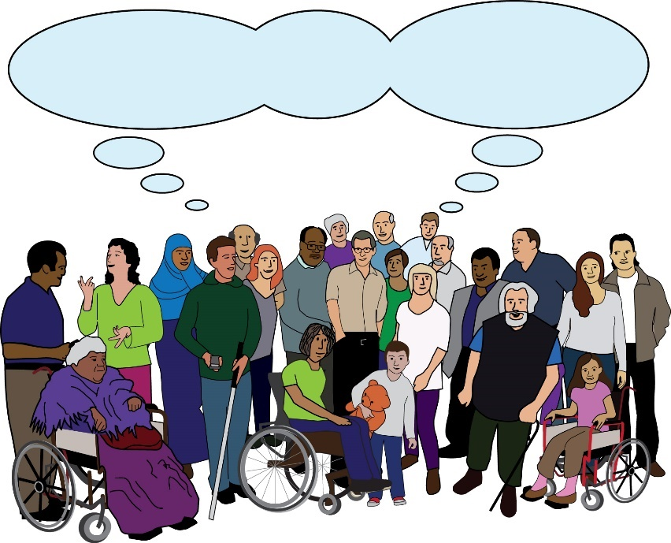

***Community***

Part 2: Easy Read Version

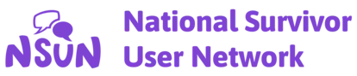

|  |  |
| --- | --- |
| Executive Summary - Part 2 | |
| **Executive summary:** this means a document that sums up the main parts of a report. | |
| **Exploring community and lived experience of mental health** | |
| **Lived experience:** in this document, this means a person who has knowledge and understanding of mental health. This is because they have first hand experience of mental ill-health, distress, or trauma. | |
|  | **This is the Easy Read version of the report.** |

|  |  |
| --- | --- |
| **Part 2** | **This is Part 2 of this report. In this part, we will sum up these sections of the report:**   * **What would we like to see?** * **Conclusion** * **People who supported this work** |
| **What would we like to see?** | |
| **Community** | We want people to stop using the word community as a way of pretending they are listening to our voices.  We want people to think more when using the word.  We want people to think more about how the word can be used for the wrong reasons.  For example, to treat people as if they are all the same. Or, to make people or groups responsible for dealing with **structural issues.** |
| **Structural issues:** this means issues in society that keep some groups in power and put up barriers for other groups. | |
|  | We want more space for:   * People with severe mental illness * People who are still facing distress * People who are **minoritised** in more than one way |
| **Minoritise:** this means treating a group or a person as if they are less important than others in society. | |
|  | This includes looking at how and why people are left out. Whose interests are being pushed for? |
|  | We must look into who claims lived experience.  The term is not specific. It can mean lots of different things. |
|  | This can be **inclusive**. It can protect people’s identities. |
| **Inclusive:** here, this means making sure that people with lived experience can take part in making decisions. | |
|  | But using the term lived experience can also lead to less **solidarity**. It can make it difficult to look at needs. It can make it difficult to put needs first. |
| **Solidarity:** this means having a sense of being together and connected. It can mean sharing interests, goals and support. | |
|  | We must pay more attention to the difficult effects of lived experience work. |
|  | We must think about:   * The experiences of being in community with each other * The hard emotional work that it takes to stay part of a community * How easy it is to become disappointed or lose belief |
| **Conclusion** | |
| **Community** | Community means different things to lots of people. It means more than just a group we share a quality with.  Community can be where we feel safe or sorted. Community can be a place where we do not have to explain ourselves.  Communities can be any size. Communities can exist in lots of different places. |
| **Community** | In mental health, the word community is often used in the wrong way.  It is often used by people with power. |
|  | It is used to talk about groups of people that share a single identity or characteristic. Or to talk about people with just a single area in common. |
|  | This research shows that feeling part of a community is a lot more complicated.  We often feel like we truly belong in smaller groups. We feel like we belong to groups which we can chop and change between. |
| **Community** | We must look at how the word community is used. The term is not specific and has lots of different meanings. We must think about how this word is used. |
|  | As part of this, we must look at how minoritised groups are being made responsible for each other’s wellbeing. |
|  | In some ways, people with lived experience could be thought of as a community. But not always. There are differences between types of community. |
|  | For example, a community could be:   * A group of people who share one same experience   Or   * A group of people who share politics. They share beliefs around what leads people to suffer. They have shared views about what needs to be done next |
| **Community**  **Community** | These are two very different meanings of community. |
|  | It is easy to talk about people with lived experience as a community. But there are important differences that we must pay attention to.  Lots of good work has been done by the lived experience movement. |
|  | But we must also be careful about whose voices are becoming loudest. We must think about who is still being left behind. |
| ?  ?  ? | We must be careful about terms that are not specific.  These terms are likely to be used by people who would rather make small fixes to the system.  They are not interested in changing the system completely. |
|  | So, we must ask:   * How do we build **collective voice?** * How do we do this and still pay attention to power? * How do we do this and keep being specific? |
| **Collective voice:** this means a voice that is shared by every member of a group. | |
|  | A lived experience community might be welcoming, safe, or encouraging. But we can’t exist in this space all the time. |
|  | We need spaces to put other parts of our lives first.  We need spaces where we can be different people at different times. |
|  | How do we use and push for our lived experience?  How do we do this without making our lived experience the only thing that people see about us? |
|  | More work is being done to make sure that groups with power work with people with lived experience.  More groups want to work with us to make decisions. This is a good step forward. |
|  | But often this is done without **resources.** Or groups don’t care or think about the people with lived experience or how the difficult work affects them. |
| **Resources:** this means time, money, staff and anything else needed to push for our goals. | |
|  | These efforts are sometimes called **co-production.** |
| **Co-production:** this means when groups of people get together to influence the way that services are designed, commissioned and delivered. | |
|  | People in power talk a lot about funding and listening to communities. This sounds good but we must be careful. |
| ***Community*** | People in power often use the word co-production, but it doesn’t actually lead to power or resources being shared.  Are we being treated as if we are all the same?  Are we being made responsible for fixing problems that are not our own?  So, it might be helpful to be a bit more specific when we use the word community. |
|  | The word community can bring people together and make them feel connected. But it can also make our meaning unclear. |
| **Community** | When it comes to talking about communities, there is often something more specific and more difficult that we are trying to talk about. |
|  | It might be easier to speak using less specific language. But being specific is what will get us free. |
| **People who supported this work** | |
| 🙏 Person with Folded Hands Emoji | Hand emoji, Praying hands emoji, Folded  hands | This research would not have been possible without support from lots of people. Carrying out this work has been inspiring. It has also been challenging. |
|  | I would like to say thank you to everyone who shared their views and experiences.  Thank you to the people named below and other people who supported this work and didn’t want their name to be shared. |
| **Thanks to these people for their support**: | |
| * Alison Faulkner * Angeline Adams * Anne Benson * Annika Mathews * Carolyn Trippick * Catherine * Charlie * Christopher Frederick * Clare Ockwell * Cleo Madeleine * Colette Lane * Ekaterina Werenowska * Fiona Malpass * GH * Hat Porter * Hazel Cowls * Helen Norman * Jacqui Lovell | * Jeremy O'Dwyer * Jess Worner * Kadra Abdinasir * Kim Laidler * Laura Buchenlicht * Lucy * Mary Nettle * Paol * Rachel Edwards * Rowan Foster * Sara Metz * Simon * Sue Thomas * Suzanne Milan * Taimour Ahmed * Tim A * Tricia |
| **This is the end of the report.**  This document was put into Easy Read by the Empower Team at People First (Self Advocacy).  **Information is Power!**  **www.peoplefirstltd.com** | |



**©** 2024