Exploring community and lived experience of mental health

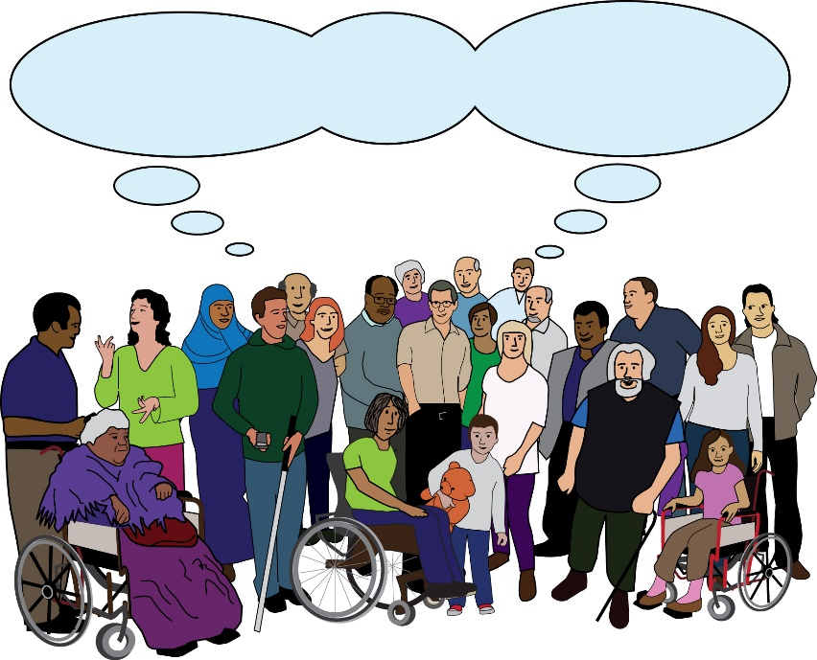
Community

Part 1: Easy Read Version

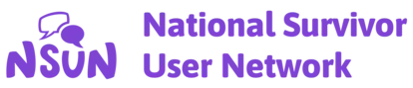

Executive Summary - Part 1

Executive summary: this means a document that sums up the main parts of a report.
Exploring community and lived experience of mental health

Lived experience: in this document, this means a person who has knowledge and understanding of mental health. This is because they have first hand experience of mental ill-health, distress or trauma.
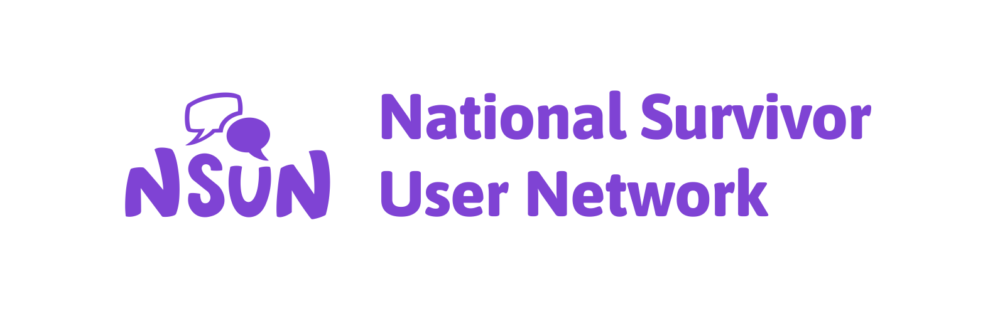 | This is the Easy Read version of the report.  This report was brought together by the National Survivor User Network.
National Survivor User Network: this is a network of people and groups with lived experience of mental ill-health, trauma and distress.
Courtney Buckler wrote this report.

Mind arranged for this piece of work to be carried out.

Mind: this is a mental health charity that works across England and Wales.
Part 1 | This is Part 1 of 2. Please make sure you read Part 2 after you have finished this part.
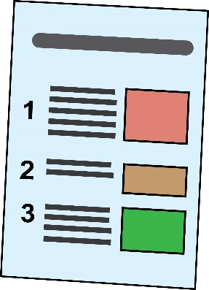 | In Part 1, we will sum up these parts:  - Introduction  - About the project  - Key findings
Introduction

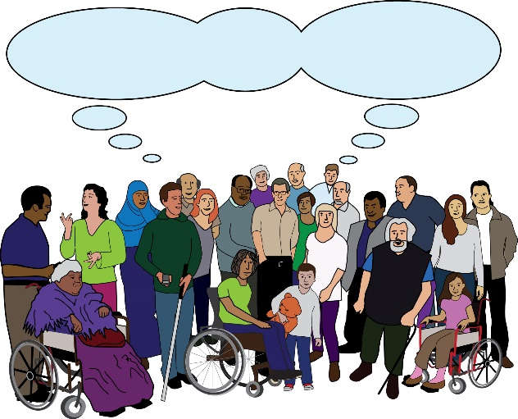 | Community is a big word. It is often used, but it is very hard to explain.
 | The term lived experience is the same. It is also a big term that is hard to explain.
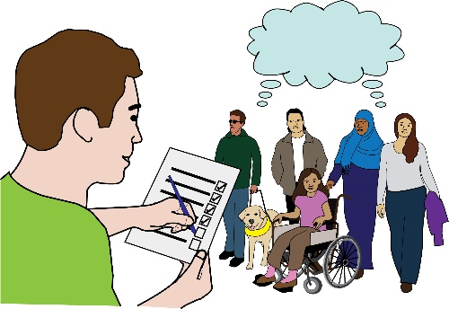 | The aim of this research is to look at what these words mean. The research aims to look at these words in relation to each other.
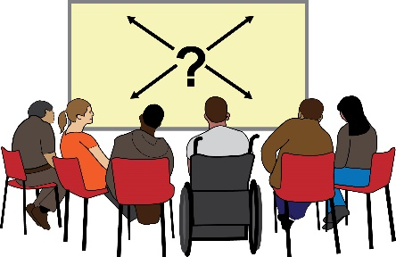 | It aims to look at some of the complicated things that come up when we talk about community.
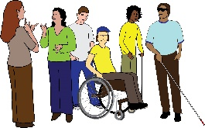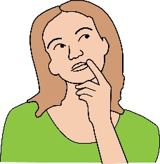 | It aims to look at some of the complicated things that come up when we think about lived experience.
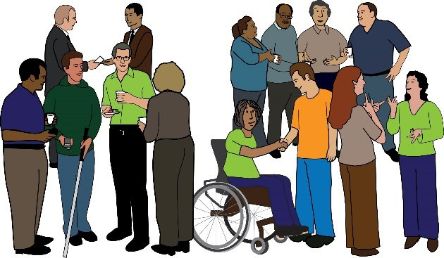 | Over the years, different groups have tried to bring together people with experience of:  - Mental ill-health  - Distress  - Trauma
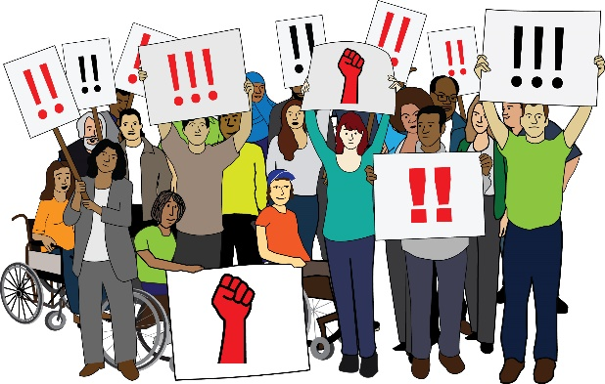 | They have tried to bring these people together lots of times. They have tried to build up a movement.
 | However, there is still not just one community of people with lived experience.
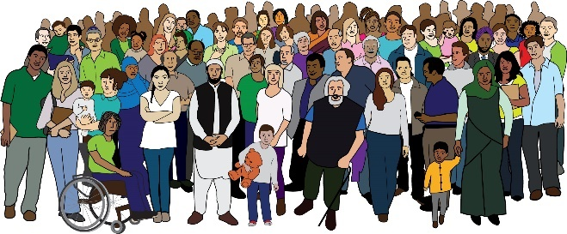 | Instead, there are lots of us. We are using our experience to make the world a better place.
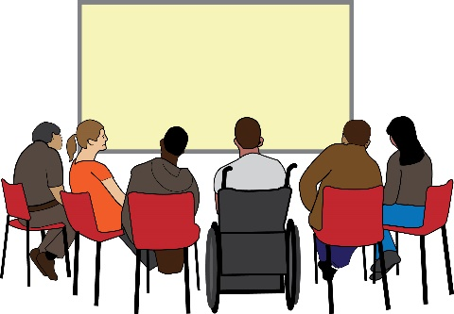 | We often have different visions for what needs to be done. We have different ways to meet these visions.
Vision: this means a big-picture view of what the future will look like.
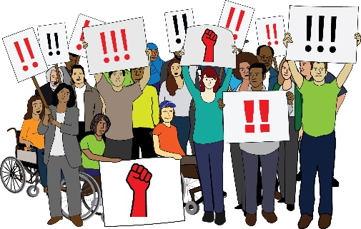 | We still want and need a community to be built. We need collective action to be taken.
Collective action: this means when a group of people take action together. They take action to push for the same goals and visions.
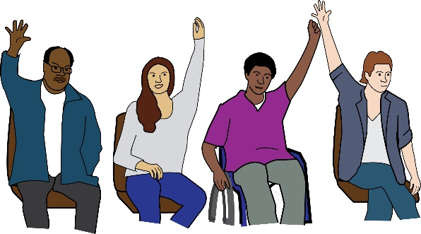 | We need a community that is led by people with lived experience. This might be needed now more than ever.
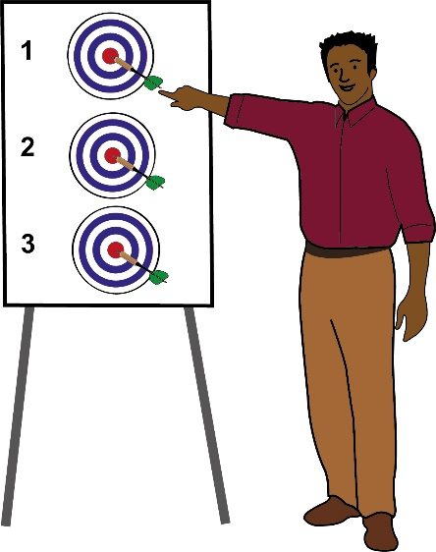 | To reach this goal, we must think about:  - What it means to claim a community  - What it means to build a community
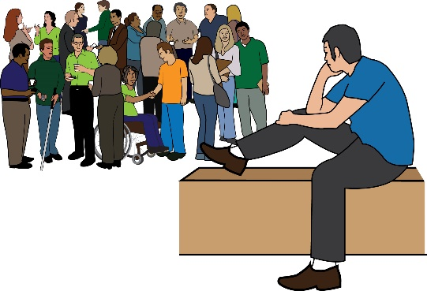  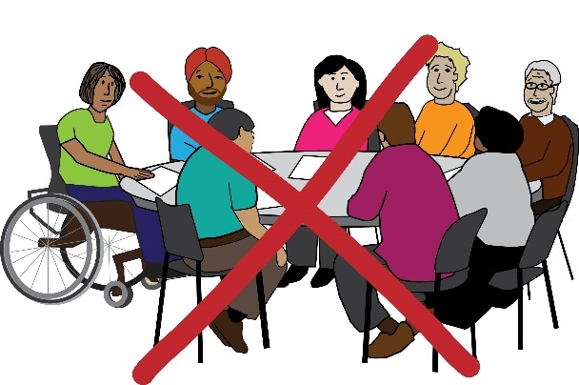 | We must think about:  - How people can be harmed in trying to do this  - Who is being left behind  - How the term community can be used by groups who are not pushing for our own interests
About the project

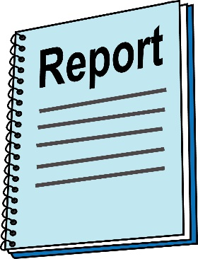 | This report talks about the findings of our research project between August and November 2023.  The project looks at people’s lived experiences and points of views.

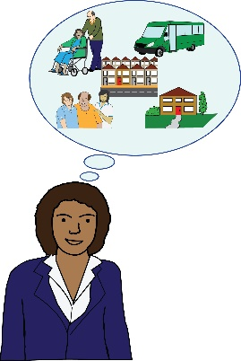 | It looks at their relationships with the idea of community. It listens to the voices of people with lived experience.  The project is built on the results of our research:  - We gave out a survey. 73 people answered  - We interviewed 5 people  - We also carried out focus groups. There were 3 people in each group
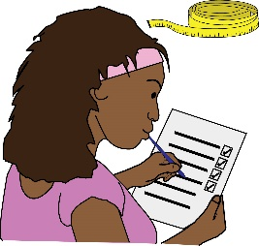
x 73
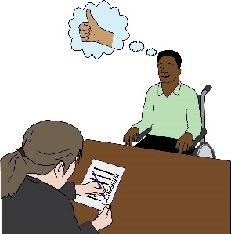
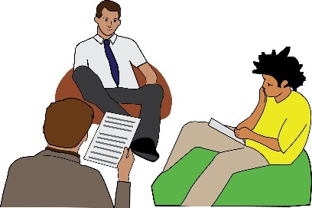
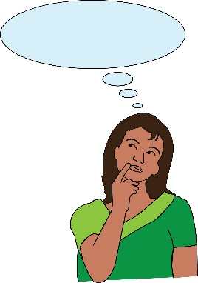  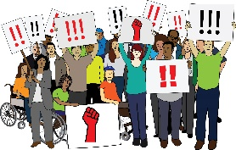  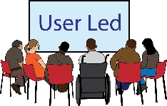 | In this report, we look at these questions:  What does it mean to try and build up solidarity and collective action?
Solidarity: this means having a sense of being together and connected. It can mean sharing interests, goals and support.
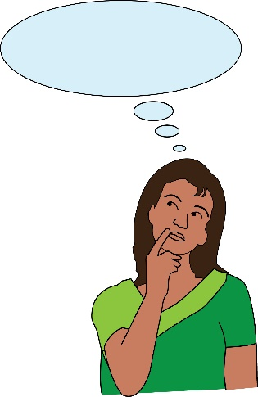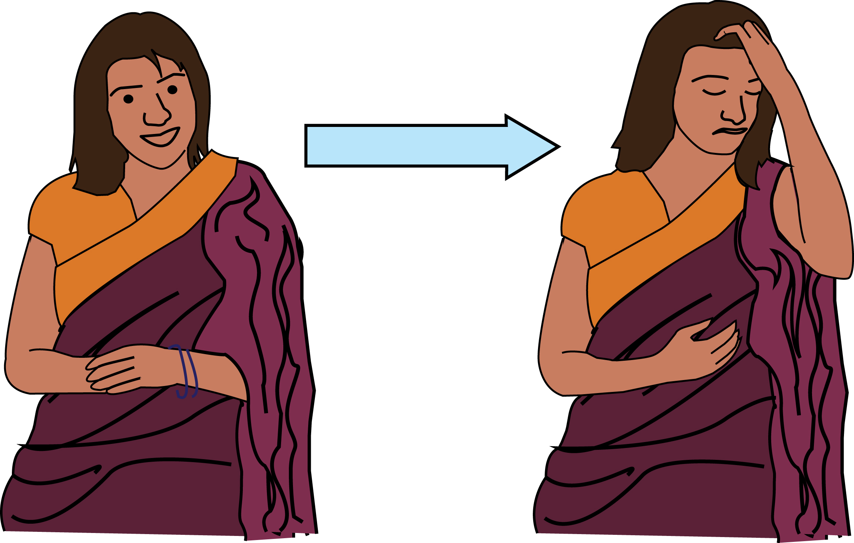 | What does it mean to build solidarity with people who have lived experience of:  - Mental ill-health  - Distress  or  - Trauma
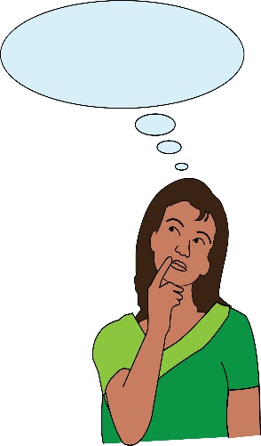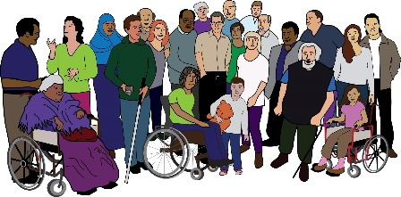 | What does community mean?  What do people assume about community?  What is suggested by the word community?  How is community forced upon us as people with lived experience?
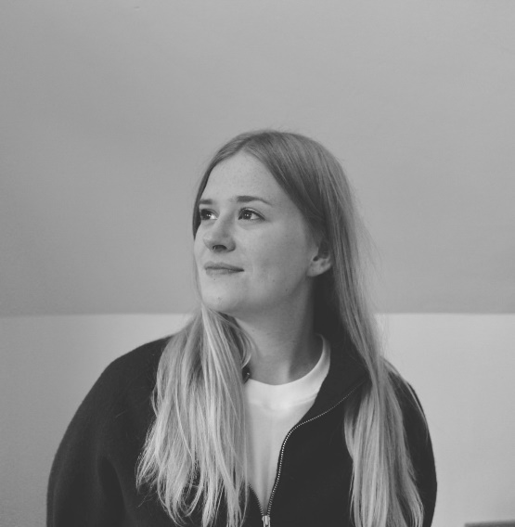 | The report was written by Courtney Buckler. They have lived experience. They carried out this research.  Courtney is an Executive Director of Make Space. This is a user-led group. It does work around self-harm.
User-led: here, this means a group that is led by people with lived experience.

Self-harm: this is when someone hurts themselves on purpose. People can self-harm in lots of different ways and for lots of different reasons.
 | The National Survivor User Network arranged for Courtney to carry out the research. They set out the plan for the project.
 | The report was funded by a grant from Mind. The funding came through their Communities Team.
Key findings – this means the most important things we found out through this research

Talking about community

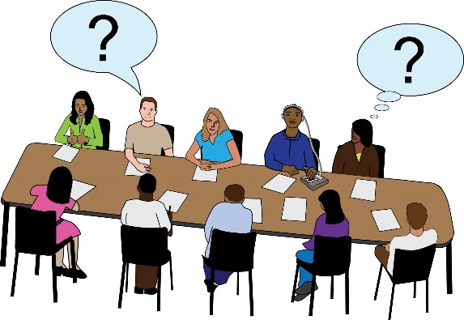 | Community is a hard word to explain. In our research, we found out that it means different things to different people.
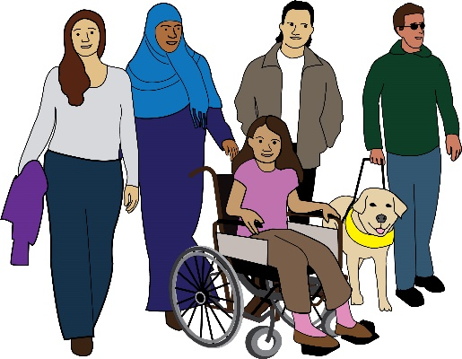  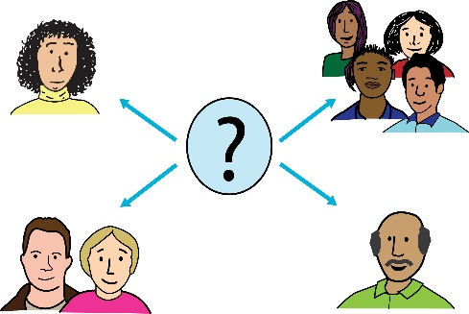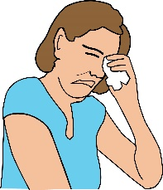 | Community could mean:  - A group you support  - People who support you  - A group you have been told that you are part of  - A space that felt painful to be in  Some people that we asked said community was important to them. Other people were not so sure.
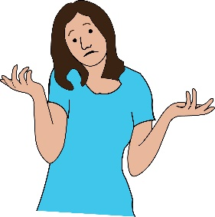
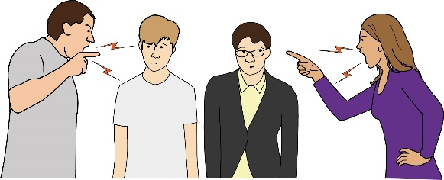 | Some people had bad experiences of community. Some people felt like community had harmed them.
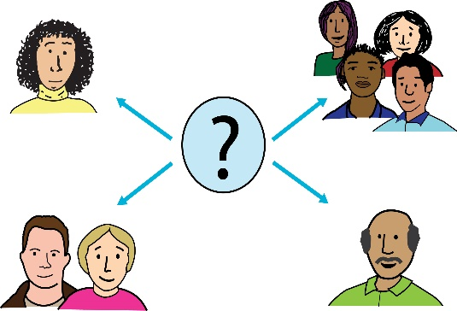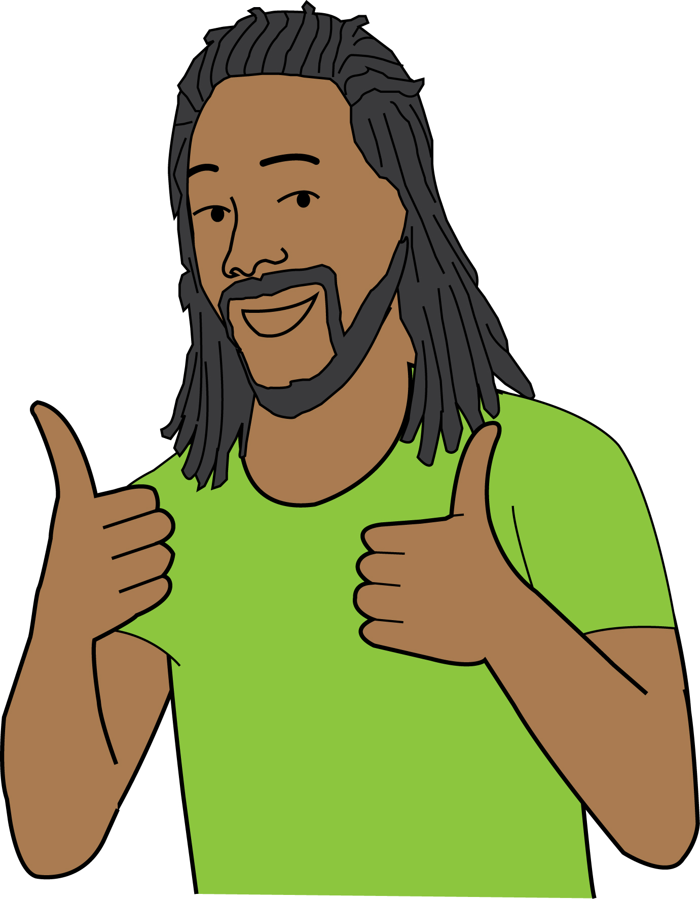 | Lots of people said it was important to be part of lots of different communities. They said communities allow them to be different people in different spaces.
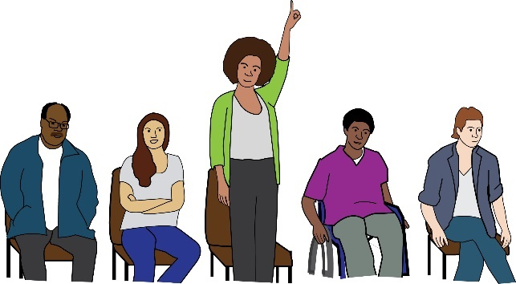 | People said it was important to be able to say which communities they were in. They didn’t like being told they were part of a group. For example, a group they didn’t feel part of.
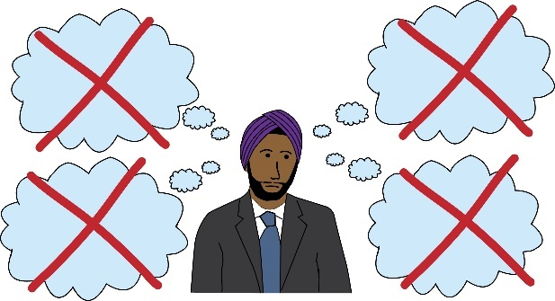 | Putting people in categories and assuming they are part of communities can be painful. It can make people feel isolated and like they don’t belong.
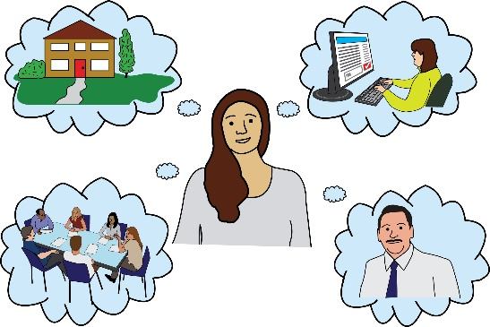  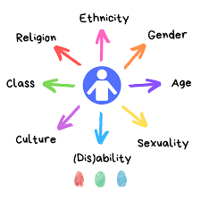 | Sometimes when people look at a community, they just focus on one issue. They don’t think about the different issues that individual people face.  This can mean that they ignore people’s intersectional experiences.
Intersectional experience: this means when a person faces more than one type of barrier or discrimination because of who they are.
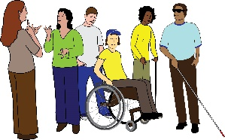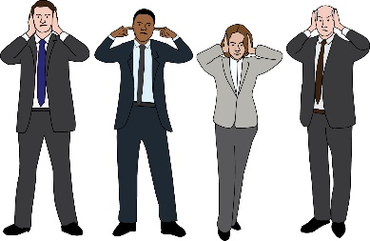 | Community can ignore the experiences of people who are marginalised in more than one way.
Marginalise: this means treating a person or group as less important than others in society.
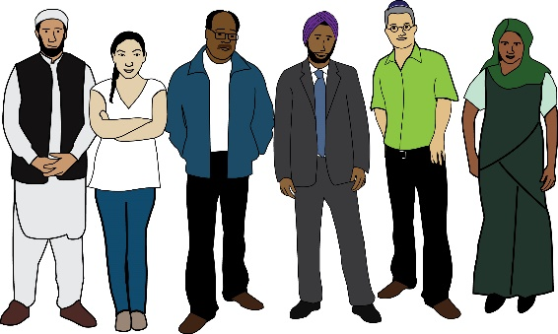 | It might be important to look at smaller communities. People sometimes view these communities as the most important groups.
Talking about lived experience

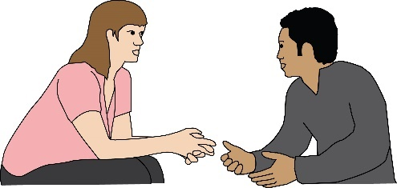 | Lived experience is a term that can mean lots of different things. It allows lots of different people to feel part of something.
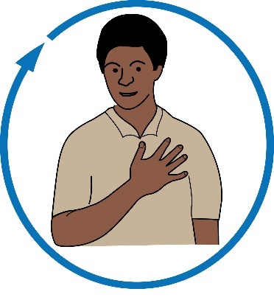 | But this can also lead to challenges. For example, it can be hard to look at the different needs of people with lived experience.
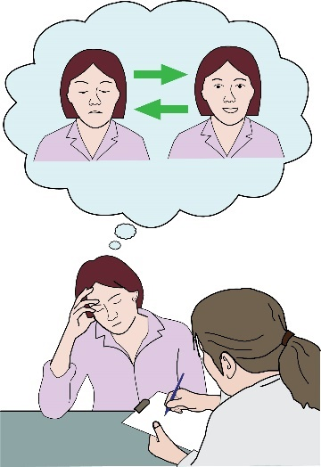 | It can also have bad effects on the way we talk about mental health.  It can make it harder to work around areas such as mental ill-health, distress or trauma.
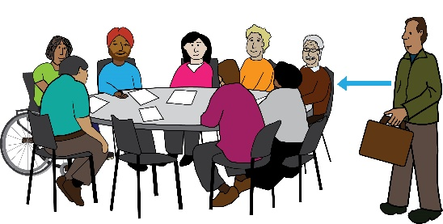 | In our research, somebody said that describing people as having “lived experience” can make it hard to see people’s different needs.
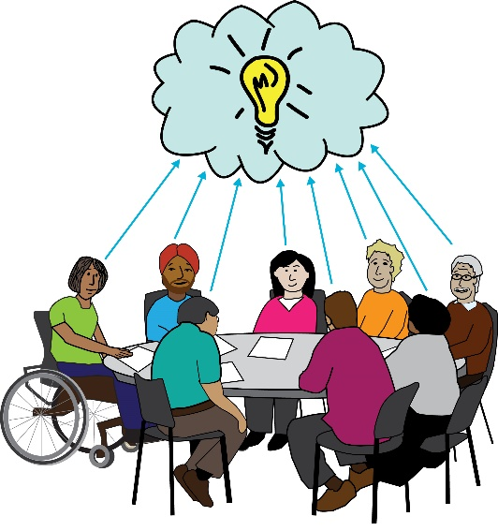  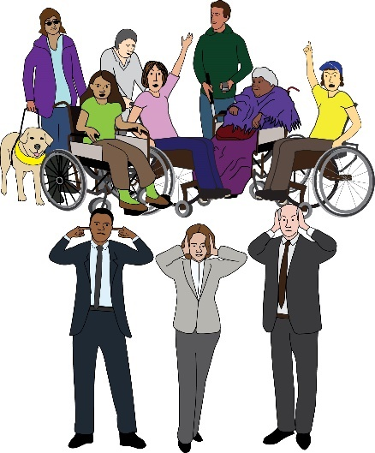 | Lived experience is not a specific term. This can be good. It means people can talk about their experiences without having to go into details.  But this can also be bad. It can allow people with power to pretend they are listening to lived experience voices.  But they don’t have to explain how they have listened. Or, they don’t have to say what experiences those people had.
 | This means that the term lived experience can be used to say yes to decisions. But these decisions might not push for our own interests.
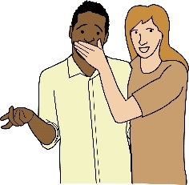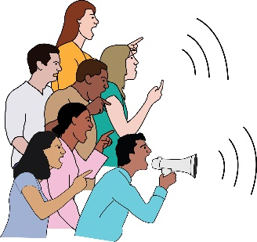 | In society, we are hearing more and more from people with lived experience. But there are still voices we do not hear much from.
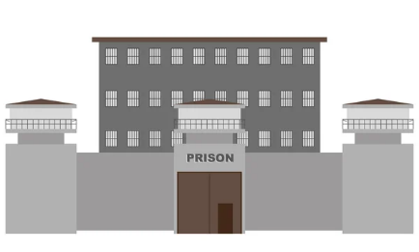  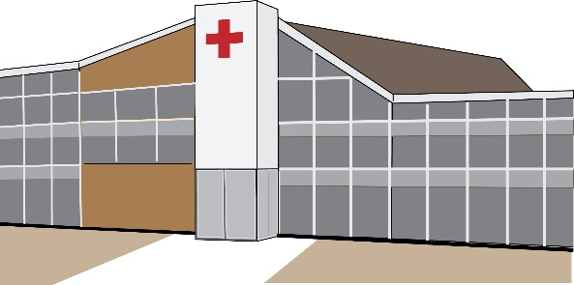  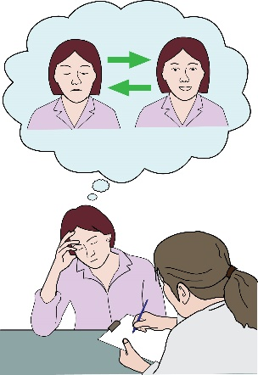 | For example, we don’t hear much from:  - People with severe mental illness  - People who are in prison  - People who are in psychiatric facilities, this means hospitals or homes for people with mental ill-health
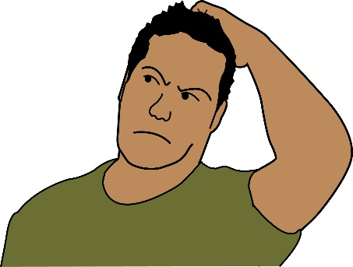 | Lived experience is not a specific term. It has lots of different meanings. This could lead to some of the problems mentioned above.
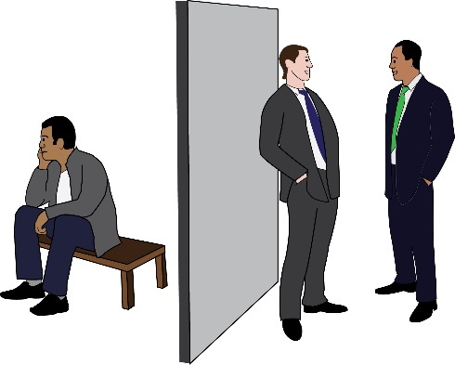 | Sometimes people don’t work to understand the politics of lived experience. This can keep power in place.
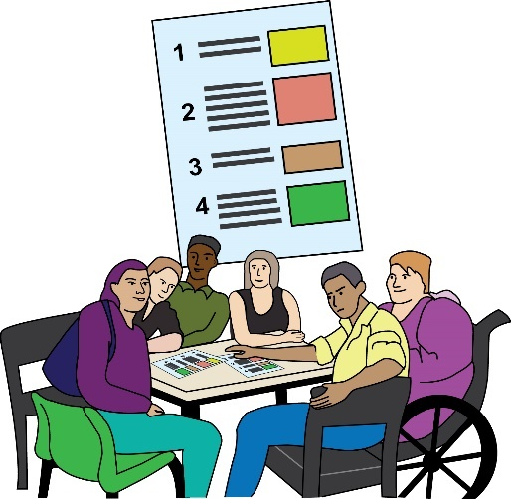 | One person in our research suggested that:  The term lived experience is used by people who have less serious mental health needs. These people have a bit more power, so their voices get heard more.
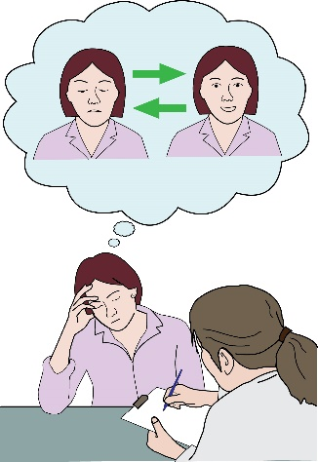  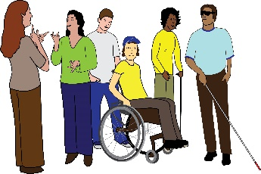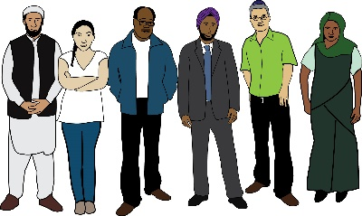 | Our research found that more space needs to be made for:  - People with severe mental illness  - People who are still facing distress  More space and opportunities must also be made for people who are minoritised in more than one way.
Minoritise: this means treating a group or a person as if they are less important than others in society.
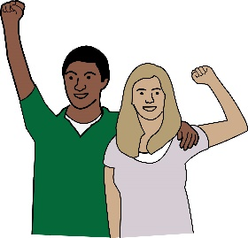 | We must think about power in the lived experience community.
The lived experience community

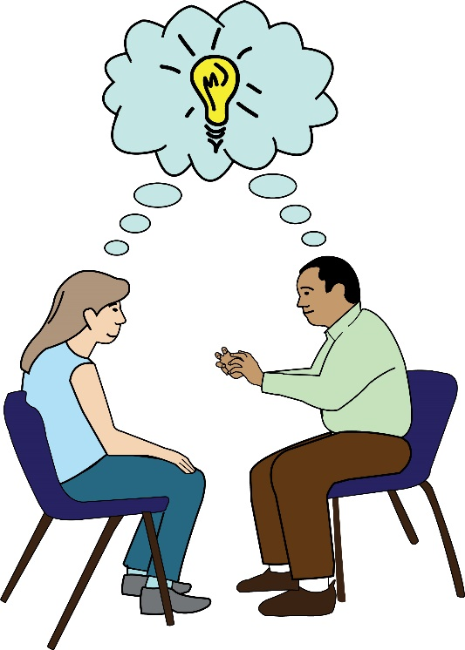 | The term lived experience can talk about a shared experience.  It can also talk about shared politics.  People with shared experiences might not necessarily be a community. But people with shared politics might be a community. This is not always clear.
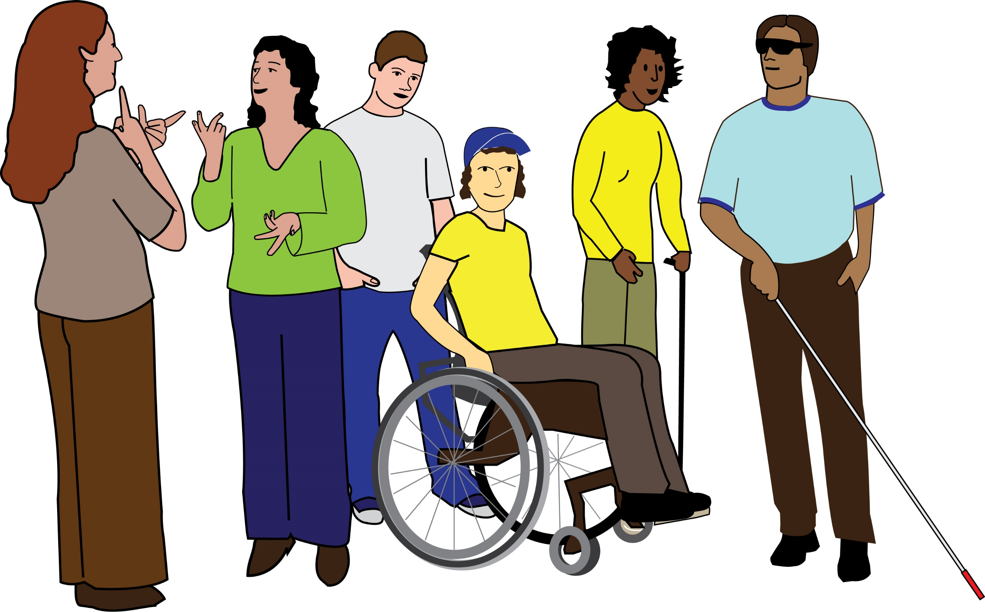 | Not everyone wants to describe themselves as someone with lived experience. Lots of people are left out from describing themselves like this.
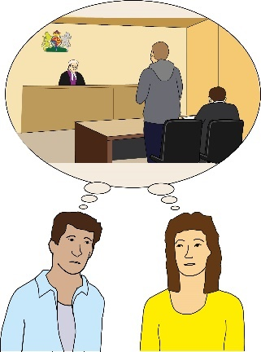 | For example, people whose experiences are seen as a crime. Or people who would be in danger if they talk about their experiences.
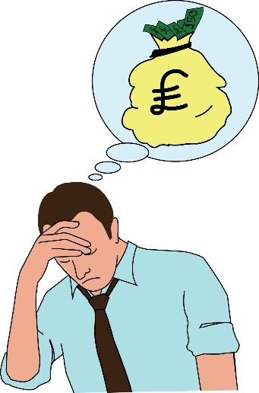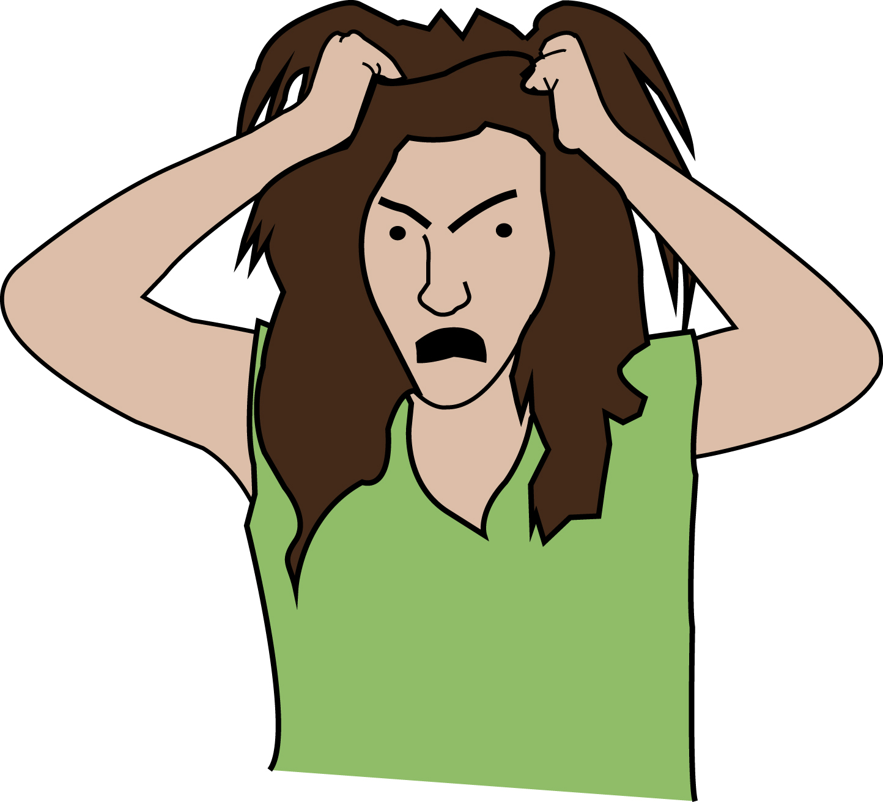 | It can be difficult to stay part of the lived experience community.  For example, it can be hard to hear about other people’s pain. Or it can be hard to think about our distress.
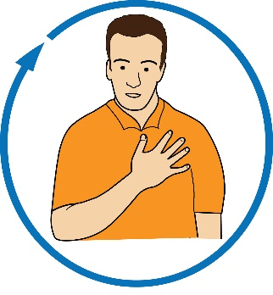 | We might be someone with lived experience. But it is important that we have space to be something other than this.
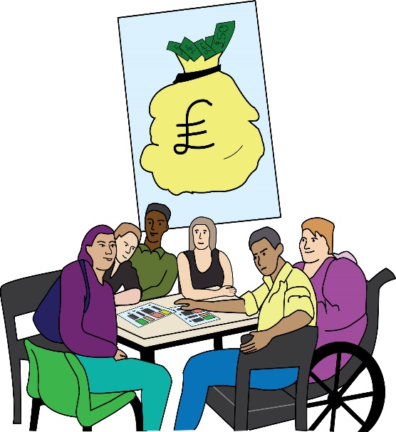 | It is also hard to keep faith in doing lived experience work.  This work is often not seen as important. It is often not funded well.  We often have to work hard to make small steps forward.
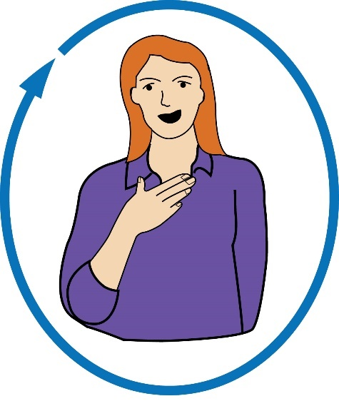 | One person who we interviewed said that:  Trying to be part of a community can be dangerous. We see lots of terrible things. This makes it more important. But it makes it hard. It’s a weight on everyone. There is no space for the weight.
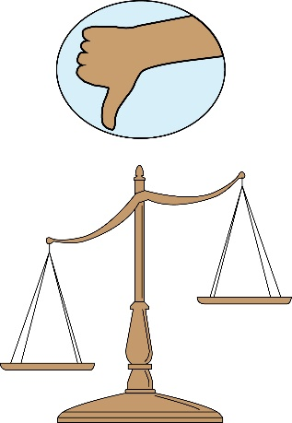 | One person in our focus group suggested that:  Lived experience is about pain and a sense of struggle against structural inequality.
Structural inequality: this means the building blocks of society that keep some groups in power and put up barriers for other groups.
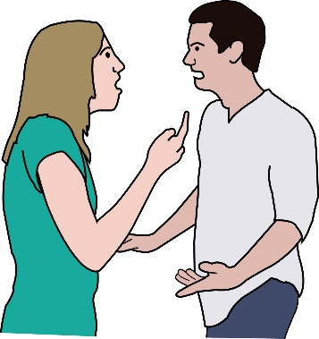 | There can be tensions that come up when doing lived experience work. Often, people have different views about what needs to be done.
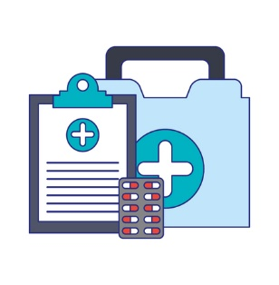 | Some people think we need to make changes to the system. Other people think we need a whole new system.
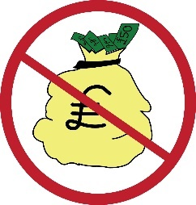 | There are also not enough resources. This can mean we have to fight over scraps.
Resources: this means time, money, staff and anything else needed to push for our goals.
 | Funding criteria can make tensions worse. These criteria don’t think about the specific details of our work.
Funding criteria: this means a set of standards that must be met to get funding.
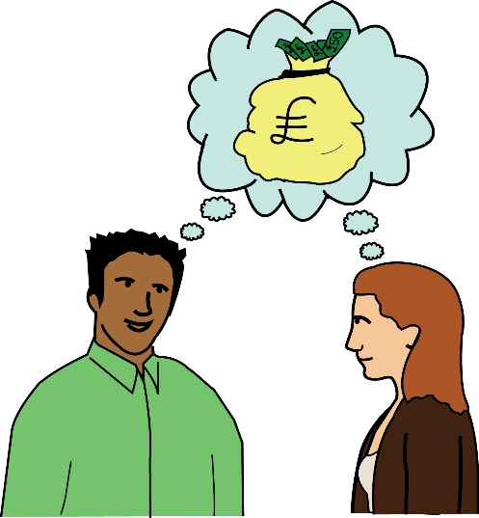  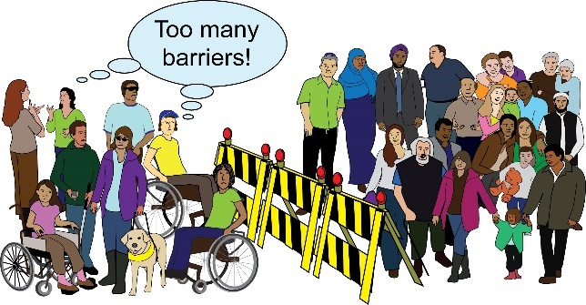 | These funding criteria don’t give enough resources to:  - People who are minoritised in more than one way  - Liberatory organising, this means working in a way that is free from the barriers caused by politics, money and society
Using the word community

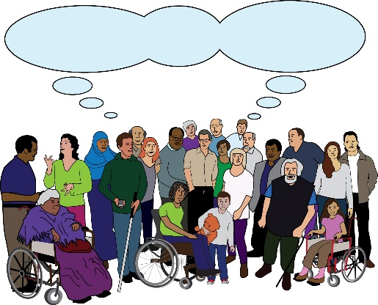  Community | Community can be a powerful word. It can help to create a collective voice. It can help to highlight issues that face most of us.
Collective voice: this means a voice that is shared by every member of a group.
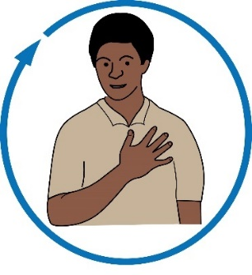 | But we must be careful that the word does not stop us being specific about the issues we are facing.
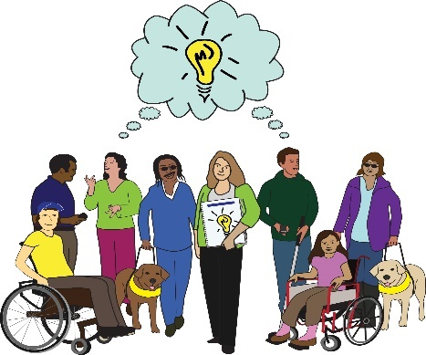  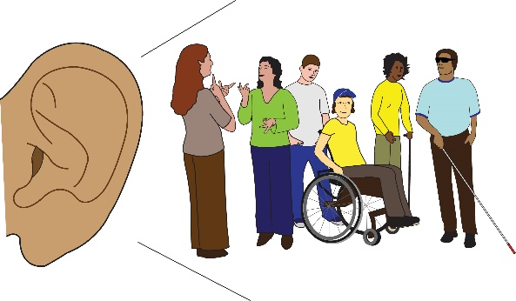 | The word community could talk about:  - People who we feel in line with  - People who we feel we have a responsibility towards  - People who we hope will benefit from our work
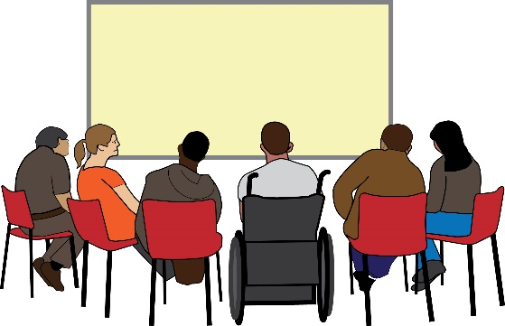  Community | It is important to be clear on what we mean when we use the word community. This will help us to look at how effective the way we work is.
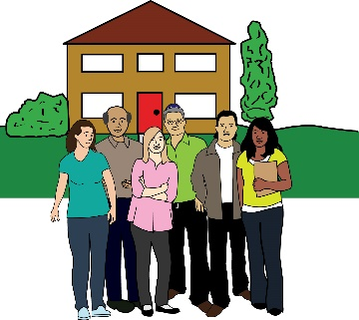 | In mental health, community often means ‘not in hospital’. This makes it seem like life is perfect outside of hospital.
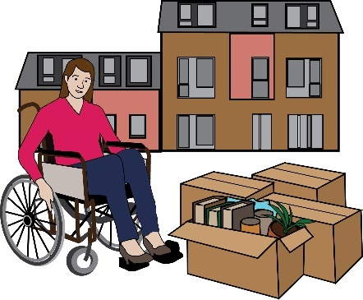 | But it can also be used to give away responsibility for care. It assumes that people have a home or support to go back to.
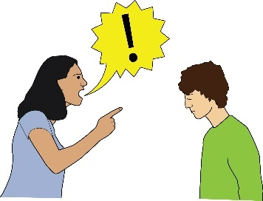 | The word community can also be used to push for interests that are not our own.
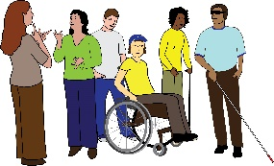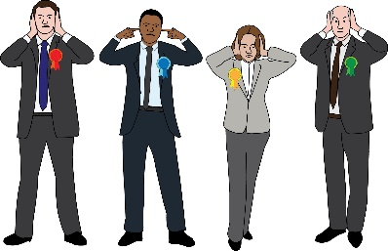  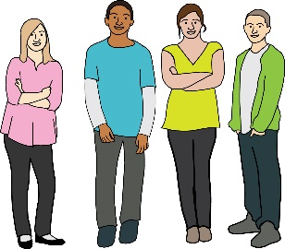 | It can be used by people in power. They can use the term to make minoritised groups responsible for keeping each other well.  This can also include celebrating communities of necessity.
Communities of necessity: this means different groups of people coming together because of a common need or characteristic.
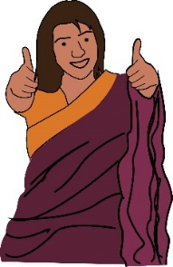 | Lived experience work can have great effects on our lives. But lots of us would rather not have to do it at all.
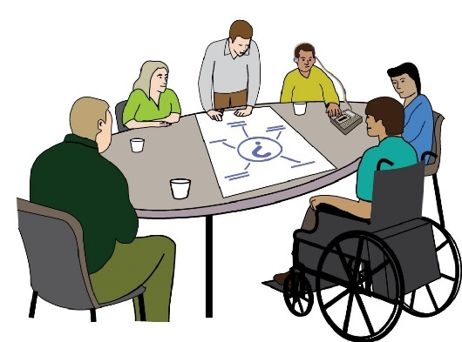 | Often, groups run co-production projects. Sometimes they take advantage of the different meanings of the term lived experience.
Co-production: this means when groups of people get together to influence the way that services are designed, commissioned and delivered.
For example, they might pick and choose people to work with. Then, they can say that they have worked with the community.

They can tick a box. But they have not really worked in an inclusive way at all.

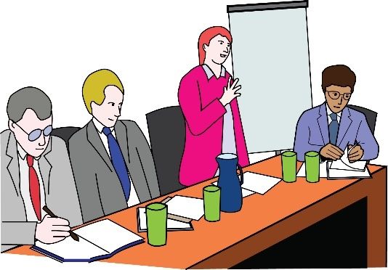 | Another example is the way that groups use people’s stories.  They might ask people to share vulnerable stories from their lives.
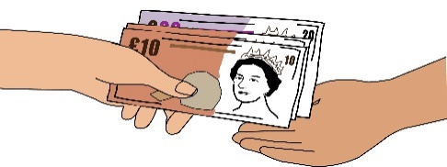  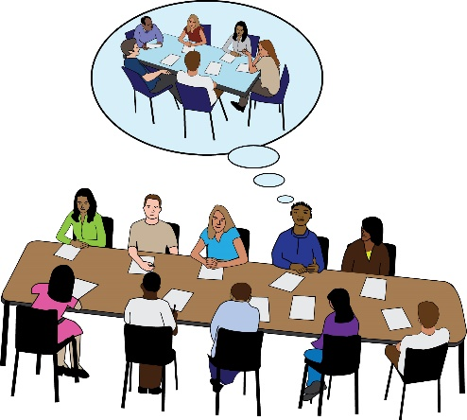  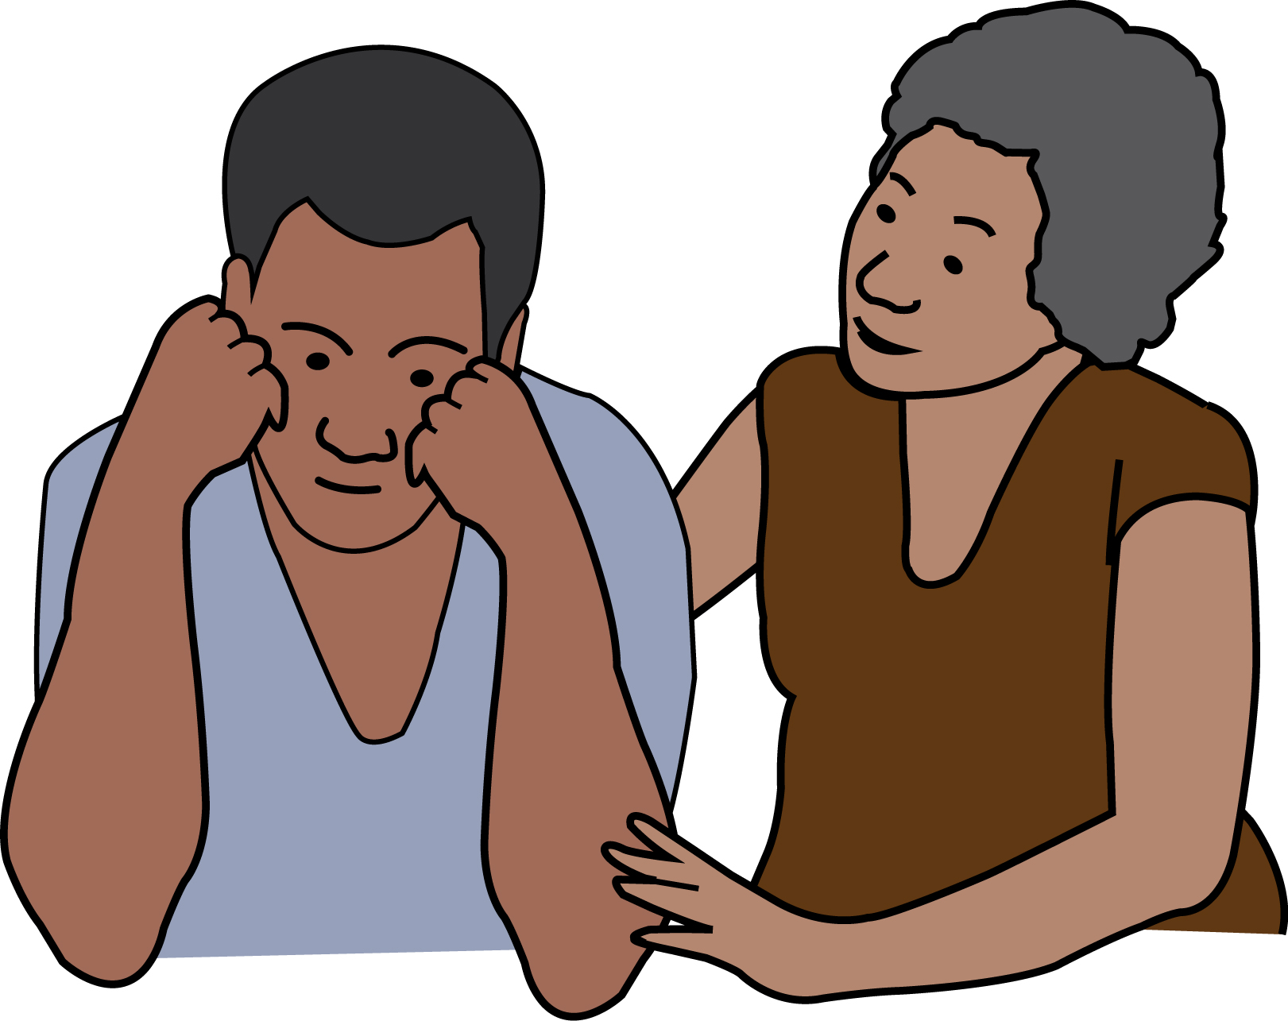 | But they don’t  - Pay them  - Promise to push for change  or  - Think about how this might affect people
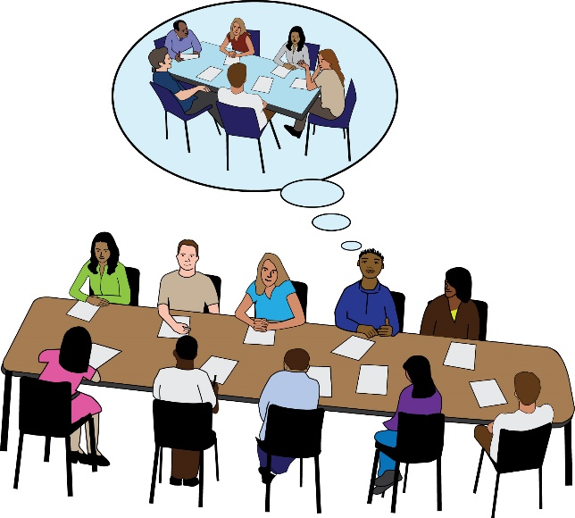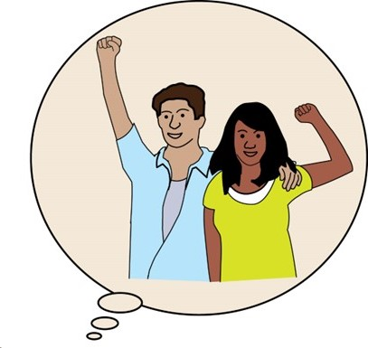 | One person from our focus group suggested that:  People are looking for a neatly packaged version of your lived experience. They're not really ready to accept the messy parts of it. It's created that kind of funnel where the more polished you are, the more you get those opportunities.
 | Groups don’t pay enough attention to the ways that co-production can harm people with lived experience. They don’t think about how telling your story can harm you.
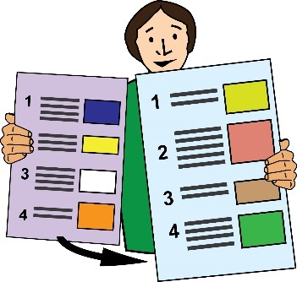 | This is the end of Part 1. Please go to Part 2 now.

