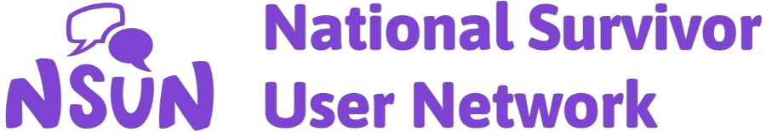

National Survivor User Network (NSUN)
Equality and Diversity Monitoring Form

Statement

- NSUN welcomes diversity in the people we work with including staff, trustees, volunteers, associates and members. Diversity is not just seen as something to aim for but as something to be valued and an asset in delivering services to different people.
- NSUN recognises that certain groups and individuals are discriminated against in society and is committed to ensuring that equality of opportunity becomes an integral feature of all our activities.
- All employees and trustees are required to comply with NSUN’s Equality, Diversity and Inclusion policy and cooperate with measures introduced by the governing body to implement and monitor it.

Monitoring form

To help us monitor the effectiveness of our Equality, Diversity and Inclusion policy, we would be grateful if you would complete this form alongside the application form. It will be separated from your application and is used solely for monitoring purposes. The anonymous information will be entered into a monitoring spreadsheet by NSUN staff and your original form deleted. This aggregated dataset will then be used by NSUN to monitor inclusivity in its recruitment and selection processes. You don't have to complete this form or answer some questions if you don't want to, but it will help NSUN if you do.

Ethnicity | White  ☐ British  ☐ Irish  ☐ Other…………………  Asian/Asian British  ☐ Bangladeshi  ☐ Indian  ☐ Pakistani  ☐ Other…………………  Chinese  ☐ Chinese British  ☐ Other Chinese  Other ethnic background  ☐ …………………..……… |  |  | Black British  ☐ African  ☐ African Caribbean  ☐ Other…………………  Mixed heritage  ☐ African and White  ☐ African Caribbean and White  ☐ Asian and White  ☐ Other…………………  Gypsy/Traveller/Roma  ☐ Romany Gypsy  ☐ Irish traveller  ☐ Scottish Gypsy/ traveller  ☐ Roma (Gypsy/Traveller/Roma)
Religion |  | How do you describe your religion/belief (if any)?
Region you live in |  | ☐ East Midlands  ☐ East of England  ☐ London  ☐ North East  ☐ North West  ☐ South East  ☐ South West  ☐ West Midlands  ☐ Yorkshire and the Humber |  |  | ☐ N. Ireland  ☐ Scotland  ☐ Wales  ☐ Europe  ☐ International
Age
Gender |  | How do you describe your gender?
Sexual orientation |  | How do you describe your sexual orientation?
Disability |  | Do you consider yourself to be disabled?  The Equality Act 2010 defines disability as ‘a physical or mental impairment which has a substantial & long-term effect on a person’s ability to carry out normal day to day activities’.  Yes ☐ No ☐ Prefer not to say ☐  If you’ve ticked Yes and you feel comfortable, please let us know which of the following disabilities you identify with (you can tick more than one):  ☐ learning disability  ☐ long-term physical health condition (including chronic pain, fatigue)  ☐ mental health difficulties (e.g depression, anxiety)  ☐ neurological condition (eg. dementia, Parkinson’s disease)  ☐ physical impairment  ☐ sensory impairment (eg. visual impairment, deaf)  ☐ social/ communication impairment (e.g. autism, ADHD)  ☐ other (please state)  Please give more information here if you wish:
Employment |  | ☐ not employed  ☐ student  ☐ carer/parent  ☐ employed PT  ☐ employed FT
Education |  | ☐ school education  ☐ college/university
English language |  | Is English your first language?  ☐ yes  ☐ no  Please give more information here if you wish:
Additional information |  | Please give any further information here if you wish e.g. related to forms of discrimination you experience, any caring responsibilities you may have.

