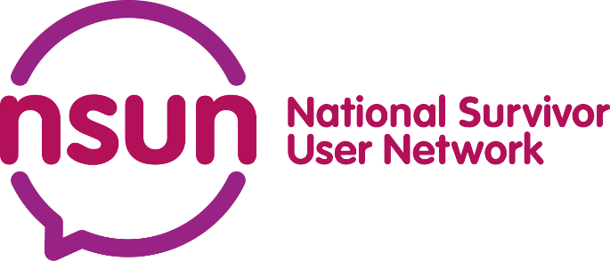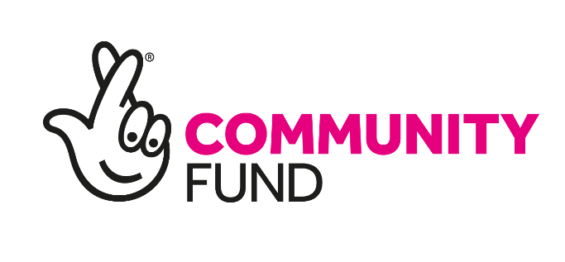

Invitations for Expressions of Interest: Community Constellations Learning Partner
NSUN is a network of people and grassroots groups with lived experience of mental ill-health, distress and trauma. We work towards the distribution of power and resource in mental health.
Our membership includes groups of people organising themselves around shared identity, emotion and experience, in order to create spaces for care and change. NSUN’s challenge is to resource, support and build the capacity of this work in a way which honours and welcomes its variety. This work has shaped & been shaped by our recently-created Theory of Change.
Since 2021, we’ve been funded by the National Lottery Community Fund to do this capacity building work through our Community Constellations programme. Some of the ways we’ve done this include:
- Platforming and connecting our members through our collaborative bulletin and our members’ blogs
- Creating spaces for people who are part of user-led groups to learn from each other, develop their practice and create alternative approaches – for instance, convening spaces to reimagine safety for people with experience of mental ill-health
- Partnering with lived experience-led organisations to deliver free training to user-led groups (e.g., trans inclusion training, workshops exploring legal structures for organisations)
- Hosting projects like North East Together and misery
Our experience has shown that capacity-building and community-building work in this complex and contested space requires a relational, trust-based and responsive approach. This approach is often more labour-intensive than a one-size-fits-all solution, but has the benefit of producing deeper and more significant change, and opening us up to unexpected discoveries and opportunities. Read more about our approach here.
We are looking for a learning partner (a freelance consultant or an organisation) to help us answer some key questions around our National Lottery Community Fund-funded capacity- and community-building work, and to develop learning frameworks which will support our work in the future.
Our questions for this work
- To what extent is “capacity building” a core part of NSUN’s work, and what does this look like across different functions and teams (e.g., policy, comms, finance, ops)? What approaches do they use, and what impacts have these approaches had? How can this work shift power in the sector?
- Relational and responsive approaches have helped NSUN to carry out its capacity-building and community-building work. How can NSUN:
  - Ensure that these approaches are also balanced with reliability, accessibility, fairness and transparency, and
  - Develop a flexible framework for learning from, monitoring and improving these approaches?
About you
You are someone who can support us to articulate the work we’ve been doing, spot patterns that we might otherwise miss, and whose approach to learning positions you as part of the work instead of an external observer. You will have:
- An understanding of and commitment to anti-oppression work, particularly as it relates to mental ill-health, trauma and distress.
- Experience of undertaking monitoring, evaluation and learning work
- Familiarity with the UK grassroots/movement-building landscape and ability to support equitable ways of working in this context
- Ability to build trusting relationships with a wide range of people – staff, partners, grassroots organisations, etc – and understand the value of working relationally
NSUN is a user-led organisation, and all staff and trustees have lived experience of mental ill-health, distress or trauma, which may include racial trauma. We don’t ask people to disclose specifics during recruitment.
Timeline
July 2023 | Onboarding & Scoping with the NSUN team
July-October 23 | Desk research, engagement with staff, NSUN members, hosted projects, other stakeholders, developing Interim Report
October 23 | Interim Report. A short exploration of findings so far on NSUN’s capacity-building methods, how & why they have developed, and their impacts.
November 23 – Jan 24 | Engagement with staff, NSUN members, other stakeholders, developing Final Report
Feb 2024 | Final Report. Building on the findings of the interim report to develop recommendations for frameworks to ensure the sustainability, accessibility and proper evaluation of NSUN’s capacity-building work.

Budget & contract
This is a contract for 8 months, with a budget of £7500 including VAT. We anticipate the work taking approximately 18–22 days worked between July 2023 and February 2024.
This is contract work and so you will manage how and when you carry out this work, within the expectations of the agreed timeline. You will need to use your own equipment and insurance. The successful candidate will require a Basic DBS check, which NSUN can arrange.
NSUN is a remote organisation and all staff work from home. There may be some opportunity for face-to-face meetings with this work.
Expressions of interest
To apply for this role, please provide no more than one A4 page outlining the following:
- What you think the challenges and opportunities are for this work, and what excites you about it.
- The relevant experience you would bring to this project.
- How you would deliver this work within the specified timeframes and budget.
The deadline for expressions of interest is 9:00am on Monday 5th June. Please email it to ruairi.white@nsun.org.uk with the subject heading ‘Community Constellations Learning Partner’.
If you have any questions about this brief, or would like this document in a different format, you can email Ruairi at ruairi.white@nsun.org.uk. Questions are really welcome.

