29th October 2020
A Statement from the National Survivor User Network (NSUN)
National Survivor User Network or NSUN: this is an organisation that brings together people and groups from across the country. We aim to make people’s lives and mental health better. To do this, we must break down barriers in society.

In this statement we want to tell you about insolvency and what this means for you, our members.
Insolvency or becoming insolvent: this means when an organisation doesn’t have enough money to pay back all the money it owes. If this happened to NSUN, we would have to close. If this happened, it would be called becoming insolvent.

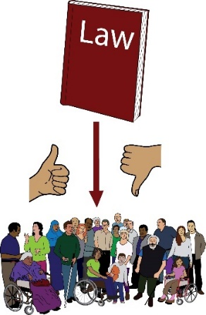
It is not very likely that NSUN will become insolvent. However, just in case it does, we want to tell our members how it will affect you. We want you to know more about your liabilities.
Liabilities: this means when you responsibilities by law.

To NSUN members,
Over the last year, we have been working on the ways that we run our organisation. This means:
- How we make big picture plans

- How we can make sure that NSUN is responsible to its members for the decision it makes. We want to make the way we run things better.
As part of this, we have been looking at our Articles of Association.
Articles of Association: this is a document about NSUN. It talks about the way our organisation is run. It talks about our aims, rules and ways of working.

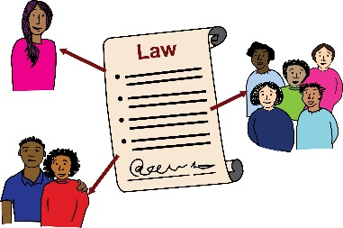
We have recently been given legal advice about insolvency. The issue probably won’t affect us in real life. However, we want to share the issue with our members as soon as possible, just in case. We want to be as honest and as clear as possible.
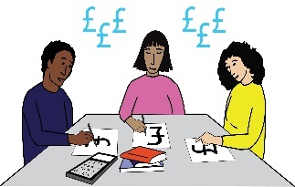
Until now, we thought that if insolvency happened and NSUN could not cover its costs, our Trustees by law, would have to pay £10 each. However, we have recently been told that this is not actually what happens.
Trustees: this means members on the board of our organisation who have the power to make important decisions.

In fact, if insolvency happens, all NSUN members as well as Trustees, would have to pay £10 each.
This part of the Articles of Association of NSUN and is written in Article 2.1 and 2.2. We didn’t understand these Articles properly when we read them. We thought that only Trustees would have to pay if our organisation had to close. This was a mistake.
The first thing we want to say is that the NSUN team are responsible for this mistake. The NSUN leadership team and the board made the mistake. We didn’t do this on purpose, we didn’t fully understand what the articles meant by law.
We know this mistake might make you feel worried. We are very sorry about this. However, our members would only ever have to pay £10 if our organisation closed and if we didn’t pay our debts.
Debts: this means any money that we owe to companies, people or organisations.

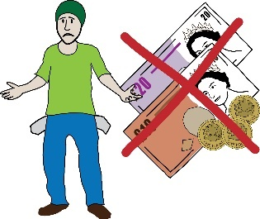
We know that lots of our members don’t get paid a lot of money. For lots of our members, £10 is a lot of money. We would never chase our members for this money if they couldn’t pay it. We have also been told that if insolvency happens, the creditors are not very likely to chase you for this money either.
Creditors: in this document, this means the people, organisations or companies that NSUN owes money to.

We have tried to see if we can change or get rid of the rules quickly, so that you wouldn’t have to pay £10 or to see if we can bring this amount down.
However, the payment is tied to our members right to vote in the Articles of Association of NSUN. This means we can’t change the rule.

We are a membership organisation. This means that members vote on important decisions. If we changed this rule, it would go against the voting rights of our members. Therefore, the rule about insolvency is not something that we can change quickly.
The second thing we want to say is that NSUN is in a strong place with money at the moment. Members would only have to pay £10 if NSUN became insolvent. Over the next year, the chances of this happening are very low.

We know this because:
- Our Trustees look at and talk about our money at every meeting. They plan ahead to make sure we can pay any money we have agreed to pay.

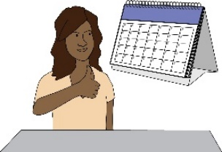
This means that if we did face any problems to do with money, we would have lots of time to deal with them. However, we don’t expect to face any problems to do with money over the next year.

- At the moment, we don’t have to pay out a lot of money. For example:

- We are not paying for any office buildings.

- We do not have any leases to pay.
Lease: this means when you agree to pay rent for a building. If you sign this agreement, you are promising to pay rent for a certain amount of time.

- Lots of our staff have short notice periods. This means that they won’t get a lot of money if they have to leave their job.
Notice period: this means the amount of time a worker has to tell their boss that they are planning to leave their job. For example, they might need to tell their boss about their plan to leave a week before they leave.

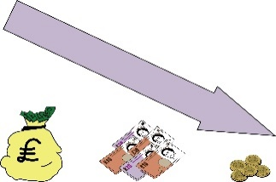
All of this means that the Trustees can make sure NSUN has enough money to pay what it needs to pay. NSUN will also have time to make changes and plan ahead. NSUN can spend less money if we need to.

- Most of NSUN’s money comes from grants. This is a very reliable way of getting money. The money we have got from grants is enough to last for the next year. We also have a small amount of savings too. We are always looking for new ways to get funding, for now and for the future.
Grant: this means money that organisations, people or companies give to us to help us run our projects and services. We have to apply for this money using application forms and having meetings with the funders.

What happens next?
Over the last 10 years, NSUN has gotten a lot bigger. We have changed a lot since 2010. We need to find a structure to meet these changes. We need a structure that works for our organisation.
Over the next 6 months, we will be looking at this. We want to find the best possible way of working. We want you, our members, to vote on this.
We are thinking about holding an Extraordinary General Meeting where you can have your say.
Extraordinary General Meeting: this is an extra meeting where we can deal with very important issues, that can’t wait for our yearly meeting.

We want to find a structure that is user-led. We want our members to be part of running the organisation.
However, we don’t want you to have to pay for anything that you haven’t agreed to.

We have also been looking at the skills of members of our Board. We want to look at how we make our inductions better. We want to bring on Trustees with expert skills in different areas. This will mean that we will be less likely to make mistakes like this again.
Induction: this means the way that we train new members of the Board when they first join the organisation.

It will take us some time for us to work out this new structure. We will keep you posted about how this is going. Thank you for being patient with us.

If you are a member of NSUN and don’t want to pay £10 for insolvency, you can become a supporter instead. This means if insolvency happens, you won’t have to pay £10. Please remember that it is not very likely that insolvency will happen anyway!
If you choose to become a supporter, your rights are a bit different to the rights that you have as a member. If you become a supporter, you won’t be able to vote at the Annual General Meeting.
Annual General Meeting: this is a meeting that happens every year. In this meeting, we talk about NSUN and important things have happened over the year and the work for the year to come.

If you choose to become a supporter, you can still come to our Annual General Meeting. You can also still get our bulletin.
Bulletin: this is our document that tells you about news, events and opportunities at NSUN.

If you would like to become a supporter instead of a member, please click here to fill in this short form. You can do this at any time.
You can also stop being a member of NSUN if you want to. If you want to stop being a member, please fill in this short form.

If you want to stop being a member, we will take you off our mailing list. This will mean that we won’t send you any more information or updates about NSUN. You can stop being a member at any time.
If you have any questions about any of this, you can email us. If you are worried about anything please send us an email.
We will save some time at our Annual General Meeting to answer any questions you might have.
If you would like to complain, you can read our complaints policy here.

Thank you.

The NSUN Board of Trustees and the CEO

