Easy Read

Information about the NSUN Side by Side Fund

This is an Easy Read version of the NSUN document: ‘Information about the NSUN Side by Side Fund’
April 2021
 | How to use this document
 | This is an easy read document. But you may still need support to read it. Ask someone you know to help you.
 | Words in bold blue writing may be hard to understand. You can check what the words in blue mean on page 19.
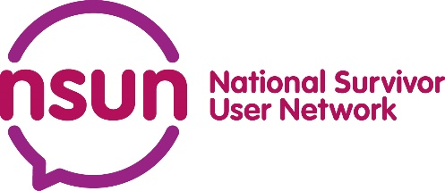 | Where the document says we, this means National Survivor User Network (NSUN). For more information or help with this document please contact:
 | E-mail: sidebyside@nsun.org.uk
 | Phone: 020 7820 8982
 | This document was made into easy read by Easy Read Wales using Photosymbols. To tell us what you think about this easy read version, click here.

 | About the fund
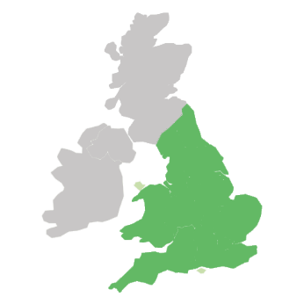 | This fund is to help groups in England and Wales.
 | We can give money of up to 500 pounds.
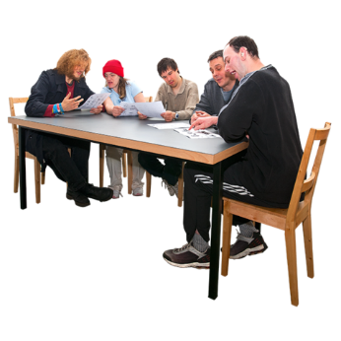 | The groups could be:
 | - Peer support group
 | A peer support group is a group of people who help each other with similar issues.
 | - Mutual aid group
 | This is where people have set up a group to support each other.
 | - Self-help group
 | A self-help group is a group where people support each other with issues that affect them.
 | What the money can be used for:
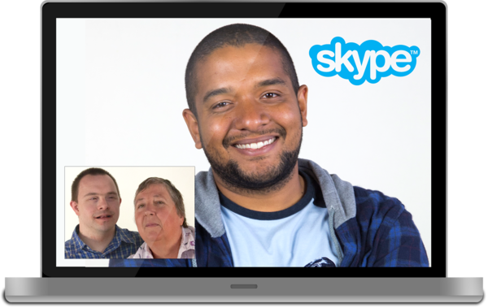 | - To run the group online
 | - To meet face-to-face
 | - Help make sure the group will last
 | The group must support people to improve their mental health and wellbeing.
 | The group may not be for people with mental health issues. But the purpose of the group must be to help improve mental health or wellbeing.
 | For example, talking to other people might help someone feel better in themselves.
 | The group should be run by its members in some way.
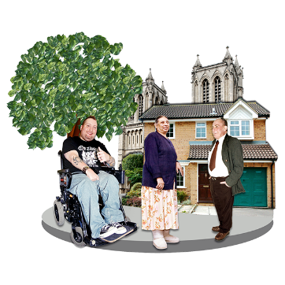 | And it should be based in the community. Not the council or a hospital.
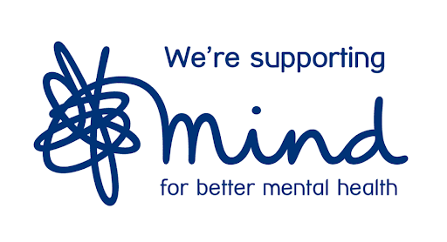 | This funding has come from the charity Mind and the supermarket Morrisons.
 | How to apply
You can apply through an online form here.
And the form in Welsh is here.
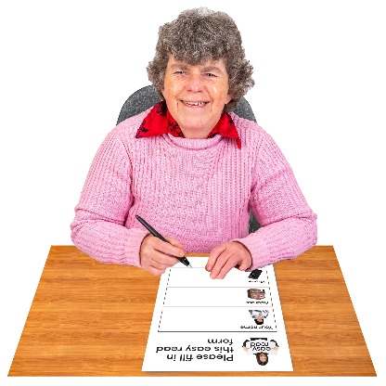 | Or by completing the form in this document.
Please contact us if you need any help with the form.
Email: sidebyside@nsun.org.uk
Phone: 020 7820 8982
 | How much can I apply for?
 | The group can apply for between £200 and £500.
 | Examples of what the money can be used for
 | - Cleaning products to help make a meeting space safe from Covid-19
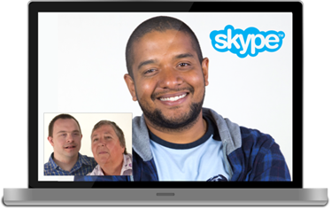 | - To pay for services like Zoom or Skype so the group can meet online
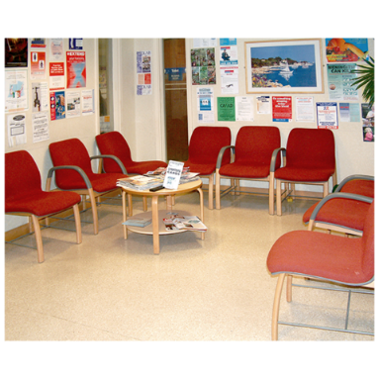 | - Room hire
 | - Equipment.
 | How will we decide who to give the money to?
 | We think a lot of groups will apply. We will give money to those we think need it the most.
 | We are really interested in getting applications from these groups:
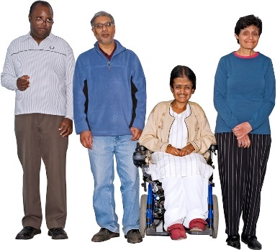 | - Groups for people of colour
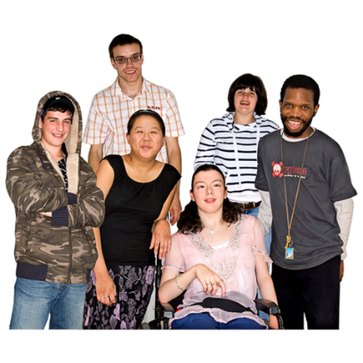 | - Groups for people aged 18 to 25
 | - Groups who have not been able to meet online during Covid-19
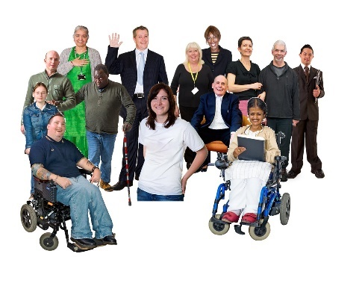 | NSUN wants to support lots of different people equally and fairly. Especially if they experience lots of other difficulties. For example, coming from a poor community.
 | What we won’t fund
We won’t fund the main running costs of the group. Please contact us if you’re not sure:
Email: sidebyside@nsun.org.uk
Phone: 020 7820 8982
 | What happens after applying?
 | We won’t be able to fund everyone.
 | A manager will check the applications.
 | We will check if the application is for the things we can fund (this is listed on page 4).
 | We will then contact these groups to find out more.
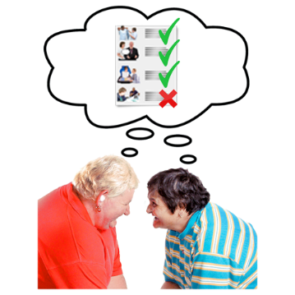 | We will make a decision about who to give money to. This may take 3 to 4 weeks.
 | We will then send an agreement for the group to sign.
 | Where must you live to get funding?
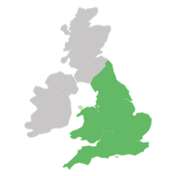 | The funding is for groups in England or Wales only.
 | However, if you meet online and some members live elsewhere, this is ok.
 | When will the group get the money?
 | By the end of July 2021.
 | When must the group spend the money by?
 | The money must be spent by 31st December 2021.
 | When is the closing date to apply?
 | 31st May 2021. But please check our website for any changes here.

Application form

- Are you a member of NSUN?
Yes ☐
No ☐
You have to be a member to apply. Please apply at our website: https://www.nsun.org.uk/member-join
When you have applied to become a member, you can complete this form and tick YES at the top of this page.
- Name of group:

- Name of organisation the group is part of, if any.

- Website (if you have one)

- Twitter name (if you have one)

- Facebook page (If you have one)

- Instagram (if you have one)

- Main contact name

- Main contact email

10. Second contact name

11.Secondary contact email

12. Organisation address

13. Phone number

14.Which area(s) of England or Wales does your organisation cover?

15.Does your group have a bank account?
Yes ☐
No ☐
16. Some groups have a legal status. What is the legal status of your group? Please tick from the list below:
A. Unconstituted group (no constitution)☐
B. Unincorporated association (with a constitution)☐
C. An affiliated group – this means your group is linked to an organisation ☐
D. Registered charity ☐
E. CIC / CIO (Community Interest Company / Charitable Incorporated Organisation) ☐
F. Company limited by guarantee ☐
G. Social enterprise ☐
H. I'm not sure ☐
I. Other ☐

17.What was your group’s income in 2020/21? (we don’t need an exact amount)

18.Did you receive the NSUN Covid Fund in 2020?

19.How much money do you want to apply for?

For the following questions, you may find it easier to write your answer in Word and then copy and paste it in the box.
- Please tell us how you will spend the money. Tell us as much as you can - but in no more than 300 words please.

- Tell us a bit about your group. No more than 300 words please.
For example:
- What is the group for?
- When was it set up?
- How many members does it have?
- How does it help people?

- What difference will the money make for your group?
For example, tell us:
- who will you help?
- what will you spend the money on?

- If we give you the money do you agree to giving NSUN:
- receipts on time
- information on how the money was spent
- the difference it has made? (NSUN can help you with this).
Yes ☐
No ☐

- We’d like to know more about how your group is run. Please tell us about things like:
- The group agreement.
- Terms of reference. This means things like the rules for how the group is to be run.
- Safeguarding processes. This means how people are kept safe.

- Would you be interested in a training session about making a safeguarding policy?
Yes ☐
No ☐

Hard words

Peer support group
A peer support group is a group of people who help each other with similar issues.
Mutual aid group
This is where people have set up a group to support each other.
Self-help group
A self-help group is a group where people support each other with issues that affect them.

