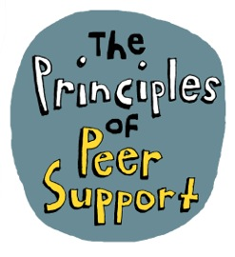
Principled Ways of Working: Peer Support in Sussex - Learning from a local partnership

Background
In 2017 Sussex Partnership Foundation NHS Trust hosted the Principled Ways of Working (PWoW) Conference in Portslade. Following on from this, a working group was established aiming to carry forward the learning from the event. In 2018 the Principled Ways of Working Peer Support Charter was produced. This has been used widely both locally and nationally (see www.nsun.org.uk/peer-support-charter).
Following the publication of this charter the group temporarily disbanded due to a lack of resources. Following the award of further funding, the PWoW group reconvened in late 2019 and agreed that its next priority would be to identify the full range of peer support available across Sussex, with a view to creating a directory outlining the choices available for someone with mental health issues who is looking for peer support.
‘Peer Support may be described as support being shared between two or more people who share similar experiences working together to offer each other mutual help to overcome challenges in ways that respect individual autonomy and expertise’.
Sarah Yiannoullou (then Managing Director of NSUN - the National Survivor User Network) chaired the conference in November 2017. The partnership formed subsequently to establish the Charter involved 13 groups and organisations across Sussex, both statutory and VCSE organisations, small and large, with the aim of getting more to sign up over time.

This Report
This report is the result of a reflective exercise undertaken by the PWoW partners with NSUN, in order to enable them to review their work together and discuss their achievements, the benefits and the challenges of their work on film. Some of the funding for the partnership accessed during 2019/2020 came from National Mind via NSUN, both of whom were interested in making the learning from the partnership more widely available. Due to Covid-19 and lockdown restrictions, the conversations took place on Zoom, phone and Skype. The final film, edited by Flexible Films, is available here: https://youtu.be/EzRHkfawqQI

Partners involved in the working group:
From an original base of 13 organisations signing up to the Charter, there are currently four active partners in the working group: Recovery Partners; Capital Project Trust; Sussex Partnership Foundation Trust; Synergy; with Sarah Yiannoullou (ex Managing Director of NSUN) as facilitator.
- Recovery Partners https://recovery-partners.co.uk/ Recovery Partners is a lived experience organisation working with Experts by Experience and in mental health recovery and suicide prevention. They are a charity that is 100% user-led and run. Everyone involved has lived experience and works to empower others in well-being, respect, recovery, hope and inspiration.
- Synergy www.synergycreative.org.uk/info/ is a peer-led space for creative expression, connection, community, promoting rediscovery, recovery and inclusion. It is a place to feel at home, to spend time with others, to be creative and enjoy a nourishing tasty meal. We are a mutually supportive group that have mental health issues, or an interest in mental health issues. We run Synergy for and by ourselves, independent of NHS or Social Services. This includes everything from setting up in the morning, helping with the food preparation, facilitating a workshop, through to fundraising. Our focus is on better mental health through creativity, mindfulness and nutrition.
- Sussex Partnership Foundation Trust is the mental health NHS Trust for Sussex. They have been training and employing Peer Support Workers since 2004, and have PSWs in more than 10 of their 100 sites across Sussex. The Trust employs people with lived experience in a variety of roles and has a Participation Directorate, which includes a lead for peer support and another for clinical strategy and integrated care. They have worked alongside their third sector colleagues to change the culture within many parts of the Trust so that there is the structure and the ethos to support the positive employment of PSWs. They are aiming towards having a 'really good supported peer workforce across the system'.
- CAPITAL Project Trust http://capitalproject.org/ is ​a not for profit mental health charity run by and for people in West Sussex who experience mental distress, offering informal peer support, training ​and volunteering opportunities to enable people to regain control of their lives. In 2011, Capital was commissioned to introduce ​formal peer support workers to the mental health inpatient wards across West Sussex, offering a service that is independent of, but complementary to, the NHS Trust. The project currently supports around 800 in-patient peers annually with a mix of one to one and group support.
The current plan is to host the emerging group with the Sussex Peer Support Network, a charity established by some of the key partners in 2016, comprised of organisations and individuals providing peer support both formally and informally for the purpose of advocacy, signposting and knowledge sharing.

Aims of the PWoW Partnership and Network
- Peer Leadership: The partnership acknowledged the rich history and experience of peer leaders and user-led organisations that existed within our communities. It is important that this history and experience is able to influence the development of peer support provision across Sussex; informing commissioners and decision makers at every level. Peer support is not a new 'model of delivery' or a 'clinical intervention', it is a valuable source of support that has existed within our communities and organisations for centuries, and where the locus of leadership resides within the peer community. One of our key aims was to protect and promote the key and core principles of authentic peer support .
- Shared understanding of peer support: The conference in 2017 was established with the aim of gaining a cross-sector shared understanding of what is meant by peer support: the principles and values that could enable everyone to recognise a project or practice as peer support. This was within a context in which peer support was beginning to be provided within the NHS Trust; local VCSE organisations wanted to see the value of the peer support they were offering recognised by commissioners. This aim was carried through by the partnership of organisations in the development of the Charter.
- Offering Choice: One of the aims of the partnership has been to ensure that people experiencing mental distress have a choice of peer support options. Consequently, one of the actions of the partnership has been to begin mapping the peer support options available across, initially, West Sussex and soon also East Sussex and Brighton & Hove.
- Influencing Commissioners: The partnership aims to influence commissioners by demonstrating the value of the range and diversity of peer support available in the community: that peer support is not a 'one size fits all' service.

Achievements to Date:
- The Peer Support Charter was successfully agreed, designed and launched in 2019: www.nsun.org.uk/peer-support-charter; the principles being: commonality, trust, diversity, empathy, hope, solidarity, mutual benefit, equality, self-determination. [See over page]
- The working group successfully re-convened in 2019 and has continued to meet and negotiate progress.
- Since that time, the working group has succeeded in mapping the peer support available to people across West Sussex.

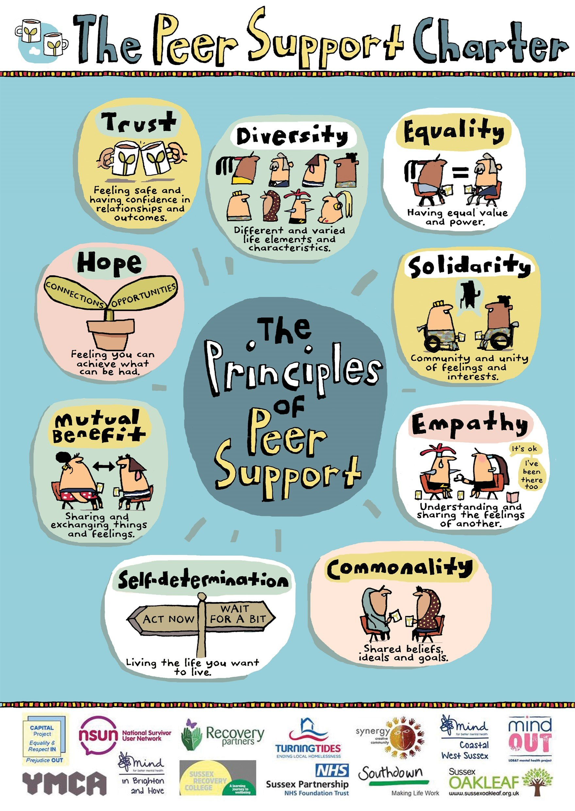

Benefits of the partnership
- Collaboration: the partnership began a journey from a situation of conflict and competition - small organisations fighting large organisations for the funding to deliver peer support - to one of partnership. The process has been one of 'grown up' discussion and of defining the underlying principles for the realisation of peer support. The principles have been key to establishing the shared ground of the partnership. The partners have shared and learned each other's languages, in order to convey and communicate the value of peer support to different stakeholders. 'I love the fact that we're together, it gives me great inspiration and hope.'

- Putting people first: The partnership has enabled all of the organisations to remember to put people, their experience and choice first, 'I just think this group have been so amazing at putting people first and centre'.

- Diversity and Choice: As a diverse partnership, they can signpost people to the sources of help that most suit them: 'The more diverse we are as a partnership, the more we can meet the needs of people who need support'. Race, gender or sexuality might be more important sources of peer support for some people than a shared lived experience of mental distress.

- The Charter: The charter became a positive focus for the different organisations to come together and share their understandings and experiences of peer support, and to come to a common understanding of the underlying values and principles. It was important to reach an understanding of the different ways in which peer support can be delivered and can help people, whilst holding on to the shared values and principles: 'Learning from each other has been powerful'.

- Accessibility. For smaller organisations attending the PWOW group, it has been important to provide some support to make sure that participation and their contribution to the partnership could be relatively consistent.

- Understanding the grassroots: It has been vital to highlight the experience of small groups who simply carry on providing services, working with peer support often free of charge 'without actually getting the funds to be able to do what we do, we still do what we do'.

- Developing working relationships: The partnership has helped the active partners to develop professional respect and understanding for each other's work, recognising the different perspectives they bring and pressures they are under. They have been able to develop professional accountability, to ask each other challenging questions in a constructive way. One of the factors enabling this to work, particularly for the statutory organisations, is the openness, honesty and transparency: 'It's really powerful to be held to account and to be able to learn from peer-led organisations'.

- National strategy links. They have been able to link the local work with national strategic work around peer support, particularly the Health Education England's New Roles in Mental Health work on peer support workers in the NHS. The PWoW partnership were able to create strong links between what was happening locally and nationally to challenge some of the national policy initiatives.

Challenges for the Partnership
- Unequal resources: Much of the funding for small groups and organisations in the partnership has disappeared during this period, so they are no longer resourced in a way that they can offer choice to people needing peer support. In addition, the larger organisations have been 'sleeping partners' in the process; they have all the funding but are not able to give back to the peer support community - even small bits of money have dried up. Inevitably, resources mean power and the power imbalance in the partnership has been a challenge to navigate. It has been a real loss for the community and the potential beneficiaries of peer support, to have significantly reduced access to choice and diversity of peer support. 'It has been a painful process.'

'I cannot see a future where all the resources are going to large national or large regional organisations or Health Trusts... how can that possibly be a positive environment in which to develop user-led services or peer support?'

- Retaining focus on the value of peer support. It has been a challenge to retain focus on the value of peer support, within a context in which most of the resources are funding a particular model of peer support in which PSWs are employed in mainstream services. It has helped for the partnership to focus on what peer support delivers for people, and to respect the learning from each other in agreement that there is no one way or 'right' way to do it. However, this has been a significant emotional challenge for those who feel strong loyalty towards a different way of providing peer support. As one person said, 'I feel sad about the reductionist view of peer support'.

- Commissioning policy. Local commissioning policy has been to give money to the larger peer support providers; they seem unable to move that funding into the community. Small groups have experienced this as discriminatory. For example, Synergy was funded by the PCT to deliver music in the hospital in the past but have received no funding over the last seven years; so most of what they do now is voluntary: 'It's painful, but again, that pain has the love in it, because we see the effect.' At Synergy, they provide peer support in creative and artistic ways, which can be hard to articulate in writing.

- Outcomes and evidence. Connected with the above, a remaining challenge for the partnership is to convince commissioners that the local grassroots peer support that people do together is valuable, because it is really difficult to measure. 'One of the challenges for me is to try and get the commissioners and other people think very differently about the way that they think about commissioning in terms of outcomes'. The hope for the future is that the PWoW will help to change this, through creating a partnership umbrella of shared goals, to really push the peer support principles forward together.

- Business model for peer support. One of the issues at the heart of the commissioning challenge is that the business model of peer support has not been widely understood. Some have understood it to be about creating PSW roles as cheap labour for mental health services. However, the business model for peer support should be about creating an additional service which is cost effective because it helps to move people away from the more expensive services more quickly. One of the aims of the partnership was to demonstrate the value of peer support to commissioners in language that they understand, so that they would commission the range of peer support activity that works for people. However, it has been a challenge to achieve this and it remains a goal for the future.

- Conflicting demands. One of the challenges for larger statutory organisations has been to meet the demands that are being asked of them by using the partnership model; for example, developing a training programme together, enabling PSWs employed by the Trust to access development opportunities within the community, and so on.

- Leadership. Leadership within a partnership of non-equal partners is a challenge. The larger organisations in the partnership have feared that if they put too much money into it, they will be seen as leading it, rather than supporting others to participate. So the challenge is about working out how the different organisations move forward with their different roles and positions within the partnership and what each can contribute. It is about finding a way of making equality work between the partner organisations, and retaining representation of the diversity of peer support.

- Energy and Vision: With the long gaps in partnership working, it has been difficult to keep the energy going. The lack of resources has affected people's energy and ability to sustain the vision, opening up the gap between the rhetoric and the reality.

Learning points
- A peer supported partnership. It has been important to remember that, as partners in this initiative,' we're all each other's peers. We all need to support each other through this.[...] because we all need to safeguard our own mental health too.' It is important to show mutual respect, kindness and compassion towards each other; this has helped the partnership to work together through tensions and differences of opinion. 'How can we apply the principles of the peer support charter to ourselves and how we work together?'

- Shared vision and goals. It is important to find ways of retaining the shared vision of diversity and choice for people who need peer support, of keeping the needs of people who need peer support central to the work. Working together on the Charter was a good example of how to harness people's complementary skills and knowledge towards a shared goal.

- Shared resources and power. Ideally, the partnership needs a basis of equality and equal resourcing to work well. This could mean larger organisations finding ways of sub-contracting with small organisations, but also sharing other resources such as knowledge, technology and venues. All partner organisations have resources they can share.

- Peer leadership: Looking back now, some felt the partnership should have been hosted by a user-led organisation, as a means of retaining the peer-led values inherent in peer support. Small community based ULOs are able to keep close connections with the potential beneficiaries of peer support. They can also be more responsive and flexible than large organisations and connect well with local communities.

- Involving Commissioners. Engaging with commissioners from the start might help to build that level of communication to change and challenge the commissioning landscape more easily.

Hopes and plans for the future
The plans for the future of the partnership include:
- Mapping peer support provision across East Sussex and Brighton and Hove.
- Peer Support Network: Developing or merging with the Sussex Peer Support Network, which was established a few years ago and could become the new host for this partnership work.
- Renewing the Charter: There are definite plans to refresh the Charter, renewing and/or removing the logos of those organisations no longer actively involved in the partnership; encouraging wider sign-up to the Charter from more groups and organisations across Sussex; raising its profile so that people might begin to use it in training and development of peer support.
- Handbooks: There were plans from the beginning to add to the Charter by developing three handbooks on peer support: one each for non-peer staff within services; peers and people with lived experience; and peer support workers. There are currently no resources to develop these, but should resources become available, they would like to progress these.
- Business case: They hope to develop the business case for peer support through links with researchers/economists who can help to provide the economic evidence for the business model.

"I just wanted to say it's been an absolute privilege and pleasure to be part of this partnership, because I think it's unique. I think that it's difficult. There's a lot more work we have to do, but we're living in very changing times now. And I think that peer support saves lives. So we're all equally committed. With the resources, we have to make sure that whoever chooses peer support, wants to be helped by peer support, it has to be there for them."

