Blog for Sociological Review

Reclaiming, challenging and reviving mental health survivor research

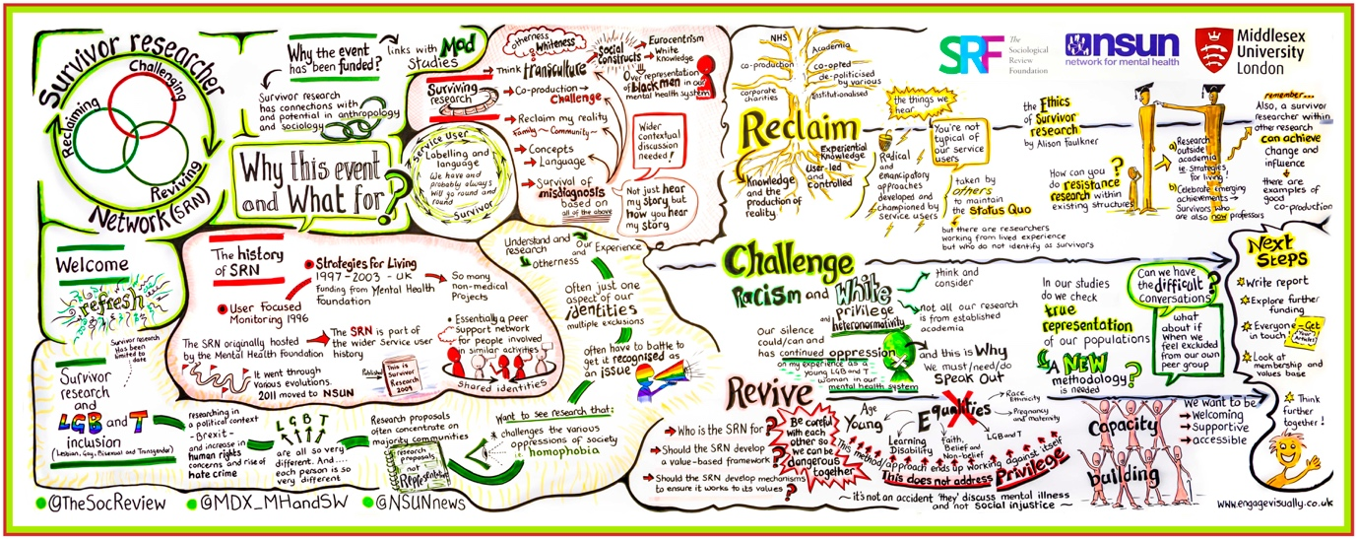

People with lived experience of mental distress have traditionally been excluded from the process of knowledge production that guides thinking, policy and practice in relation to mental health (Wallcraft et al., 2009). Research in this field continues to be dominated by clinical frameworks and positivist methodologies that position service users and survivors as the objects of study. However, Russo & Beresford, 2014 have argued that the social sciences and humanities have also excluded people with lived experience from research and reproduced inequalities by positioning service users/survivors as ‘outsiders’. People with lived experience are often asked to share their stories and the knowledge gained from these experiences, only to find them reinterpreted by an ‘expert’ and “colonised or reduced to a new area for academic activity” (Russo & Beresford, 2014 ).

Over the last 25 years, ‘survivor research’ has grown and developed at a rapid rate. Sharing its political roots with the service user activism that seeks to challenge the psychiatric system and the dominance of the medical model of mental illness, survivor research aims to generate forms of knowledge production that focus on lived experience. Key milestones in the development of the area include the first survivor-led research programmes, Strategies for Living (Faulkner & Layzell, 2000) and User Focused Monitoring (Rose, 2001). Survivor edited works have also been published, including This is Survivor Research (Sweeney et al., 2009) and more recently, Mental Health Service Users in Research (Staddon et al., 2013).

Studies that focus on experiential knowledge and the perspectives of the service users and survivors themselves continue to be marginalised within mainstream research. However, an increasing number of user/survivors are now centrally involved in research in mental health in England (Patterson et al., 2014). There is also a growing knowledge base which is developing through the discipline of Mad Studies in addition to the development of theories and evidence generated by users and survivors (Russo & Sweeney 2016; LeFrancois et al., 2013). It is also clear that when user/survivor generated philosophies and methodologies are employed a very different kind of evidence emerges. For example, in relation to perspectives of electroconvulsive therapy (Rose et al., 2005) and experiences of recovery under the 2008 Care Programme Approach (Gould, 2012).
The Survivor Researcher Network
The Survivor Researcher Network is an independent, user-controlled and diverse network for all mental health service users and survivors who are engaged in or interested in research. It was originally formed after the ‘Strategies for Living’ Mental Health Foundation project (1997-2003) and was hosted by the Mental Health Foundation until 2001 when it moved to the National Survivor User Network. In early 2016, a working group was assembled to seek funding to re-establish the network to support and grow survivor research.

On 26th July 2016, members of the SRN met for a seminar entitled ‘Reclaiming, Challenging and Reviving Survivor Research’. The event was funded by the Sociological Review Foundation and Middlesex University and provided a starting point to explore what ‘survivor research and knowledge’ is today and how to revive the network and build for the future. Given that survivor research continues to be a white, heteronormative enterprise, the event aimed to ensure proactively the inclusion of black and minority ethnic survivors as speakers and participants.

Reclaiming survivor knowledge

Presenters drew on their own personal experiences, focusing on inequalities and the need to break patterns of oppression both within and outside of survivor research. Colin King, drawing on his own experiences of surviving research said “my reality is informed by whiteness as a privilege. Like in the film The Sixth Sense, where they see dead people? Well, I see a lot of white people. The over reliance on the idea of blackness concerns me… if we talk about blackness we need to talk about whiteness too”. Dorothy Gould discussed equality for researchers with lived experience from lesbian, gay, bisexual and transgender communities. She drew attention to the way in which research proposals continue to concentrate on majority groups because a focus on minority communities still isn’t considered relevant. Participants reflected on the way in which ‘whiteness’ and ‘straightness’ continue to be constructed as universal and invisible. Rather than directly addressing issues of white privilege and heteronormativity that maintain the status quo, discussions tend to focus instead on the need for greater ‘diversity’ and ‘inclusion’ - concepts which are frequently reduced to tokenistic recruitment practices. There is a real need to question and challenge these naturalised assumptions and develop new methodologies in this area.

Jayasree Kalathil and David Crepaz-Keay addressed issues arising from the co-option of ‘service user research’ into ‘public and patient involvement’ by the NHS, academia and large corporate mental health charities. User involvement and ‘co-production’ initiatives are conceptually very different to survivor research where people with lived experience are creating their own knowledge and theories. What constitutes good and bad mental health has historically been defined by Western psychiatry and that continues to be reflected in the hierarchy of evidence in which scientific approaches and quantitative methods are highly valued. People with lived experience are now more likely to be included in research studies through ‘co-production’ initiatives and can make a valuable contribution, but often the research that is produced continues to reflect one narrow perspective. Therefore, one of the key questions raised by participants was how to reclaim agency and maintain integrity as a survivor researcher whilst also working within these hierarchical structures.

Challenging survivor knowledge

With regard to challenging survivor knowledge, Alison Faulkner and Sarah Carr asked how we critically examine survivor research and knowledge itself, when much of the (known) history of the movement is white and heteronormative. Discussion focused on the importance of reflecting on practices of inclusion as survivor researchers. User-led/user-controlled research continues to replicate what we are so critical of in mainstream research, meaning that marginalised or minority individuals and groups are positioned as ‘hard to reach’, ‘difficult to engage’ or ‘seldom heard’. As such, we reflect the institutional racism and heteronormativity in our society and in psychiatry. Participants reflected on how difficult it can be to think about our own privilege when we have been oppressed ourselves. Some participants who identified as white and/or heterosexual raised the issue of staying silent for fear of ‘getting it wrong’ or having a lack of experiential understanding. It was felt that these issues should be acknowledged and openly addressed. There needs to be a much greater recognition and understanding of heteronormative attitudes, white privilege and white fragility in our society. It is vital that we all understand and recognise our own racialisation and how we contribute to oppressive systems in order for normativity to be challenged. This cannot be the responsibility of people from racialised and LGB and T communities alone, otherwise nothing will change.

Reviving survivor knowledge

Jasna Russo and Jan Wallcraft focused on the importance of strengthening and developing the Survivor Researcher Network itself to ensure that it is truly diverse. They asked how the network can reach out to survivor researchers across the country who might be working in isolation and how to think about capacity building in order for survivor researchers to develop skills and continue to generate experiential research knowledge.

The event created a space for researchers whose voices have not historically been included to consider issues around survivor research, whiteness and heteronormativity. The discussions that took place covered new ground in this area and began to shift significantly the white and heteronormative centre of survivor research. You can watch interviews with some of the participants as they reflect on their experiences of the day.

The next step in the process will be to build a funding application to develop the network further. If you are interested in joining the Survivor Researcher Network mailing list, please e-mail: Emma.Perry@nsun.org.uk

