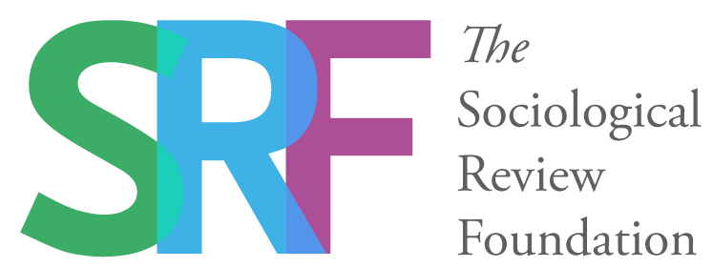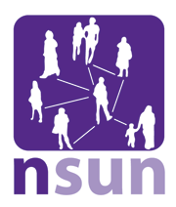

Survivor Researcher Network Report

Reclaiming, Challenging and Reviving Survivor Research Seminar held on 26th July at The Arlington Centre, London

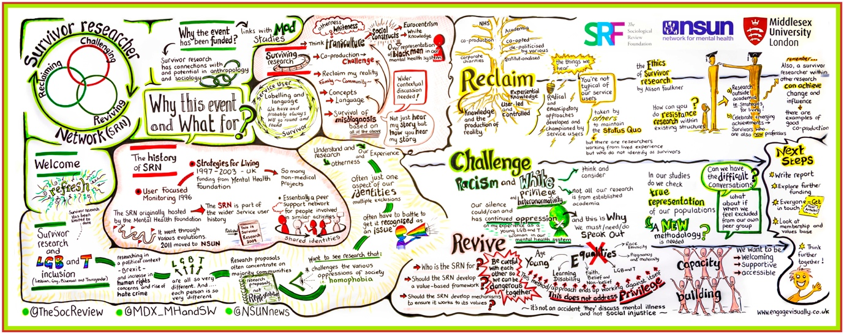

The Survivor Researcher Network

The Survivor Researcher Network (SRN) is an independent, user-controlled and diverse network for all mental health service users and survivors who are engaged in or interested in research. It was originally formed after the 'Strategies for Living' Mental Health Foundation project (1997-2003) and was hosted by the Mental Health Foundation until 2011 when it moved to be hosted the National Survivor User Network (NSUN). In 2012, NSUN conducted a survey of SRN members and set up a working group of members who developed aims, objectives and a work plan based on the feedback from the survey.

The SRN has the following aims:
• To provide mental health service users and survivors involved and interested in research a forum for networking, sharing information and supporting each other.
• To promote the evidence based on lived experience as fundamental to the knowledge base on mental health, human rights and social justice.
• To set standards and promote good practice in user/survivor research in mental health.
Although the SRN currently has no funds to support it, there is a database of around 200 members and a bulletin of research news and opportunities is produced and sent to members every six weeks.
Reclaiming, Challenging and Reviving Survivor Knowledge Seminar

In early 2016, an ad hoc working group of interested people came together to seek funding to re-establish the network to support and grow survivor research. The seminar, funded by the Sociological Review Foundation and Middlesex University, was an opportunity for service user and survivor researchers to discuss what ‘survivor research and knowledge’ is today and consider how to revive the network and build for the future.

The event aimed to explore the following topics:

Reclaiming survivor knowledge – how do we address the issues arising from the co-option of ‘service user research’ into ‘public and patient involvement’ by the NHS, academia and large corporate mental health charities?

Reviving survivor knowledge – how do we address the broader social issues of marginalisation, oppression, inequality and impoverishment, and question the relationship between deepening inequalities and mental health?

Challenging survivor knowledge – how do we critically examine survivor research and knowledge itself, when much of the (known) history of the movement is white and ‘heteronormative’?

Given that survivor research continues to be white and heteronormative, the event aimed to have conversations led by people from BME and LGBT perspectives. It also aimed to ensure proactively the inclusion of black and minority ethnic survivors as participants and invite people who were less familiar with the SRN as well as those who had been actively involved with the network in the past.

Programme

Chair and facilitator: Tina Coldham

10.30 – 11.00: Registration

11.00 – 13.00: Setting the Scene: why are we holding this event and what is it for?

11.00 – 11.40: Speakers:
- Brigit McWade: Welcome from Sociological Review Foundation
- Sarah Carr: Welcome from NSUN
- Alison Faulkner and Sarah Gibson: The history of SRN
- Colin King: Surviving research – racialisation from a black perspective
- Dorothy Gould: Survivor research and sexualities
11.40 – 13.00: Questions for panellists; open discussion with all participants about their experiences of survivor and user-led research and the past, present and possible futures of the Survivor Researcher Network.

13.00 – 14.00: Lunch
In the afternoon, we will all take part in three sessions, each facilitated by two people who will give a brief set of statements and facilitate a full group discussion on the topic in question.

14.00- 14.50: Reclaiming Survivor Research: (David Crepaz-Keay and Jayasree Kalathil)

14.50 – 15.00: Break

15.00 – 15.50: Challenging Survivor Research (Alison Faulkner and Sarah Carr)

15.50 – 16.00: Break

16.00: Reviving Survivor Research (Jasna Russo and Jan Wallcraft)

16.50 – 17.00: Break

17.00: Closing remarks and next steps

17.30: Farewell

Key discussion points

- There is a real need to break patterns of oppression within and outside of survivor research. ‘Whiteness’ and ‘straightness’ continue to be constructed as universal and invisible. We need to acknowledge and openly address the racism and homophobia in our society.

- We all need to reflect on our own privilege, recognise our own racialisation and understand how we all contribute to oppressive systems in society. This might be difficult to do when we have been oppressed ourselves. But if real, lasting change is to take place, it cannot be the responsibility of people from racialised and LGB and T communities alone.

- Mainstream research proposals continue to concentrate on majority groups because a focus on minority communities still isn’t considered relevant. Concepts such as ‘diversity’ can often be reduced to tokenistic recruitment practices. It is important to question and challenge these assumptions at the outset. We need to develop new, creative methodologies in this area that foreground user-generated experiential knowledge and address diversity and complexity as standard.

- User involvement and ‘co-production’ initiatives are conceptually very different to survivor research where people with lived experience are creating their own knowledge and theories. We need to consider how we reclaim agency, sustain power and maintain integrity as survivor researchers, whilst also working within hierarchical structures.

- User-led and user-controlled research can replicate the things we are critical of in mainstream research, meaning that we reflect the institutional racism and heteronormativity in our society and in psychiatry. We need to reflect on our practices of inclusion as survivor researchers.

- The SRN needs to ensure that it is truly diverse. It will be important to develop a values-based framework and build capacity within the network. This will help support survivor researchers across the country to develop their skills and continue to generate experiential research knowledge.

Evaluation of the event
20 of the 40 participants returned their evaluation forms. All felt that they gained new information, most (80%) felt able to participate in the event, 75% felt listened to and 75% felt supported. There were also some very positive comments from participants about the nature of the debate and the issues covered:
A chance for the members of the SRN to meet, talk and listen to each other. The focus on inequalities, race issues, diversity etc. was impactful and thought provoking and needed.
Truly unheard (silenced, marginalized) perspectives. Authentic personal shaping.

Good challenging conversations about race and identity – appreciate the honesty of the speakers.

Amazing debate and discussion.

However, some participants felt that it had been difficult to participate in the discussion:
Information overload, overwhelming. I am quite an introvert in new groups – couldn’t express my voice.
I was aware that a few people said a lot. Was that because the others had nothing to say or was it because they lacked the confidence in such a large group. Having flipchart paper to write things on / stick on post it notes or even have an opportunity to discuss issues on tables would have helped.
Others wrote that the event lacked focus and felt inconclusive:
Some more structure and focus going forward is need if the SRN is to become an active and supportive organisation.
The content of the discussion became increasingly unfocused on the stated aims of the day. I am not sure much was produced that will move the SRN forward in relation to aims but perhaps that’s a step too far at this stage!
These will be important issues to take into consideration when planning future events.
With regard to discussion and debate, the event successfully began to cover new ground and shift the white and heteronormative centre of survivor research.

In addition to this evaluation report, the following have been produced:

- Statement from the event working group detailing the event planning and process
- Funder report for Middlesex University
- A blog for the Sociological Review
- Interviews with participants

Next steps

This seminar was an exploratory event with the aim of providing the basis for a funding proposal for a seminar series on survivor research and knowledge.

As the SRN moves to the next stage of planning, we will ensure that our work is open, inclusive and transparent. We will develop a framework that reflects our shared values as well as acknowledging and working with values when they are in conflict.

The next step in the process will be to build a funding application to develop the network and its activities. NSUN will put a call out in the bulletin to the wider SRN network asking for volunteers to form a new working group in the near future. We will aim to ensure that this new working group is representative and includes people from BME and LGBT communities as well as researchers from different regional areas.

If you are interested in joining the Survivor Researcher Network mailing list, please e-mail Emma.Perry@nsun.org.uk. You do not need to be a researcher or have any previous experience of doing research in order to join.

“Amazing day – much appreciated. Lots of bravery. Lots of helpful discussion. Huge investment on part of the working group. THANK YOU to speakers”.

“I am new to the SRN sphere. This meeting was exploratory for me. It was interesting, thought provoking, inspiring. Learnt that the survivor research network is more than a space for research practice. It is about activism, creativity, political challenges”.

NSUN would like to thank the following people for helping to organise and/or speak at the event: Sarah Carr, Brigit McWade, Tina Coldham, Jayasree Kalathil, Alison Faulkner, Dorothy Gould, Colin King, David Crepaz-Keay, Sarah Gibson, Jasna Russo and Jan Wallcraft.

The survey report and draft documents are available on the NSUN website: http://www.nsun.org.uk/about-us/our-work/survivor-researcher-network/
The term ‘white’ is used with reference to theories of ‘whiteness’. Whiteness is a social and political construct resulting in the unequal distribution of privilege and power in society based on skin colour. Kivel states that “racism is based on the concept of whiteness – a powerful fiction enforced by power and violence. Whiteness is a constantly shifting boundary separating those who are entitled to have certain privileges from those whose exploitation and vulnerability to violence is justified by their not being white”. (Kivel, P. (1996, p.19) Uprooting racism: How white people can work for racial justice. Gabriola Island. BC. Canada: New Society Press
Heteronormativity denotes or relates to a world view that promotes heterosexuality as the normal or preferred sexual orientation.
For further information about the planning of the event, please see the working group statement: http://www.nsun.org.uk/assets/downloadableFiles/SRN-July2016-STATEMENTSRNFINALVERSION22.pdf

